PE Funding

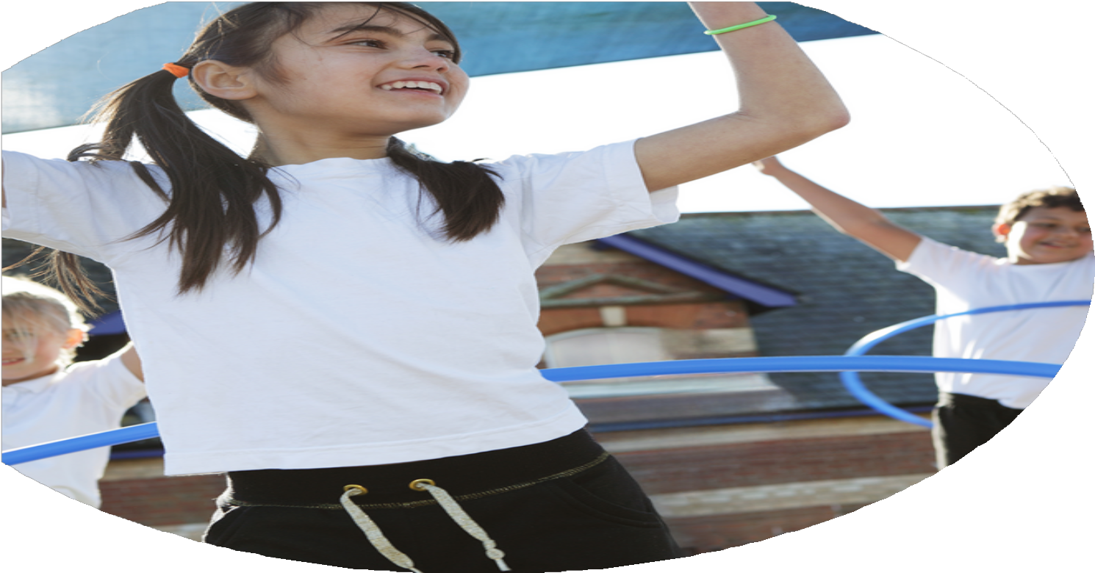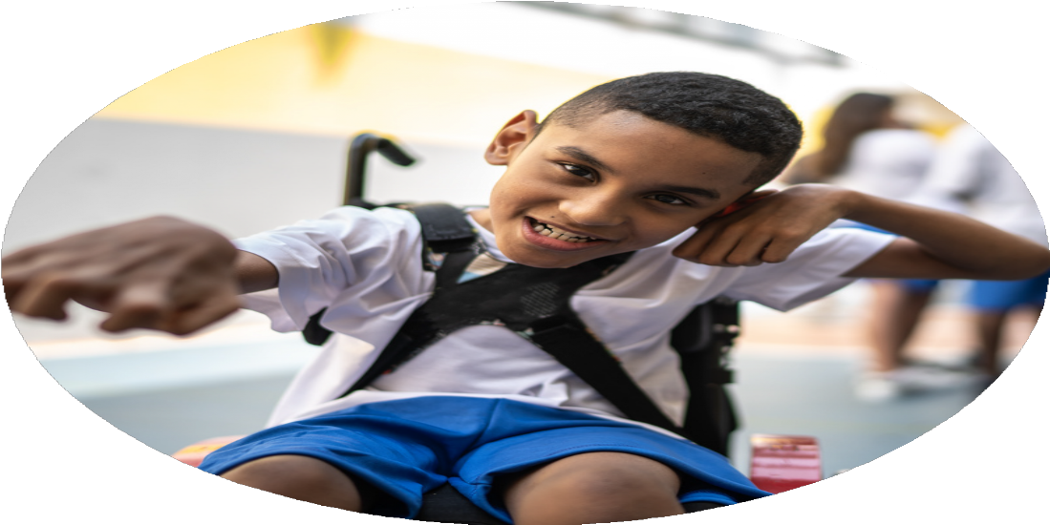

Evaluation Form

**Commissioned by**

**Created by**

Images courtesy of Youth Sport Trust

**PE Funding Evaluation Form**

 It is intended that this template should be used as preparation for the completion of the statutory digital reporting tool being introduced this academic year. You can upload data (including swimming) from this template onto this platform once it becomes accessible.

 Before you decide how you are going to use the funding for this academic year you should reflect and evaluate the impact of your use of the funding in 2023/24.

 All spending of the funding must conform with the terms outlined in the Conditions of Grant document.  The template is a working document that you can amend/update during the year.

 Based on your evaluation of last year’s funding you should decide what you intend to do this academic year, how you will do it, and what impact you expect it to have.

It is important that the funding is used effectively and based on your school’s needs.

 You must use the funding to make additional and sustainable improvements to the PE and sport in your school.  You must develop and add to the PESSPA activities that your school already offers.

*Summative digital reporting from June 2025 will continue to include swimming and water safety information therefore funding can be used to provide top-up lessons where necessary to ensure pupils meet national curriculum swimming requirements.*

High engagement in after school clubs

Participation in JMAT academy sporting events

Active lunchtimes and structured play improved participation

Wide range of extracurricular activities offered

Outdoor climbing equipment remained safe and in use

PE resources audited and improved

Children’s participation and engagement improved in PE lessons

Attendance records show variable uptake

|  |
| --- |
|  |

|  |
| --- |
| Feedback from staff and children |
| CPD logs and feedback forms  Some resources not maintained properly  Attendance lists show gaps |

Safety audit highlighted areas needing updates

Equipment sometimes inaccessible

Teacher observations and pupil voice

Some clubs less popular (e.g., specific sports not attended as well)

Not all staff accessed the full CPD offer

Equipment management still inconsistent

Not every child engaged

Some areas of playground need further development

Storage solutions not fully effective

Some less confident children remain hesitant

Increased attendance and uptake across the year

High enthusiasm from pupils, especially girls football

Teachers report feeling more confident; visible improvements in lessons

Supervisors report greater engagement; children use equipment well

Events were attended and enjoyed (Movement Evening, Festivals)

Passed safety inspections; children actively using equipment

New equipment purchased and in use in lessons and play

Observations show greater resilience, teamwork, enjoyment

What are your plans for 2024/25?

Intent

How are you going to action and achieve these plans?

Implementation

Continue to work with JMAT coaches and sports coordinators.

Provide CPD opportunities for staff, including ECTs.

Monitor and refresh PE equipment and outdoor play structures.

Organize and support participation in trust-wide events and competitions.

Encourage structured active play through playground supervisors.

Maintain existing after-school provision and introduce new opportunities.

Continue to provide a broad, engaging PE curriculum.

Further develop staff skills through ongoing CPD and collaboration with sports coaches.

Maintain high-quality equipment and safe facilities for PE and active play.

Increase participation in extracurricular and competitive events.

Promote physical activity and healthy lifestyles through structured play and community engagement.

What impact/intended impact/sustainability are you

expecting?

How will you know? What **evidence** do you have or

expect to have?

Records of CPD and staff evaluations.

Participation numbers in clubs and events.

Feedback from children and staff.

Health and safety reports on equipment.

Observations of active lunchtimes and lessons.

Staff and children maintain high engagement in PE and sport.

Increased pupil confidence, resilience, teamwork, and enjoyment.

Sustainable improvement through CPD, partnerships, and resources.

Clear systems for maintaining equipment and activity levels embedded into school routines.

What **impact/sustainability** have you seen?

What **evidence** do you have?

Ongoing CPD and coaching partnerships helping build staff confidence and skill

Embedded systems for maintaining equipment and PE provision

High-quality equipment maintained for long-term use

Increased pupil enjoyment and engagement, which supports lasting impact

Supervisors promoting structured active play, contributing to sustainable lunchtime activity

High engagement in after-school clubs

Active participation in JMAT academy events

Improved participation during lunchtimes and structured play

Children's participation and engagement in PE lessons increased

Outdoor climbing equipment remained safe and in active use

PE resources were audited and improved

High enthusiasm, especially in areas like girls' football

Improved teacher confidence and lesson quality (via CPD)

Supervisors observed greater engagement during playtimes

Children demonstrated increased resilience, teamwork, and enjoyment

New equipment actively used in lessons and during play

Events (e.g., Movement Evening, festivals) were well attended and enjoyed