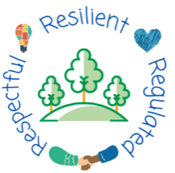
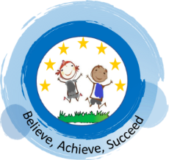
School Improvement Plan 2025-26
Priorities
Quality of Curriculum and Teaching,  Inclusion to enable Achievement | English: | - Implement Little Wandle Phonics and Reading programme.  - Develop the teaching of reading fluency in Y2.  - Develop modelling of writing across school.  - Further develop oracy through a structured, coherent plan across EY and KS1.
 | Maths: | - To develop secure knowledge of number facts in KS1.  - To implement Fluency B across Y1 and Y2.
 | Wider Curriculum: | - To refine activities for SEN children within wider curriculum subjects.  - To further embed retrieval practice in line with assessment documents for Foundation subjects.
 | SEND: | - To identify children who need the Little Wandle SEND programme and implement.  - To refine interventions used to support children, inc Speech and Language, SEMH and curriculum
Behaviour and Attendance | Behaviour:  - Whole school training from Dynamis which focuses on preventative behavior strategies to support regulation and des-escalation.  - Embed use of behaviour RUBRICs to set clear expectations of pupils and staff  Attendance:  - To work in partnership with parents/carers to improve attendance and punctuality
Personal Development  and Wellbeing | - Develop pupils’ physical, social and Mental fitness through ‘One Life’  - To further develop a sense of belonging and teamwork through the structured activities in school houses
Leadership and Governance | - To ensure the effective implementation and monitoring of Little Wandle to ensure fidelity and rigor of teaching phonics  - Strengthen links with feeder school through Mastery maths programme, implementation of One Life whole school approach to PSHE/SMH, writing project and working in partnership with parents with an attendance focus.
Early Years | - Implement Little Wandle Phonics programme  - Develop and implement coherent and progressive plan of Oracy to work alongside Little Wandle.  - To strengthen the progression of writing across EY  - Strengthen Maths curriculum with Maths Mastery programme in F2  - Strengthen personal and emotional development through One Life activities

Joint School Improvements with BEP to develop fidelity and seamless progression across EY to End of KS2.

