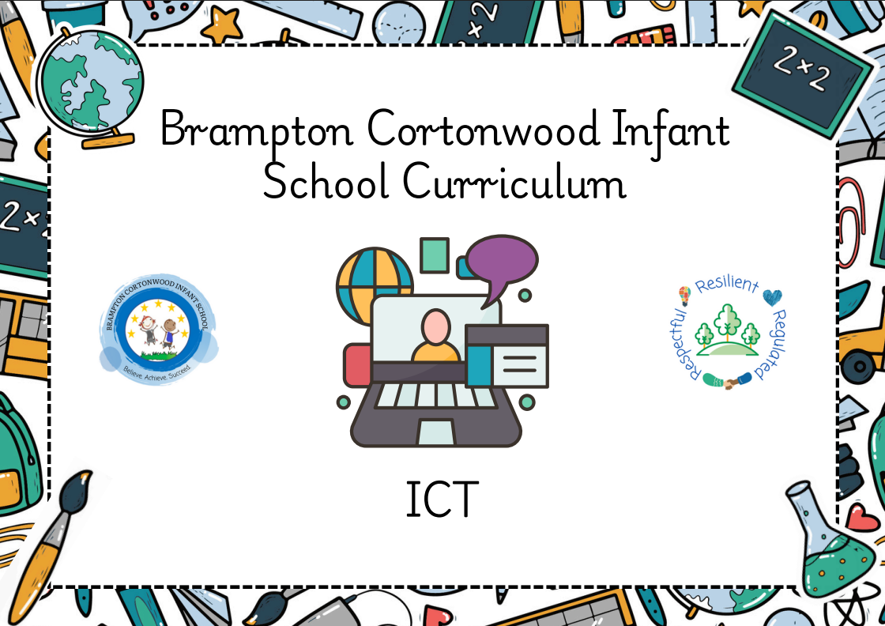
May 25

Progression of knowledge & skills within ICT
‘A high-quality computing education equips pupils to use computational thinking & creativity to understand and change the world. Computing has deep links with mathematics, science, & Design Technology, & provides insights into both natural & artificial systems. The core of computing is computer science, in which pupils are taught the principles of information and computation, how digital systems work, & how to put this knowledge to use through programming. Building on this knowledge and understanding, pupils are equipped to use information technology to create programs, systems & a range of content. Computing also ensures that pupils become digitally literate – able to use, & express themselves & develop their ideas through, Information & Communication Technology – at a level suitable for the future workplace & as active participants in a digital world.’ - The English National Curriculum for Computing.

Intent
Our intent is that all pupils can understand & apply the fundamental principles & concepts of computer science, including abstraction, logic, algorithms & data representation. That they can analyse problems in computational terms, & have repeated practical experience of writing computer programs in order to solve such problems as well as evaluating & applying information technology, including new or unfamiliar technologies, analytically to solve problems. We also aim for pupils that are responsible, competent, confident & creative users of Information & Communication Technology.

ICT taught through a topic approach
The breadth of our topic-based learning curriculum is planned to give pupils appropriate experiences both in & out of the school environment to develop as confident and responsible citizens through the world they live in. It is designed to provide rich cultural capital & provide them with the knowledge & skills to succeed in the future working world. It is delivered in a coherent, structured, practical curriculum that leads to a sustained mastery for all & a greater depth of understanding for those who are capable.

Our topic-based curriculum design is based on evidence from cognitive science; three main principles underpin it:
- Learning is most effective by repetition.
- Interweaving helps pupils to discriminate between topics & aids long-term retention.
- Retrieval of previously learned content is frequent & regular, which increases both storage & retrieval strength.
In addition to the three principles, we also understand that learning can be invisible in the short-term & that sustained mastery takes time. Some of our content is subject specific, whilst other content is combined in a cross-curricular approach. Continuous provision, in the form of daily routines, replaces the teaching of some aspects of the curriculum (where appropriate) and in other cases, provides retrieval and practice for previously learned content.

The impact of our curriculum is that by the end of year 2, the vast majority of our pupils have sustained mastery of the content that is they remember it all through their learning experiences & are fluent in applying both learnt knowledge & skills to a wide variety of tasks & situations.
Domains
 | e-Safety.  Keeping children safe when using the internet. | Functional Skills  The correct physical use of technology and corresponding functions. | Information Technology: Computing.  The correct use of technology and it’s corresponding functions.
Smarties & F1  children will know how to… | Composite:  - Know what to do if they see something they do not like online. | Composite:  - Introduction to technology online | Composite:  - Introduction to physical technology
Smarties & F1  children will know how to… | Components:  - Brainstorm ideas from children who use the internet, making a mind map poster as a class. Include such things as Roblox (child open world game), Minecraft (child friendly exploration and building game), YouTube (video search and play), Google (search engine).  - Ask children what they would do if they saw something scary on those platforms – encourage children to seek a trusted adult immediately and the adult can ‘fix it’ and ‘take the scary things away’.  Taught in Spring 2 | Components:  - Using Google Kidrex (search engines) to find out answers such as ‘bug identifying’ in Forest School and the weather (on an ADHOC basis)  - Using Google Earth (adult led) for basic geography locations (where children might have been/going on holiday)  Taught in Summer 1 | Components:  - In role-play areas have disused technology such as keyboards, cameras, mobile phones, landline phones and listening stations. Shown the purpose to correctly role play independently.  Taught in Summer 2
F2  children will know how to… | Composite:  - Know that information to help us learn can be found online and where to find it (search engine).  - Be introduced to passwords and their use. | Composite:  - Develop hand/eye co-ordination. | Composite:  - Have basic knowledge of algorithms and direction  - Understand user command and corresponding result on screen.
F2  children will know how to… | Components:  - Discuss the uses of internet for research by asking leading questions (If I need to know an answer to a question, what could I do?)  - Discuss Google/Kidrex (a child friendly search engine that filters out harmful search results).  Taught in Autumn 1 | Components:  - Use the Apps on the iPads such as, Paintpad, Pick a Pair, Robo Math, Twinkl Creation Studio, 100 Animals Words  - Children can practice finger to screen correspondence.  - Encourage App exploration and further knowledge of the Apps on the iPad. Link to home Apps and encourage chat about online interests.  Taught in Spring 1 | Components:  - Practice basic algorithms (telling a computer/device to do an action and the computer/device following those instructions).  - Explore the Beebots by changing direction/speed.  - Explore Code-a-pillar to follow a path from start to finish.  - Use Coding Safari to build a path to connect the animal to the waterhole/cave/palm tree using a simple algorithm to complete it.  - Use Code Karts . By dragging a directional block to the coding area at the top of the screen, users can move the race car to the finish line. Levels increase in difficulty.  Taught in Spring 2
 | Components:  - Create an individual poster about the things you would like to keep safe behind a lock and key – some real-life objects (toy, money, crystal!) and some online (game access, work, bank details) and explain why those should be password protected.  - Using the ‘Perfect Passwords’ worksheet from Twinkl, children should follow the steps to create a memorable password and to list things that they would password protect.  Taught in Autumn 2 |  | Components:  - Use the Beebots (control, directional language & programming)  - Practice forwards (one step), backwards (one step), left (one step) and right (one step). Explain that Beebot will not do a step unless it is told to. Move on to each direction 2 steps and then three steps.  - Set tasks where children have to problem solve getting a Beebot from point A to point B. Use Beebot cards & mats (ICT cupboard) to encourage forward computational thinking. Increase difficulty where necessary.  Taught in Summer 1
Year 1  children will know how to… | Composite:  - Understand the use of a password and the importance of keeping it secret.  - Understand the school’s e-Safety code (SMART ) and each practice. | Composite:  - Develop hand/eye co-ordination with the mouse.  - >Develop keyboard skills. | Composite:  - Understand what algorithms are and how they are implemented.  - Use logical reasoning to predict the behaviour of simple programs.  - Recognise common uses of information technology beyond school.
Year 1  children will know how to… | Components:  - Week 1: (S rule)… S=Safe Using the package, work through the slides for the ‘S rule’. Relate to experiences to make information more relatable and real life  - using teaching tool SAFE poster as WAGOLL and create own posters  - Week 2: (M rule)… M=Meet Using the package, work though the slides for the ‘M rule’. Relate to experiences to make information more relatable and real life  - Act out similar scenarios  - Week 3: (A rule)… A=Accept Using the package, work through the slides for the ‘A rule’. Relate to experiences to make information more relatable and real  - write TRUE & FALSE facts (eg; ‘always click WINNER pop-ups!) – explain word bank on slide.  - Week 4: (R rule)… R=Reliable Using the package, work through the slides for the ‘R rule’. Relate to experiences to make information more relatable and real life  - Create individual posters about fake news. Animal name in centre of paper with TRUE and FALSE facts around it. Include ‘key’ on poster and use interactive display sloth poster as WAGOLL.  - Week 5: (T rule)… T=Tell Using the package, work through the slides for the ‘T rule’. Relate to experiences to make information more relatable and real life  - Create an individual poster about safe adults that children can talk to. Use ‘Mr Savage’ poster from interactive display as WAGOLL. Complete ALL slides on package to conclude the e-Safety package. Emphasise that ALL school staff are safe people.  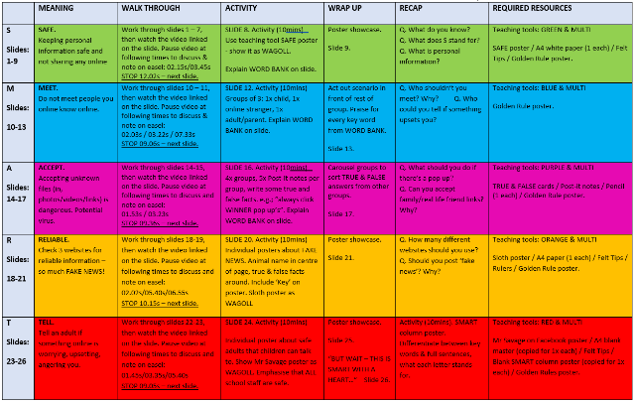  Taught in Summer 2  SMART planning in ICT suite | Components:  - Using PAINT, children to navigate the programme using the different tools available:  - brushes (including brush, calligraphy, spray paint, oil brush, marker, crayon, pencil and watercolour)  - widths (using the SIZE option (five horizontal lines of varying widths)  - colour change (using the palette options on the top right of the screen)  - shape (next to brush selection)  - erase  - Children to familiarise themselves with touch pad control – where they click and drag, the cursor will go.  - Using the mouse pad on a laptop to move, left click and paint using Microsoft Paint to create a self portrait of themselves, using correct skin shades, eye and hair colour and facial features.  - Using the mouse pad on a laptop to move, left click and paint using Microsoft Paint to create a picture of the human and physical features of a seaside setting.  Taught in Autumn 1 | Components:  - Week 1: Beebot App Using the Beebot iPad App children are to familiarise themselves with directional language (forward, backwards, left and right). The Beebot will only follow the instructions given to it – this is called an algorithm, giving a device a set of instructions to follow. The Beebot App progresses through levels, increasing in difficulty. Advise children who find it difficult to think one step at a time and logically direct the Beebot.  - Week 2: Beebot Children are now familiar with the algorithm to successfully complete a Beebot challenge, now the physical use of Beebot (ICT cupboard) can be used in the same way. Using the challenge cards (ICT cupboard), create a track for Beebots to follow once instructed by the children. Progress to using the Beebot floor mat (ICT cupboard) for independent algorithm following by placing the Beebot on the mat and asking children to go from Point A to Point B.  - Week 3-5: Beebot As above, increasing in difficulty with the use of obstacles to manoeuvre around. Children to work in teams to create and complete challenges, whilst writing algorithms on paper as evidence of direction understanding.  Taught in Spring 2
Year 1  children will know how to… |  | Components:  - Children to select the correct keys for typing and to be made aware of keyboards showing all CAPS but when the key is pressed it will type the corresponding lowercase letter.  - Children to be shown how to use the SPACE bar for finger spaces and location of the full stop.  - Children to type numbers 0-20 and to type simple sentences such as ‘I like cats and dogs’ to practice typing skills.  - Children to type an instructional letter to Father Christmas, including time adverbials, on what to do upon landing on child’s roof to deliver presents. Include chimney access, creeping along the room, where to leave presents, ‘Santa’s Treat’ and exiting building. Sign off letter with full name (including CAPS) and age.  Taught in Autumn 2
 |  | Components:  - Children to search for images using Kidrex related to current topic. Search Kidrex for images relating to The Wright Brothers and copy/paste (using the right click option) onto a Microsoft Word document.  - Children to search for images using Kidrex related to current topic. Search Kidrex for images relating to Amelia Earhart and copy/paste (using the right click option) onto a Microsoft Word document.  - Children to copy/paste (using the right click option) an image of The Wright Brothers and Amelia Earhart on to Microsoft Word document and to type related facts using research via the Kidrex search engine.  - Fact sheet to include CAPS, punctuation and spacing. E.g: ‘The Wright Brothers flew the world’s first aeroplane.’ Accompanied with an image of The Wright Brothers.  Taught in Spring 1 | Components:  - Sphero Week 1: Using the Sphero devices (ICT cupboard), and an iPad – children are to learn how to control a Sphero remotely. To do this, they must create algorithms for the ball to follow.  - To wake a Sphero tap or gently shake the ball once the iPad App has started. This will link the 2 devices. Once the devices are linked, press PLAY on the iPad to gain access to the Sphero dashboard.  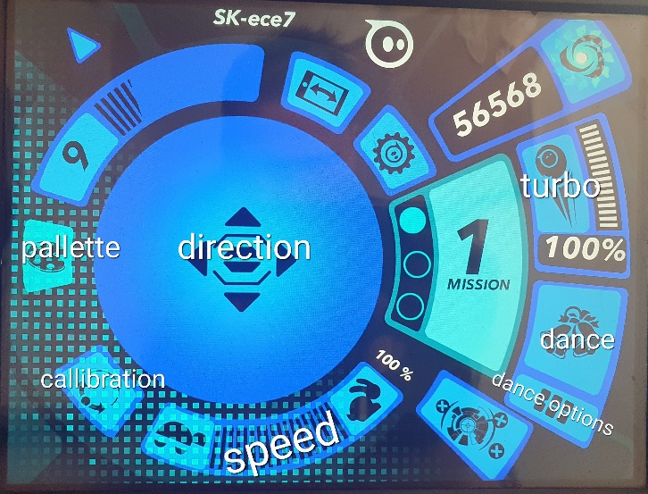  Sphero dashboard  - The first step for any Sphero session is to calibrate the device. On the bottom left of the dashboard is the CALIBRATION option. Pressing this option will initiate a light on the Sphero ball – this is its “eye” – Sphero must always be looking at where its instructions are coming from – the iPad. To calibrate, hold your finger on the screen and rotate the ball until Sphero is looking at you. (This step may have to be repeated during the session if Sphero is not following correct instructions – this is due to the electrical interference and other devices in school). Children can then move Sphero LEFT, RIGHT, FORWARDS and BACKWARDS by dragging their finger on the DIRECTION part of the dashboard. This session should be used allowing the children to familiarise themselves with that control.  - Week 2: Start with calibration. Further investigate the different options on the dashboard – PALLETTE which changes Sphero’s colour, SPEED where Sphero follows the command of fast or slow, DANCE which when pressed makes Sphero do a pre-programmed dance and DANCE OPTION where the user can select different dances for Sphero to do.  - Week3: Start with calibration. Create an obstacle course for children to guide Sphero through. Children are to stay stood/sat in one place and control Sphero via the iPad App. Have the obstacle course marked on the floor with masking tape which changes directions, has colour matching cards (where children have to stop Sphero and use the PALLETTE function to match the colour of the card before continuing), dance cards (where children use the DANCE function to use the card as Sphero’s dance floor) and a finish line.  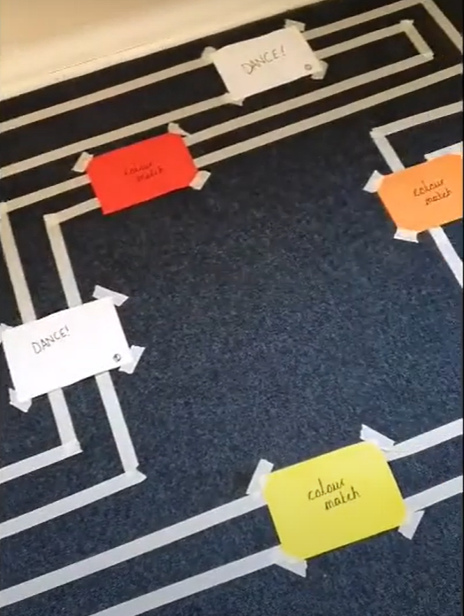  An example of the obstacle  Taught in Summer 1  course
Year 2  children will know how to… | Composite:  - Follow and share the school’s e-Safety code (SMART ) and give reasons why we follow this code to others. File path: SERVER-e-safety-SMART lessons Resources (inc. planning): Interactive display in ICT suite with colour coordinated stickers.**USE LAMINATED PLANNING ON INTERACTIVE DISPLAY IN ICT SUITE FOR ALL SESSIONS** | Composite:  - Develop hand/eye co-ordination with mouse  - Develop keyboard and computer skills. | Composite:  - Understand what algorithms are and how they are implemented using computational thinking  - Create and debug simple programs.  - Use technology purposefully to create, organise, store, manipulate and retrieve digital content.
Year 2  children will know how to… | Components:  - Week 1: (S rule)… S=Safe Using the package, work through the slides for the ‘S rule’. Relate to experiences to make information more relatable and real life, for example; “Little Sally is on Roblox and a message comes through asking her for her personal information – she gives it because this person plays Roblox with her every day. The person isn’t who they say they are – clones the details, puts Sally in danger” etc. Pause video for talks: 02.15s /03.45s Stop video to return to slides: 12.02s Slide 8: Activity – using teaching tool SAFE poster as WAGOLL and create own posters – explain word bank on slide.  - Week 2: (M rule)… M=Meet Using the package, work though the slides for the ‘M rule’. Relate to experiences to make information more relatable and real life, for example; “Sally is back on Roblox and a message comes through from another contact. Sally ignores it and the messages start turning nasty. Sally is being cyberbullied. Pause video for talks: 02.03s/03.22s/07.33s Stop video to return to slides: 09.06s Slide 12: Activity – groups of 3 (1x child actor, 1x stranger actor & 1x safe adult actor) and act out similar scenarios – explain word bank on slide.  - Week 3: (A rule)… A=Accept Using the package, work through the slides for the ‘A rule’. Relate to experiences to make information more relatable and real life, for example; “Sally is now on a new game online and every now and then a pop-up fills her screen, it says she has won 100 new teddies! She is so excited and runs to tell her mum who is too late to stop the hackers from stealing all of the personal information on the device – the pop-up was a trick to steal from Sally!” Pause video for talks: 01.53s/03.23s Stop video to return to slides: 09.36s Slide 16: Activity – 4x groups, 5x post-it notes per group, write TRUE & FALSE facts (eg; ‘always click WINNER pop-ups!) – explain word bank on slide.  - Week 4: (R rule)… R=Reliable Using the package, work through the slides for the ‘R rule’. Relate to experiences to make information more relatable and real life, for example; “Sally is doing her homework and is using Google to research about sloths. She finds some funny facts and adds them to her work. Did you know sloths are really fast when nobody is watching?! Sally hands her homework in and is in trouble for putting FAKE FACTS on her work – she never checked her facts against 3 different websites.” Pause video for talks: 02.02s/05.40s/06.55s Stop video to return to slides: 10.15s Slide 20: Activity – individual posters about fake news. Animal name in centre of paper with TRUE and FALSE facts around it. Include ‘key’ on poster and use interactive display sloth poster as WAGOLL.  - Week 5: (T rule)… T=Tell Using the package, work through the slides for the ‘T rule’. Relate to experiences to make information more relatable and real life, for example; “Sally has been playing with her friends at school and one of them mentioned a game they like to play. It sounds cute and harmless so Sally googles it when she gets home and is shocked when the game is actually scary and Sally is very afraid.” Pause video for talks: 01.45s/03.35s/05.40s Stop video to return to slides: 09.05s Slide 24: Activity – Individual poster about safe adults that children can talk to. Use ‘Mr Savage’ poster from interactive display as WAGOLL. Complete ALL slides on package to conclude the e-Safety package. Emphasise that ALL school staff are safe people.  SMART planning in ICT suite  Taught in Summer 2 | Components:  - Using Microsoft Word and Kidrex, children to research their current topic (e.g. explorers, famous people, locations etc) and create a fact file.  Week 1:  - Logging on, typing name (including CAP letter and SPACE), changing the font size and colour.  Week 2:  - Independent logging on, opening WORD, typing name multiple times (including CAP letter and SPACE) and changing font.  Week 3:  - Independent logging on, opening WORD, typing name, changing colour/size/font, underline and create a list of ‘My 10 favourite things’.  Week 4:  - Independent logging on, opening WORD, typing name (including CAP letter and SPACE), change colour/size/font, changing to BOLD, CAPS, full stops, finger spaces, type a piece ‘All About Me’.  Week 5:  - Independent logging on, opening WORD, typing name (including CAP letter and SPACE), typing full date (including CAP for month), typing facts about Daisy Makeig-Jones, typing fluency, SAVE document.  Taught in Autumn 1 | Components:  - Scratch.  Login: BCIscratchers (p/w: Welcome123!)  - Week 1: Use WAGOLL of the underwater scene, explain to children they will make one similar and use correct vocabulary of: Sprite (the actor), Backdrop (the stage), Algorithm (the script/instructions for the actor), Coding Blocks (puzzle pieces that click to form an algorithm) and Debug (correcting errors in an algorithm). Provide each child with unique login and password (connected to Class) and show them how to login. Go to CREATE, hover over BACKDROPS and go to PAINT. Convert to BITMAP. Using paint tools, create an underwater scene with NO SPRITES. At the end of the session FILE>SAVE AS>child’s name.  - Week 2: Create 2 Sprites (actors) by loading up last week’s project (‘My Stuff’ file on the top right hand of the Scratch screen once logged in). ‘SEE INSIDE’ project to edit. Hover over Sprite icon (cats head) on the bottom right of the screen and select the PAINT option. Convert to BITMAP. Using paint tools, create an underwater character in detail – show how to change shades in palette for texture by sliding the slider of the colour from lighter to darker - again using Mr Savage’s as WAGOLL. At the end of the session FILE>SAVE. (This will save any edits done in this session onto the original project)  - Week 3: Login and use Mr Savage’s WAGOLL to show the end result of the project – the movement, the sound, the speech and the control. Press ‘SEE INSIDE’ to see the coding blocks and algorithms. Explain that the tray on the left-hand side is full of instructions for the Sprite and it is our job to make those instructions make sense. Investigate the tray and the coloured pieces of coding. Explain that a Sprite will not do anything unless it is told to and it will only do what it is told to – like an actor on a stage, it needs a script to follow. Children to copy WAGOLL but be told what each coding block is doing and why we are using it – when one algorithm is complete read it: “So now we are telling our Sprite that when I press go…” and run your finger on every coding block and explain its function. Their turn to press go and see theirs in action. Complete all steps for both Sprites by clicking on Sprite 2 and seeing its code. Copy. Play. At the end of the session FILE>SAVE. (This will save any edits done in this session onto the original project)  - Week 4: Using the ‘Scratch Cards’ allow for a free session of coding exploration. No login required, go to CREATE and follow the instructions on the cards, share WAGOLL’s from different children when successful. Cards are step-by-step colour coordinated guides.  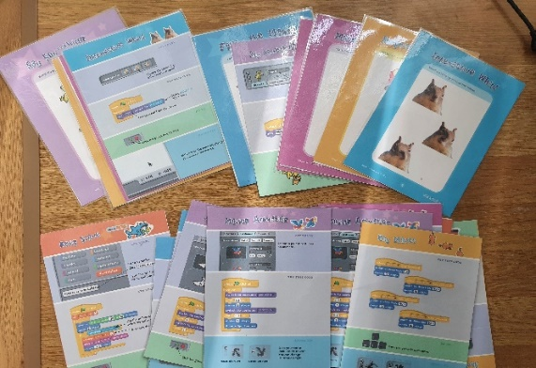  Scratch Cards  - Week 5: Using www.code.org children to access coding adventure games (Minecraft, Angry Birds, Dance Party etc) at their choosing to make coding fun! Have learning breaks every 15 minutes for volunteers to show their creations/projects and talk about the steps they took to get to that result. Encourage logical thinking for the maze games (“2 steps forward” – bump that on the screen to show where character would be, mapping out the action). Children that finish the mazes will receive a code.org certificate to print out – encourage this.  Taught in Spring 2
 |  | Components:  Week 1:  - Independent logging on, opening saved document, continuing with Daisy Makeig-Jones work with change of colour text. SAVE every sentence  Week 2:  - Add photographs to Daisy Makeig-Jones work, using Kidrex to research facts, copy/paste into document, SAVE, PRINT  Week 3:  - Type a list of questions to use Kidrex to answer, use of ‘?’, e.g. “how many tigers are there in the world?” and “who invented the light bulb?”, SAVE.  Week 4:  - Opening Google > Kidrex, type in questions to search bar, locating answers (search results), changing between open windows (WORD and Google)  Week 5:  - Continuation of week 4  Week 6:  - Using the internet to access different websites such as Kidrex/YouTube/Top Marks / Scratch  Week 7:  - Fun games session, different websites full of games.  Taught in Autumn 2 | SPHERO
Components:
Week 1-2:
- Using Google/Kidrex children to fact hunt about Sacageweya, including facts such as: Her nationality: Lemhi Shoshone (Native American), her accomplishments: travelled North America and explored with Lewis & Clark (chartering), interpreter. Her hardships: kidnapped as a child, forced labour. Her children: Jean Baptiste Charbonneau, Lizette Charbonneau. Her birth & death dates: May 1788 – December 1812 and Any more interesting facts.

Week 3-4:
- Using Google/Kidrex children to fact hunt about Robert Falcon Scott, including facts such as:
His nationality: English His accomplishments: two expeditions to Antarctic Regions.

His hardships: low supplies, depleted crew, died in a blizzard on 2nd expedition

His children: Peter Markham Scott

His birth & death dates: June 1868 – March 1912

Any more interesting facts

Week 5:
- Type a similarities and differences article using Microsoft WORD highlighting those of Sacagaweya and Robert Falcon Scott. Include photos from Google using previously taught method (copy/paste)
Taught in Spring 1

Key:
Autumn 1, Autumn 2, Spring 1, Spring 2, Summer 1, Summer 2

Whole School Retrieval Question Map
 | Autumn 1 | Autumn 2 | Spring 1 | Spring 2 | Summer 1 | Summer 2
Smarties + F1 |  |  |  | What can you do if you see something on a screen that makes you feel unhappy or scared? | What things can you do on a tablet or computer? | What is a keyboard used for?  What can you do on a mobile phone?  Why do people have cameras?
F2 | Last taught in Spring 2 in F1:  How do we use the internet to find information or pictures about things we want to learn? | Last taught in Autumn 1 in F1:  Why do we use a password to keep our things safe on a computer or tablet? | Last taught in Summer 1 in F1:  How do you use your finger to touch and move things on the screen? | Last taught in Summer 2 in F1:  How do you make the BeeBot turn or go faster and slower? | Last taught in Spring 2 in F1:  Can you remember how to make the BeeBot move forwards and backwards?
YR1 | Last taught in Spring 1 in F2:  What does clicking the right hand side of the mouse do?  What does clicking the left hand side of the mouse do?  How do you change the position of the cursor? | Last taught in Autumn 1 in F2:  How do you use the keyboard to create a capital letter?  How do you use the keyboard to type a word? | Last taught in Autumn 2 in F2:  How do you use the internet to search for pictures?  How do you copy/paste an image? | Last taught in Summer 1 in F2:  How can you make the BeeBot go forwards/backwards? | Last taught in Spring 2 in F2:  How do you move/control the Sphero to get it to move where you want it to go? | Last taught in Autumn 2 in F2:  How can you keep safe on the internet?  Should you ever meet anyone off the internet?  How can you find out if a fact is true or false?
YR2 | Last taught in Spring 1 in Y1:  How do you open Microsoft word?  How do you change the colour of your font?  How do you log on to the computer? | Last taught in Autumn 1 in Y1:  How do you open Kidrex?  How do you use the search bar? | Last taught in Autumn 2 in Y1:  How do you copy and paste words or pictures on the computer to use them in your work? | Last taught in Summer 1 in Y1:  What can you do if your code doesn’t work? |  | Last taught in Summer 2 in Y1:  How can you keep safe when using the internet?

