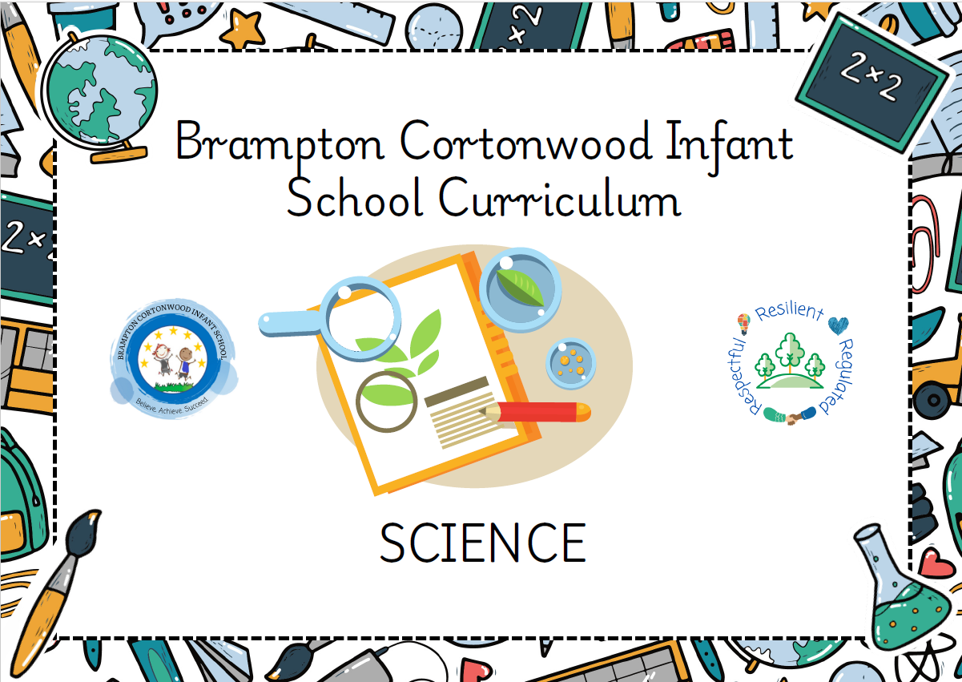

Progression of knowledge and skills within Science Updated Jan 2025
Each skill is developed within the specific scientific domain based on the science knowledge taught at each year group.
A high-quality science education provides the foundations for understanding the world through the specific disciplines of biology, chemistry and physics. Science has changed our lives and is vital to the world’s future prosperity, and all pupils should be taught essential aspects of the knowledge, methods, processes and uses of science. Through building up a body of key foundational knowledge and concepts, pupils should be encouraged to recognise the power of rational explanation and develop a sense of excitement and curiosity about natural phenomena. They should be encouraged to understand how science can be used to explain what is occurring, predict how things will behave, and analyse causes.
Intent
Our intent is that Science teaching will help our young children to understand, explain, observe and question the world around them. We teach carefully sequenced, progressive lessons which focus on accurate vocabulary choices and scientific investigation. It is essential that our children have a wide, rich vocabulary in order to explain what they see in the world around them. We aim to provide a hands-on science curriculum which allows children to question and explore through practical experiences. We give all children a strong understanding of the world around them whilst acquiring specific skills and knowledge to help them to think scientifically, to gain an understanding of scientific processes and also an understanding of the uses and implications of Science, today and for the future.

Science taught through a topic approach
The breadth of our topic based learning curriculum is planned to give pupils appropriate experiences both in and out of the school environment to develop as confident and responsible citizens through the world they live in. It is designed to provide rich cultural capital and provide them with the knowledge and skills to succeed in the future working world. It is delivered in a coherent, structured, practical curriculum that leads to a sustained mastery for all and a greater depth of understanding for those who are capable.

Our topic based curriculum design is based on evidence from cognitive science; three main principles underpin it:
- Learning is most effective by repetition.
- Interweaving helps pupils to discriminate between topics and aids long-term retention.
- Retrieval of previously learned content is frequent and regular, which increases both storage and retrieval strength.
In addition to the three principles, we also understand that learning can be invisible in the short-term and that sustained mastery takes time. Some of our content is subject specific, whilst other content is combined in a cross-curricular approach. Continuous provision, in the form of daily routines, replaces the teaching of some aspects of the curriculum (where appropriate) and in other cases, provides retrieval and practice for previously learned content.

The impact of our curriculum is such that by the end of year 2, the vast majority of our pupils have sustained mastery of the content. That is, they remember it all through their learning experiences and are fluent in applying both learnt knowledge and skills to a wide variety of tasks and situations.

Science Domains
 | Working Scientifically | Plants | Animals including humans  Living things and their habitats | Materials  Uses of materials | Seasonal changes
Smarties and F1  Children will know how to… | Composite:  EYFS Three to Four  - Talk about what they see, using a wide vocabulary. | Composite:  EYFS Three to Four  - Plant seeds and care for growing plants.  - Understand the key features of the life cycle of a plant and an animal.  - Begin to understand the need to respect and care for the natural environment and all living things | Composite:  EYFS Three to Four  - Use all their senses in hands-on exploration of natural materials.  - Understand the key features of the life cycle of a  plant and an animal.  - Begin to understand the need to respect and care  for the natural environment and all living things. | Composite:  EYFS Birth-Three  - Explore materials with different properties.  - Explore natural materials, indoors and outside.  EYFS Three to Four  - Explore collections of materials with similar and/or different properties.  - Explore and talk about different forces they can feel.  - Talk about the differences between materials and changes they notice. | Composite:  EYFS Birth-Three  - Explore and respond to different natural phenomena in their setting and on trips.  EYFS Reception  - Explore the natural world around them.
Smarties and F1  Children will know how to… | Components:  - Identify their head, nose, mouth, eyes, ears, arms and legs (Smarties).  Taught in Autumn 1 | Components:  - Plant and grow cress. Observe the changes cress goes through as it grows (seed, shoot and then plant with leaves).  - Discuss the story ‘tiny seed’ by Eric Carle and identify that a seed needs sun, soil and water to grow. However, cress does not need soil to grow, it just needs water.  - Identify that a vegetable is a plant that we eat and give examples such as carrots, potatoes, peas, cabbages, rhubarb, beetroot, spinach.  - Taste the vegetables and describe their taste. Share their preference of which ones they do and do not like.  - Describe that a fruit is a plant with seeds that we eat and give examples such as apple, banana, oranges and pear.  Taught in Summer 1 | Components:  - Observe and monitor the changes that a caterpillar goes through to become a butterfly (eggs, caterpillar, cocoon/pupa to butterfly).  Taught in Summer 1  - Explore natural items freely in provision though atelier treasure baskets and loose part construction (pine cones, conkers, wood etc.) Ongoing throughout the year  - Explore natural materials outside by sending home a ‘we’re going on a leaf hunt bag’ for children to fill with Autumn objects, to be shared and discussed in school.  Taught in Autumn 1 | Components:  - Explore materials with different properties freely in provision through water, dough and clay. Ongoing throughout the year.  - Explore magnets in a tough tray with a variety of materials (metal, wood and plastic) and discuss what they notice.  Taught in Spring 2  - Observe and explore how water changes into ice as it freezes and that as it warms up it melts and changes back into water.  Taught in Spring 1 | Components:  - Explore their natural surroundings, such as water collecting inside tyres and looking under logs for worms. Ongoing throughout the year (Smarties).  - Observe and monitor the changing leaves across the four seasons and describe that:  - In Autumn the leaves change colour and fall off the trees. Explore and describe the changes in colour that they can see.  - In Winter the branches are bare, Discuss which animals go to sleep for their Winter hibernation.  - In Spring there is blossom om the trees and there is new life e.g lambs/chicks being born and in Summer there are green leaves on the trees.  Taught within appropriate season
Smarties and F1  Children will know how to… | - Identify their hands, fingers, shoulders, knees, feet, toes and hips and describe them as body parts that they can see.  - Discuss that we have body parts that we cannot see and name the heart, lungs, brain and stomach.  Taught in Autumn 1
F2  Children will know how to… | Composite:  EYFS Reception  - Describe what they see, hear and feel whilst outside. | Composite:  EYFS Reception  - Explore the natural world around them.  EYFS ELG  - Explore the natural world around them, making observations and drawing  pictures of animals and plants.  - Know some similarities and differences between the natural world around  them and contrasting environments, drawing on their experiences and what has been read in class. | Composite:  EYFS Reception  - Explore the natural world around them.  - Recognise some environments (habitats) that are different from the one in which they live.  EYFS ELG  - Explore the natural world around them, making observations and drawing pictures of animals and plants.  - Know some similarities and differences between the natural world around them and contrasting environments, drawing on their experiences and what has been read in class. | Composite:  EYFS ELG  - Understand some important processes and changes including changing states of matter. | Composite:  EYFS Reception  - Explore the natural world around them.  - Understand the effect of changing seasons on the natural world around them.  EYFS ELG  - Understand some important processes and changes in the natural world around them, including the seasons and changing states of matter.
F2  Children will know how to… | Components:  - Monitor the changes and describe the things that they have observed across the four seasons:  - Identify that in Autumn, the leaves change from green to red, orange, yellow and brown and they fall from the trees. The weather gets windier and cooler.  - Identify that in Winter, it is much colder. Observe the frost on the ground on a morning, and all of the places in the outdoor provision that the water has changed into natural ice.  - Identify that in Spring, the weather is much more mild, sunny but rainy. Observe that there are buds and flowers growing.  - Identify that in Summer, the trees have healthy green leaves and it is hot and dry.  - Listen carefully on a sound walk of the environment. Discuss the noises they can hear such as birds, traffic, children playing, wind, rain, helicopter and aeroplanes.  Taught within appropriate season | Components:  - Explore the natural provision in forest school freely and develop their play through manipulation and exploration of natural materials in forest school sessions and outdoor continuous provision. Ongoing throughout the year.  - Draw an observational sketch of the tree in front of the school during each season. Children to discuss the changes they have observed, such as bare branches in Winter, blossom in the spring, green leaves in the Summer and red, yellow, orange and brown leaves falling from the tree in the Autumn. Ongoing throughout the year.  Taught within appropriate season  - Discuss that the country we live in is the United Kingdom (UK). Identify animals commonly found in the UK (badger, squirrel, owl, hedgehog and fox).  - Discuss that animals such as mice and bats hibernate for the winter.  - Discuss that some birds migrate, which means travelling south to warmer weather for the winter period.  - Identify animals commonly found in the Arctic (penguin, arctic fox, arctic hare and polar bear).  - Compare the UK to the Arctic as a contrasting environment. Discuss that the terrain is snowy and icy all year round and that it is much colder and darker than in the UK.  Taught in Spring 1 | Components:  - Describe a habitat as a home/environment for something that is living. Discuss and sort the different types of animals that live in different habitats such as Barn Owl, Fox, Badger, Squirrel and hedgehog that are typical of the UK and an artic hare, arctic fox, arctic wolf and polar bear that are typical in the Arctic.  - Describe the difference between the climates in the UK and Arctic as the UK as moderate/temperate climate with four distinct seasons, whereas the climate in the Arctic is stormy, wet and cold with heavy snowfall.  Taught in Spring 2  - Draw a picture of the sunflower that they have planted at different stages commenting on the changes and drawing the differences that they notice.  Taught in Summer 2 | Components:  - Experiment by putting water into the freezer to create ice and then use their senses of sight and touch to describe that the ice is cold and wet. Observe the ice changing state back to water again and discuss that the reason for this is because the ice is warming up, which makes the ice melt.  - Experiment with different ways of speeding up the melting process, such as rubbing the ice, putting it in the sunshine and breaking it into smaller pieces.  Taught in Spring 1 | Components:  - Describe that we have four seasons that happen in a cycle. Describe that Autumn is windy and the leaves change colour before falling off the trees, Winter is cold, icy and snowy and the branches on the trees are bare, Spring is warmer with rain and the trees have blossom on them and Summer is hot, dry and the trees have healthy green leaves.  Taught within appropriate season
Year 1  Children will know how to… | Composite:  - During years 1 and 2, pupils should be taught to use the following practical scientific methods, processes and skills through the teaching of the programme of study content:  - Asking simple questions and recognising that they can be answered in different ways  - Observing closely, using simple equipment  - Performing simple tests  - Identifying and classifying  - Using their observations and ideas to suggest answers to questions  - Gathering and recording data to help in answering questions. | Composite:  - Identify and name a variety of common wild and garden plants, including deciduous and evergreen trees.  - Identify and describe the basic structure of a variety of common flowering plants, including trees. | Composite:  - Identify and name a variety of common animals including fish, amphibians, reptiles, birds and mammals.  - Identify and name a variety of common animals that are carnivores, herbivores and omnivores.  Describe and compare the structure of a variety of common animals (fish,  amphibians, reptiles, birds and mammals, including pets).  - Identify, name, draw and label the basic parts of the human body and say which part of the body is associated with each sense. | Composite:  - Distinguish between an object and the material from which it is made.  - Identify and name a variety of everyday materials, including wood, plastic, glass,  metal, water, and rock.  - Describe the simple physical properties of a variety of everyday materials.  - Compare and group together a variety of everyday materials on the basis of their simple physical properties. | Composite:  - Observe changes across the four seasons.  - Observe and describe weather associated with the seasons and how day length  varies.
Year 1  Children will know how to… | Components:  - Observe the weather over the period of a week and create a weather station to collect data.  - Create a rain gauge to observe the rainfall using a plastic bottle, scissors, duct tape, marker pen and small stones. Predict how much rainfall they think there has been and then measure the rainfall by pouring into a jug and reading the scale. Compare their prediction to the amount recorded.  Taught in Autumn 2  - Observe and sequence the lifecycle of a frog. Predict what changes tadpoles will go through. Use the observations to create a frog lifecycle diary (frogspawn, tadpole, froglet, frog).  - Identify the different wild plants that can be found on a walk of the school grounds. Create a tally of the species found to identify which variety of wild plant is the most common.  Taught in Autumn 1 | Components:  - Identify that garden plants are plants that people choose to grow in their gardens.  - Identify common garden plants, including:  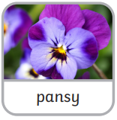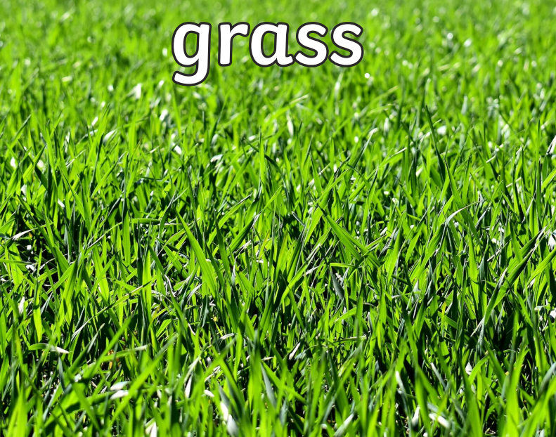  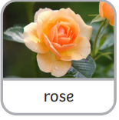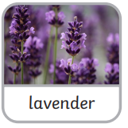  - Identify that a wild plant has a seed that grows where it lands. It does not need to be planted or cared for as it grows.  - Identify common wild plants, including:  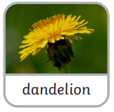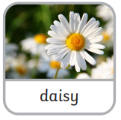  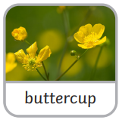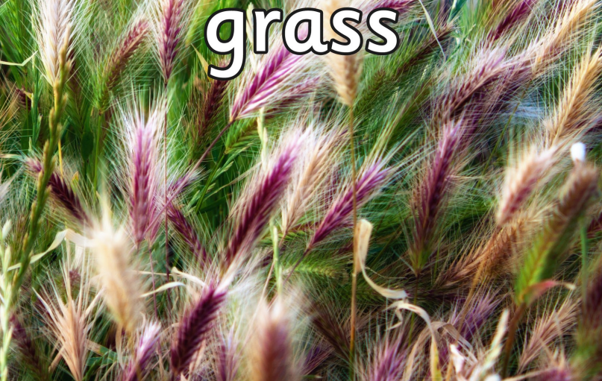  - Name and label the basic structure of a flowering plant with flower, stem, leaves and roots.  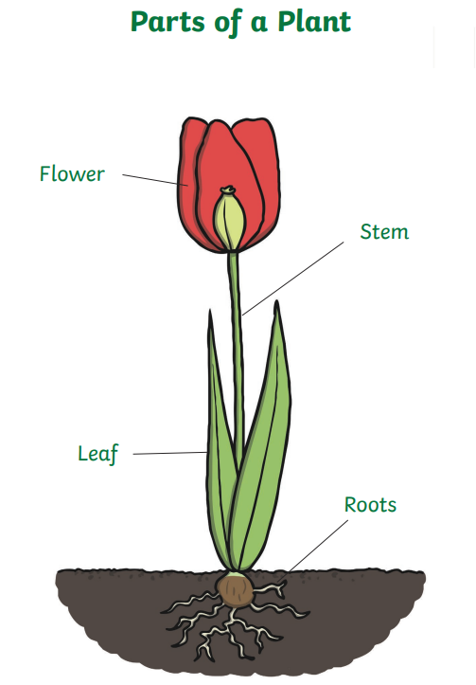  - Classify trees as either evergreen or deciduous by identifying if their leaves stay green all year round, or change colour and fall off in the Autumn.  - Sort a mixture of evergreen trees (Pine Trees, Spruce Tree, Fir Tree and Cedar Tree) and deciduous trees (Sycamore Tree, Hazel Tree, Beech Tree and Oak Tree).  - Identify trees and their leaves, including: Beech, Sycamore, Spruce, Oak, Hazel, Pine, Cedar and Fir.  - Label the basic structure of a tree with crown, bark, leaves, branches, roots and trunk  - Plant a bean and observe the changes that happen to it as it grows (seed, seedling and finally plant).  Taught in Summer 1 | Components:  - Identify that mammals are warm blooded, breathe oxygen, grow hair or fur, have a skeleton, give birth to live babies and drink milk their mother’s milk as a baby.  - Identify the following land mammals: cat, rat, bat and giraffe.  - Identify that some mammals live in the seas and oceans and give examples such as whales and dolphins.  - Identify that amphibians are cold blooded, live on both land and in water, lay eggs, have moist skin and webbed feet and have a skeleton.  - Identify the following amphibians: frog, salamander, blind worm, newt and toad.  - Identify that reptiles are cold blooded, live on land and in water, have a skeleton, have scaly skin and lay eggs.  - Identify the following reptiles: Crocoldile, alligator, snake, lizard and a turle gecko.  - Identify that fish live and breathe underwater though their gills. They have scaly skin. They have a skeleton, are cold blooded and lay eggs.  - Identify the following fish: clownfish, carp, pike, catfish and trout.  - Identify that birds have a beak, two legs, feathers and wings. They have a skeleton, are warm blooded, lay eggs and live on both land and water.  - Identify the following birds: Robin, goldfinch, magpie, starling and chaffinch woodpecker.  - Identify, classify and sort: human, mouse, dog, cow, frog, toad, newt, salamander, snake, tortoise, lizard, alligator, goldfish, tuna, shark, eel, penguin, chicken, flamingo and robin into the correct category of mammal, amphibian, reptile, fish or bird and give a reason as to why they have classified it in that way. E.g. “A robin is a bird because it has a beak and wings.”  - Identify that a carnivore is an animal that eats mostly meat from other animals, such as a lion; a herbivore is an animal that only eats plants, such as a cow; an omnivore is an animal that eats both plants and meat, such as a chicken.  - Sort, group and classify animals (lion, shark, alligator, cow, rabbit, sheep, chicken, humans, ladybird, caterpillars and robins) into carnivores, herbivores or omnivores by identifying what they eat.  - Identify features of a land mammal, sea mammal, bird, fish, amphibian and reptiles by:  - Label a lion with paws, ears, tail, fur and legs.  - Label a whale with etes, blowhole, flipper and stomach.  - Label a seagull with eyes, tail, beak, wings and feathers.  - Label a goldfish with fins, scales, tail, eyes and gills.  - Label a frog with eyes, wet skin, webbed feet and legs.  - Label a reptile with scales, ears, tail, claws and feet.  - Identify that a human is a mammal and label the following parts of the body: head, hair, ears, mouth, teeth, eyes, nose, shoulder, hand, fingers, elbow, thumb, leg, knee, foot and toes  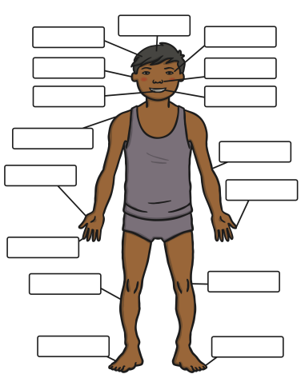  - Discuss that our five senses are hearing, sight, smell, touch and taste and identify the body part associated with it (hearing – ears, sight- eyes, smell – nose, touch – hands, taste – mouth).  - Name the things that a human needs to survive (Oxygen, water, sleep, shelter and a healthy diet) and explain why humans cannot survive without their basic needs.  Taught in Spring 2 | Components:  - Identify a variety of objects and say the material which it is made from; such as the table is made from wood, clothes are made from fabric, the bottle is made from plastic, the drinking glass is made from glass and the cutlery is made from metal).  - Discuss the different properties of everyday materials (wood, metal, plastic, glass, sponge, water and rock) using vocabulary such as: hard – not easily broken or pierced, squashy- easily crushed or squeezed, smooth – an even regular surface, absorbent – able to soak up liquid, bumpy/rough – uneven, raised patches, irregular surface, opaque – cannot be seen through, dull – lacking shine or brightness, brittle – hard but may break easily, translucent – allowing some light to pass through, rigid – unable to be bent or forced out of shape, transparent – Can be seen through, soft – not firm to touch, flexible – able to bend, waterproof – repels water and liquids, elastic – springs back once stretched, shiny – reflects light, smooth surface, conductor – lets heat, electricity or sound pass through it.  - Explore how materials can be changed by changing state. For example, Water can be frozen into ice, which then melts back into water.  - Describe how the properties change as the state does. For example. Water is fluid and moves/flows easily and is transparent. whereas ice is hard, brittle and translucent.  Taught in Spring 1 | Components:  - Identify that we have four seasons and they are Autumn, Winter, Spring and Summer. Describe the seasons as a continuous cycle.  - Discuss that in the Autumn the weather is usually rainy, cloudy and windy, in the Winter the weather is usually cold, damp, icy and snowy, in the spring the weather is usually sunny, cool and wet and in the summer the weather is usually hot, dry and sunny.  - Name the twelve months of the year and identify that in September, October and November it is Autumn, in December, January and February it is Winter, in March, April and May it is Spring and in June, July and August it is Summer.  - Categorise and sort clothing that is appropriate to wear for the different seasons. Identify that we need raincoats and umbrellas in spring, sunhats, sun cream, shorts and t-shirts in summer, warm jumpers and wellies in Autumn and warm coats, boots, hats and scarves in Winter.  - Explain and expand their reasoning as to why their clothing choices are appropriate for each season, e.g. “I will wear a hat, coat and boots in winter because it is cold.”  - Observe the changes that a tree goes through in a year across the different seasons. Describe that in the Autumn the leaves change colour and fall off, in winter the branches are bare, in spring there are buds and blossom on the tree and in summer there are healthy green leaves on the tree.  Taught within appropriate season
Year 2  Children will know how to… | Composite:  - During years 1 and 2, pupils should be taught to use the following practical scientific methods, processes and skills through the teaching of the programme of study content:  - Asking simple questions and recognising that they can be answered in different ways  - Observing closely, using simple equipment  - Performing simple tests  - Identifying and classifying  - Using their observations and ideas to suggest answers to questions  - Gathering and recording data to help in answering questions. | Composite:  - Observe and describe how seeds and bulbs grow into mature plants.  - Find out and describe how plants need water, light and a suitable temperature to grow and stay healthy. | Composite:  - Explore and compare the differences between things that are living, dead, and things that have never been alive.  - Identify that most living things live in habitats to which they are suited and describe how different habitats provide for the basic needs of different kinds of animals and plants, and how they depend on each other.  - Identify and name a variety of plants and animals in their habitats, including micro-habitats.  - Describe how animals obtain their food from plants and other animals, using the idea of a simple food chain, and identify and name different sources of food.  - Notice that animals, including humans, have offspring which grow into adults.  - Find out about and describe the basic needs of animals, including humans, for survival (water, food and air).  - Describe the importance for humans of exercise, eating the right amounts of different types of food, and hygiene. | Composite:  - Identify and compare the suitability of a variety of everyday materials, including wood, metal, plastic, glass, brick, rock, paper and cardboard for particular uses.  - Find out how the shapes of solid objects made from some materials can be changed by squashing, bending, twisting and stretching.
Year 2  Children will know how to… | Components:  - Perform a simple test by setting up a fair experiment to observe a plant growing in different conditions (without light, water or soil) and make predictions and comparisons of how the plants grow. Make a list of the things a plant needs to grow and be healthy.  Taught in Summer 1 | Components:  - Identify and sort different types of plants:  - Flowering plants – Rose, Lily, Tulip, Sunflower and Daisy.  - Herb plants – Basil, Coriander/Cilantros, Oregano and Parsley.  - Fruit plants – Pear, Raspberry, Blackberry and Mango.  - Vegetable Plants – Carrot, Potato, Broccoli and Sprouts.  - Describe that some plants come from a bulb and some plants come from a seed.  - Identify that herbs, lemons, peas, sunflowers and pumpkins come from seeds.  - Identify that onions, beetroots, daffodils and tulips come from a bulb.  - Describe that a plant needs sunlight, water, soil and the right temperature to grow.  - Predict how a plant would grow in specific conditions:  1. water and sunlight  2. no sunlight but with water  3. no water but with sunlight  4. no sunlight and no water  Taught in Summer 1 | Components:  - Identify things that things that are alive are living, move, have babies and gives waste. Give examples of things that are alive, such as spider, frog, worms, chimpanzees, dog, fish, bird, grass and snail.  - Identify things that things that have never been alive do not grow, give waste or have babies and will never be alive. Give examples such as, fire, ice, clock and crayons.  - Identify things that were once alive and are not anymore used to be living and now they are dead. Give examples, such as, paper and meat.  - Describe adult animals have offspring which grow into adults. Identify that an adult dog has a puppy, and adult cat has a kitten, an adult hen has a chicken and an adult elephant has a calf.  - Describe adult humans have offspring which grow into adults.  - Sequence the stages of growth as: baby, toddler, child, teenager then adult.  - Identify specific changes that happen during each stage as:  - Baby – sleeps a lot, cries and drinks milk.  - Toddler – Learns to do new things such as walking and talking.  - Child – Becomes more independent with the things that they can do and develops new skills quickly.  - Describe a habitat as a natural environment for animals that live there.  - Identify that a woodland habitat provides animals with shelter, food and a safe place to raise their young and identify that this habitat is suitable for the animals that live there including: squirrels, hedgehog, foxes and bird.  - Identify that a pond habitat provides animals with food, shelter and a safe place to raise their young and identify animals that live there including: fish, frogs, toads, newts, snails, beetles and leaches.  - Describe that healthy foods are foods that are good for us and keep us healthy. Describe that unhealthy foods are foods that are not as good for you and often contains a lot of fat and sugar that our bodies do not need as much of, therefore you should only eat a little of these as part of a healthy, balanced diet. Define that a balanced diet means the right amount of different types of food.  - Define exercise as physical activity that contributes to being healthy and active.  - Define personal hygiene as keeping our bodies clean. This can include: showering or bathing daily, washing hands regular (in particular before we eat or after we use the toilet) and brushing our teeth.  - Describe that animals get their food from plants and other animals. Animals have different sources of food.  - Create a simple food chain to show ‘Producer, consumer, consumer, predator’. For example, grass, cricket, frog, snake.  - Describe that a microhabitat is a very small piece of a habitat, for example the grass within a woodland, or rocks next to a pond.  - Identify minibeasts in the environment including: woodlice, spiders, worms, wasps, beetles, earwigs, snails and slugs.  - Investigate what animals can be found in different microhabitats such as:  - A fallen log – worms, wasps, beetle and woodlice.  - A leaf pile – worms, woodlice, beetles, earwigs, snails and centipedes.  - Grass – ants, ladybirds, beetles, caterpillars, spiders, moths and worms.  - Rocks – toads, frogs and spiders.  - Compare different habitats and explore the reasons why some animals would not live there, for example a penguin would not live in the desert because they have thick fur and cannot live without food or water for a long time.  - Identify the basic needs for animals and humans to survive as water, food, shelter for protection and oxygen.  Taught in Spring 2 | Components:  - Identify an object and discuss why the material was chosen by thinking about the objects suitability linked to their physical properties, for example an umbrella is waterproof and made of plastic. A washing up sponge is absorbent and it is made of sponge. A table is hard and rigid and is made out of wood. A window is made from glass because it is transparent.  - Explore how the shapes of solid objects made from some materials can be changed, or altered by squashing, bending, twisting and stretching.  - Discuss why some materials are easier to change to the shape than others. E.g. Soft plastic is easier to twist and manipulate than wood because is wood ridged and does not mould.  Taught in Spring 2

Key = Autumn 1, Autumn 2, Spring 1, Spring 2, Summer 1, Summer 2
Key vocabulary is highlighted in yellow

 | Autumn 1 | Autumn 2 | Spring 1 | Spring 2 | Summer 1 | Summer 2
Smarties + F1 | N/A | N/A | Last taught in Autumn 1  Can you name body part, inside and out?  What changes happen in Autumn? | Last taught Spring 1  What changes happen in Winter? | Last taught Spring 2  Discuss the changes across the different seasons. | N/A
F2 | Last taught in Summer  Can you name some fruits and vegetables?  Can you name the parts of the body, inside and out?  How did you grow a Pumpkin? What did the seed need? | N/A | Last taught in Autumn 1  What Changes happen in Autumn? | Last taught in Spring 1  Can you name the four seasons? Can you name changes that happen across them all? | Last taught in Summer 1  Describe the lifecycle of a butterfly. | Last taught in Summer 2  Can you describe how to grow cress? What changes happen?
YR1 | Last taught F2 Summer 1  Can you name the seasons of the year? Can you describe the changes across the different seasons? | N/A | Last taught F2 Spring 1  Can you describe the changes of state and how they occur (water to ice). | Last taught F2 Spring 1  Define: habitat, migration and hibernation. | Last taught F1/F2  Summer 1/Summer 2  What does a seed need to grow and be healthy? | N/A
YR2 | Last taught Year 1, Autumn 1  Can you name the four seasons and the months associated with them? | N/A | Last taught in Year 1, Spring 1  Can you describe the properties of different materials? | Last taught F2, Spring 1  What is a habitat? | Last taught Year 1, Summer 1  Can you name some garden flowers and wild flowers?  Can you say which trees deciduous and evergreen? | N/A

