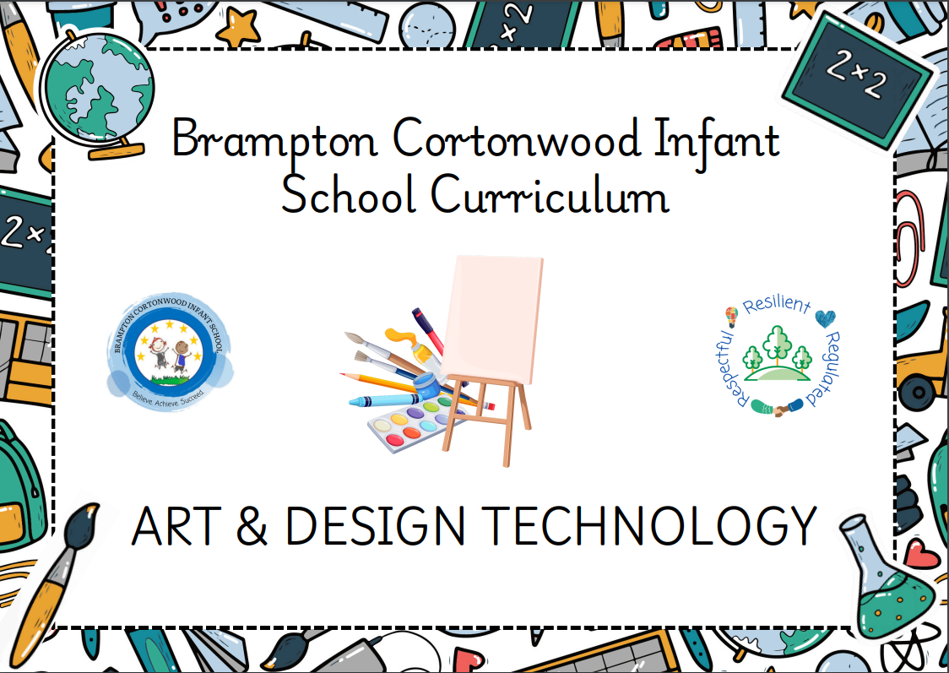

Progression of knowledge and skills within Art and Design
Each skill is developed within the specific art and design domain based on the artistic knowledge taught at each year groups.
Art, craft and design embody some of the highest forms of human creativity. A high-quality art and design education should engage, inspire and challenge pupils, equipping them with the knowledge and skills to experiment, invent and create their own works of art, craft and design. As pupils progress, they should be able to think critically and develop a more rigorous understanding of art and design. They should also know how art and design both reflect and shape our history, and contribute to the culture, creativity and wealth of our nation.
Intent
Our intent is that the teaching of art will be based upon the knowledge and skills children need to become good artists and express themselves using art as a medium. During their time in our school, we will introduce children to a number of ‘the greats’ from the art world so they can explore, create and appraise their art. Learning about the artists and their contributions they will learn about the importance of art in the past and the present. They will explore painting, drawing and sculpture and be taught a series of knowledge and skills which culminates in a finished piece of art for each theme. The curriculum is carefully planned to build progressively from the EYFS through Years 1 and 2. Our intention is that our children will grow to love and appreciate art and become curious young people who want to find out more. We aim to give them the knowledge and skills they need to appraise art and form their own opinions and to be able to use art in their own lives.

Art and Design taught through a topic approach
The breadth of our topic-based learning curriculum is planned to give pupils appropriate experiences both in and out of the school environment to develop as confident and responsible citizens through the world they live in. It is designed to provide rich cultural capital and provide them with the knowledge and skills to succeed in the future working world. It is delivered in a coherent, structured, practical curriculum that leads to a sustained mastery for all and a greater depth of understanding for those who are capable.

Our topic-based curriculum design is based on evidence from cognitive science; three main principles underpin it:
- Learning is most effective by repetition.
- Interweaving helps pupils to discriminate between topics and aids long-term retention.
- Retrieval of previously learned content is frequent and regular, which increases both storage and retrieval strength.

In addition to the three principles, we also understand that learning can be invisible in the short-term and that sustained mastery takes time. Some of our content is subject specific, whilst other content is combined in a cross-curricular approach. Continuous provision, in the form of daily routines, replaces the teaching of some aspects of the curriculum (where appropriate) and in other cases, provides retrieval and practice for previously learned content.

The impact of our curriculum is that by the end of year 2, the vast majority of our pupils have sustained mastery of the content that is they remember it all through their learning experiences and are fluent in applying both learnt knowledge and skills to a wide variety of tasks and situations.
Artistic, Design and Technology Domains
 | Drawing | Painting | Sculpture | Textiles | Talking as an artist  Evaluation |  | Food Technology
Smarties and F1  Children will… | Composite:  (EYFS Birth-Three)  - Notice patterns with strong contrasts and  - Be attracted by patterns resembling the human face.  - Start to make marks intentionally.  - Express ideas and feelings through making marks,  and sometimes give a meaning to the marks they make.  (EYFS Three to Four)  - Create closed shapes with continuous lines and begin to use these shapes to represent objects.  - Draw with increasing complexity and detail, such as representing a face with a circle and including details.  - Use drawing to represent ideas like movement or loud noises. | Composite  (EYFS Birth-Three)  - Notice patterns with strong contrasts and  be attracted by patterns resembling the human face.  - Explore paint, using fingers and other parts of their bodies as well as brushes and other tools.  - Express ideas and feelings through making marks,  and sometimes give a meaning to the marks they make. | Composite:  (EYFS Birth-Three)  - Notice patterns with strong contrasts and  be attracted by patterns resembling the human face.  - Explore different materials, using all their senses to investigate them.  - Manipulate and play with different materials.  - Make simple models which express their ideas.  (EYFS Three to Four)  - Explore different materials freely, to develop their ideas about how to use them and what to make.  - Join different materials and explore different textures. | Composite:  (EYFS Birth-Three)  - Notice patterns with strong contrasts and  be attracted by patterns resembling the human face.  - Explore different materials, using all their senses to investigate them.  - Manipulate and play with different materials. | Composite:  (EYFS Three to Four)  - Develop their own ideas and then decide which materials to use to express them.
Smarties and F1  Children will… | Components:  Smarties  - Mark make a picture of their family.  - Create different marks throughout provision.  F1  - Use pastel chalk to draw a continuous line (one whole side) to form two circles that represents a snowman. Adding increasingly complex details such as: eyes, nose, mouth, arm, buttons, hat and a scarf.  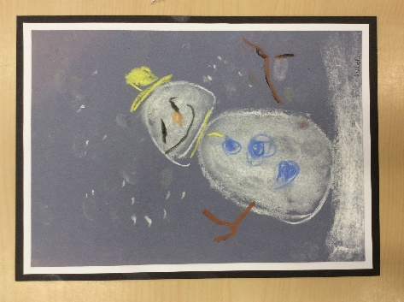  Taught in Spring 1 | Components:  Smarties  - Observe spring flowers, talking about the colours of spring such as – yellow, green, purple and orange.  - Use readymade paint to create a image of daffodils and primroses.  Taught in Spring 2 | Components:  F1  - Use continuous provision including playdough, using cutters, rolling pins, knives, tools and enhancements.  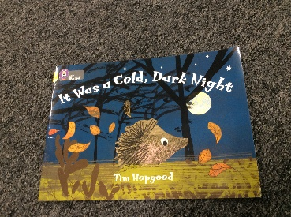  - Use clay to roll into a ball and form a nose to make a hedgehog. Use natural resources such as berries and stones to create features that include eyes, nose and a mouth.  Key vocabulary is highlighted in yellow.  - Use sticks to push into the clay and create spikes on the hedgehog’s back.  - Use clay to roll a ball and pinch to make a pot that resembles a nest. Add sticks and leaves for texture.  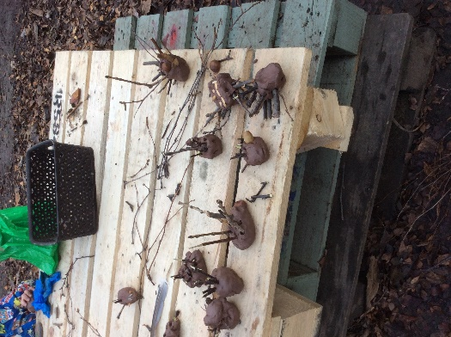  Taught in Autumn 2 | Components:  Smarties  - Use atelier and loose parts, such as pasta, pine cones, curtain hooks to create representations of a face, which features such as eyes, nose and mouth.  - Use a large needle and embroidery thread or wool to pinch and pull through hessian fabric to create their own piece of textile art. (used for Mothers Day cards)  F1  - Create a collaborative large piece of textile art.  - Thread beads on the needle before pinch and pull.  Taught in Spring 1 |  |  | Components:  F1  - Talk about ingredients and recipe from the gingerbread man story. – flour, ginger, butter, milk, raisins  - Roll out with a rolling pin and cut out with a gingerbread man cutter and decorate with raisins.  - Bake and eat the gingerbread men.  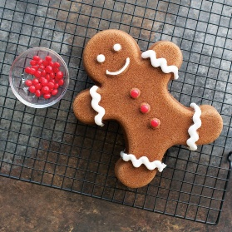  Taught in Spring 2  F1  - Grow cress from seed.  - Use ingredients to make a sandwich – bread, butter, ham, egg mayonnaise and cress.  - Eat the sandwich and discuss if they liked the cress.  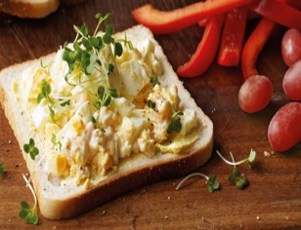  Taught in Summer 1
Smarties and F1  Children will… |  | F1  - Observe ‘The Tiny Seed’ painting by Eric Carle and discuss colour choice.  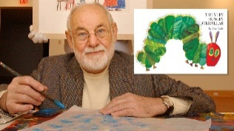  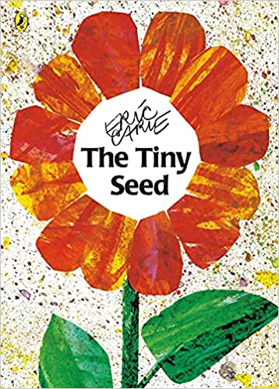  - Discuss that he is an artist and his job is to create pictures.  - Create their own potato print version of ‘The Tiny Seed’ flower using a variety of shades for the petals, including yellow, orange and green  - Print petals, leaves, stem and butterflies and use a toothbrush to create the grass.  Taught in Summer 1
F2  Children will know how to… | Composite:  - Explore, use and refine a variety of artistic effects to express their ideas and feelings. (EYFS)  - Safely use and explore a variety of materials, tools and techniques, experimenting with colour, design, texture, form and function. (ELG) | Composite:  - Explore, use and refine a variety of artistic effects to express their ideas and feelings. (EYFS)  - Safely use and explore a variety of materials, tools and techniques, experimenting with colour, design, texture, form and function. (ELG) | Composite:  - Explore, use and refine a variety of artistic effects to express their ideas and feelings. (EYFS)  - Create collaboratively, sharing ideas, resources and skills. (EYFS)  - Safely use and explore a variety of materials, tools and techniques, experimenting with colour, design, texture, form and function. (ELG) | Composite:  - Explore, use and refine a variety of artistic effects to express their ideas and feelings. (EYFS)  - Create collaboratively, sharing ideas, resources and skills. (EYFS)  - Safely use and explore a variety of materials, tools and techniques, experimenting with colour, design, texture, form and function. (ELG) | Composite:  - Return to and build on their previous learning, refining ideas and developing their ability to represent them. (EYFS)  - Share their creations, explaining the process they have used (ELG) |  | Composite:  - Talk about the different factors that support their overall health and wellbeing (healthy eating).
F2  Children will know how to… | Components:  - Observe their faces and sketch a representation.  - Use pastels to create a self-portrait that has increasing complex details, such as: eyes, eyelashes, eye brows, nose, nostrils, mouth, freckles, cheeks, hair, chin and ears.  - Use the pastels to smudge to create the correct tone.  Taught in Autumn 1 | Components:  - Discuss that:  - Van Gogh was a famous Dutch Artists and he was born is 1853.  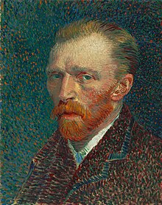  - He painted landscape and portrait pictures and he used bright colours and bold brushstrokes in his work.  - He used watercolours and oil paints.  - Explore the style of painting that Van Gogh chose, which is Impressionism. (He used dabs of paint and colour, with visible brushstrokes. He used bright colours to show emotions in his artwork.)  - Identify and name some familiar paintings, which include Starry night, Sunflowers and The Potato Eaters.  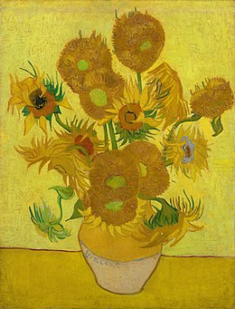  - Create an acrylic painting of The Sunflower using bold brushstrokes.  Taught in Summer 1 | Components:  - Use clay to roll a ball and pinch and push using fingers and thumbs to make a Diwali pot.  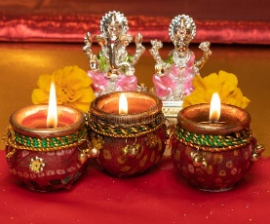  - Select and use tools to create patterns and texture.  - Decorate Diwali pots using pearlised paint embellish with glitter and sequins.  Taught in Autumn 2 | Components:  - Design and create a simple Easter cross using a running stitch on Ada material.  - Use a needle and thread to accurately go up and down through the holes in the material to create a running stitch.  Taught in Spring 2 | Components:  - Share the process and be able to discuss techniques used to create a sculpture or piece of art.  Taught in Autumn 2 |  | Components:  Oliver’s fruit salad  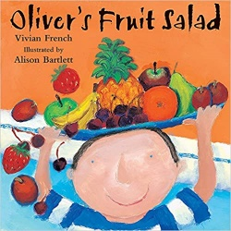  - Select ingredients and recipe for a fruit salad (apples, bananas, strawberries, grapes, pears and oranges).  - Peel and chop the fruit using tools, such as a peeler and a knife.  - Eat the fruit salad and discuss if they liked it.  Taught in Summer 1
Year 1  Children will know how to… | Composite:  - Use drawing to develop and share their ideas, experiences and imagination.  - Develop a wide range of art and design techniques in using colour, pattern, texture, line, shape, form and space | Composite:  - Use painting to develop and share their ideas, experiences  and imagination.  - Develop a wide range of art and design techniques in using colour, pattern, texture,  line, shape, form and space. | Composite:  - Use a range of materials creatively to design and make products.  - Use sculpture to develop and share their ideas, experiences and imagination.  - Develop a wide range of art and design techniques in using colour, pattern, texture, line, shape, form and space.  - Build structures, exploring how they can be made stronger, stiffer and more stable.  - Explore and use mechanisms [for example, levers, sliders, wheels and axles], in their products. | Composite:  - Use a range of materials creatively to design and make products.  - Develop a wide range of art and design techniques in using colour, pattern, texture, line, shape, form and space.  - Design purposeful, functional, appealing products for themselves and other users based on design criteria.  - Generate, develop, model and communicate their ideas through talking, drawing, templates, mock-ups and, where appropriate, information and communication  technology  - Select from and use a range of tools and equipment to perform practical tasks [for example, cutting, shaping, joining and finishing]  - Select from and use a wide range of materials and components, including construction  materials, textiles and ingredients, according to their characteristics.  - Explore and evaluate a range of existing products  - Evaluate their ideas and products against design criteria |  | Composite:  - Learn about the work of a range of artists, craft makers and designers, describing the  differences and similarities between different practices and disciplines, and making  links to their own work. | Composite:  - Design purposeful, functional, appealing products for themselves and other users based on design criteria  - Generate, develop, model and communicate their ideas through talking, drawing, templates, mock-ups and, where appropriate, information and communication technology  - Select from and use a range of tools and equipment to perform practical tasks [for example, cutting, shaping, joining and finishing]  - Select from and use a wide range of materials and components, including construction materials, textiles and ingredients, according to their characteristics  - Explore and evaluate a range of existing products  - Evaluate their ideas and products against design criteria
 | Components:  - Use drawing pencils and charcoal. Identify which pencils to use for outline and shade. Name of the pencil to use such as HB, B etc.  - Draw an observational sketch of mining artefacts – lamplight, hardhat, pick axe.  - After a visit to the coal mining museum to explore a box of artefacts and coal from the museum.  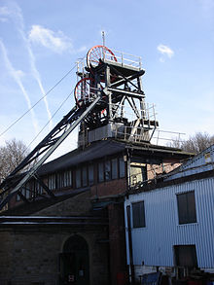  The artist Henry Moore.  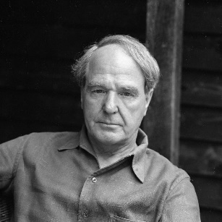  - Discuss the painting ‘Pit Boys’ and recreate it using charcoal.  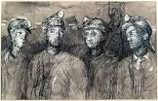  - Recreate the image in soft pastel and discuss which media was more appropriate to emotionally link to the picture.  Taught in Autumn 1 | Components:  - Discuss who the artist Andy Wahol is and his links to Pop Art.  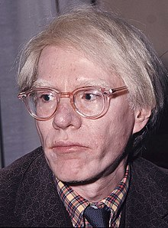  - Discuss that Andy Warhol was born in the USA. In his first job, they misspelt his name as ‘Warhol’ instead of Warhola. He started making Pop art in the 1960s. Andy loved cats and had several as well as a pet dog ‘Archie’ Andy produced pictures of mass-production. This led him to use techniques such as screen printing. He used repeated patterns and changed the colour of his art.  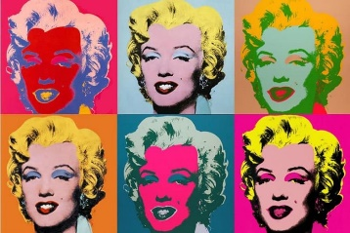  - Design 4 repeated images of a flower.  - Colour mix appropriate colours for their flowers, by use primary colours to make a secondary colour.  - Use white to make tints of secondary and primary colour.  - Use their designs and colour mixing skills to paint a repeated 4 flower image in the style of Andy Worhol.  Taught in Summer 1 | Components:  Create clay animals  - Observe and discuss animals made from clay from images.  - Design and make a clay animal using techniques such as cross hatching, using slip to attach separate pieces, using tools to create any texture.  - Use their design to decide what pieces will need to be attached.  - Make a clay tile using a square template to cut around, using specific language such as rolling and cutting.  - Mix colours appropriate to the animal to create shades and test what they look like on the clay tile before applying to their animal.  - Use their knowledge of colour mixing to paint their animal.  - Evaluate:  How they can make their clay animal better?  Taught in Spring 2  Rocket modelling  - Design a rocket after looking and discussing rocket images.    - Source correct equipment and tools to make a rocket model.  - Use a variety of joins and attachments such as – spilt pins, string, glue, staples, tape.  - Use junk resources to construct, attach together applying the knowledge of different ways of joining and attaching pieces.  - Use paper mâché to cover their rocket.  - Use paints to decorate and add space themed embellishments  - Evaluate:  Next time how can I make my model better.  Taught in Spring 1 | Components:  Finger puppet  - Make a design of a Victorian finger puppet through using images of different Victorian puppets, specifically animal puppets.  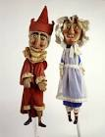  - Use a template to cut around felt to stitch along a running edge with a running stitch. then to turn it inside out to hide the seam.  - Decorate / embellish with various media attached with PVA glue.  - Evaluate:  - Does my finished product match my design?  - Does my finished product match the criteria of a Victorian puppet?  - Is my product held together with a running stich?  - Does my product work as a puppet?  Taught in Autumn 2 | Components:  - Evaluate:  - What worked well?  - What needed improvement?  - Does my finished product match my design?  - Does my finished product match the criteria of a Victorian puppet?  - Is my product held together with a running stich?  - Does my product work as a puppet?  Taught in Autumn 2 |  | Components:  Food technologist.  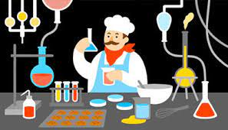  Greek food.  - Look and talk about different features of Greece (see geography progression model).  - Talk about different Greek foods.  - Taste and evaluate the ingredients and recipe for a Greek salad. Such as - feta cheese, green and black olives, olive oil, pitta bread, green, red, yellow peppers, red onion, and salad leaves.  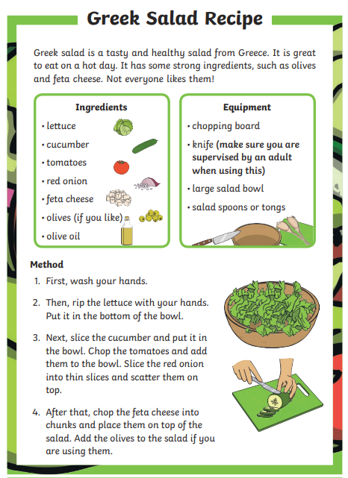  - Evaluate the ingredient and choose likes and dislikes.  - Design a Greek salad – list the ingredients and draw their design.  - Talk about the equipment needed such as a chopping board, sharp knife, salad bowl, spoon and fork.  - Prepare their ingredients for their design to by chopping into smaller pieces and make their salad and eat.  Taught in Summer 2
- Evaluate:
How can I make my clay animal better?

Rocket ship
- Evaluate:
Next time how can I make my model better?

Taught in Spring 1
Year 2  Children will know how to…. | Composite:  - Use drawing to develop and share their ideas, experiences  and imagination.  - Develop a wide range of art and design techniques in using colour, pattern, texture,  line, shape, form and space | Composite:  - Use painting to develop and share their ideas, experiences  and imagination.  - Develop a wide range of art and design techniques in using colour, pattern, texture,  line, shape, form and space. | Composite:  - Use a range of materials creatively to design and make products.  - Use sculpture to develop and share their ideas, experiences and imagination.  - Develop a wide range of art and design techniques in using colour, pattern, texture,  line, shape, form and space.  - Build structures, exploring how they can be made stronger, stiffer and more stable.  - Explore and use mechanisms [for example, levers, sliders, wheels and axles], in their products. | Composite:  - Use a range of materials creatively to design and make products.  - Develop a wide range of art and design techniques in using colour, pattern, texture, line, shape, form and space.  - Design purposeful, functional, appealing products for themselves and other users based on design criteria  - Generate, develop, model and communicate their ideas through talking, drawing,  templates, mock-ups and, where appropriate, information and communication  technology.  - Select from and use a range of tools and equipment to perform practical tasks [for  example, cutting, shaping, joining and finishing].  - Select from and use a wide range of materials and components, including construction  materials, textiles and ingredients, according to their characteristics | Composite:  - Learn about the work of a range of artists, craft makers and designers, describing the  differences and similarities between different practices and disciplines, and making  links to their own work. |  | Composite:  - Design purposeful, functional, appealing products for themselves and other users based on design criteria.  - Generate, develop, model and communicate their ideas through talking, drawing,  templates, mock-ups and, where appropriate, information and communication  technology  - Select from and use a range of tools and equipment to perform practical tasks [for  example, cutting, shaping, joining and finishing].  - Select from and use a wide range of materials and components, including construction  materials, textiles and ingredients, according to their characteristics  - Evaluate their ideas and products against design criteria  explore and evaluate a range of existing products.  - Evaluate their ideas and products against design criteria
Year 2  Children will know how to…. | Components:  - Use their knowledge of physical/human features of Chile, children will choose a feature and draw an outline with HB pencil.  - Choose appropriate gradient of pencil through practicing drawing lines and patterns using words such as shade, adding texture, forming shape  Taught in Summer 2 | Components:  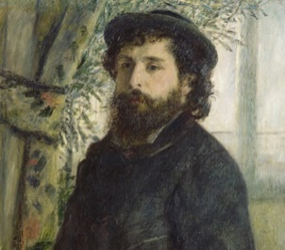  - Discuss who the artist Claude Monet is  - his famous paintings such as ‘a bridge over water lilies’, ‘woman with a parasol’, ‘ a haystack at the end of summer’.  - his date of birth 1840 and his death 1926 and that he was 86 when he died.  - He was from Paris, France.  - His style was impressionism  - He used oil paint using a thin brush with quick brush strokes and the paint was a thick texture.  - Draw an outline, inspired by either ‘Poppy fields near Argenteuil’ or ‘The red boats’  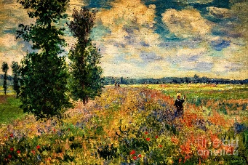  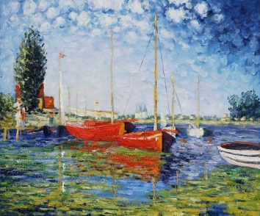  - Create a background using a wash  - Mix tints and shades of colour and tertiary colours such as lime, beige and turquoise.  - Apply acrylic paint in the style of Claude Monet.  - Peer-evaluate their paintings.  Taught in Summer 1 | Components:  - Introduction to sculpture and a look at famous sculptures.  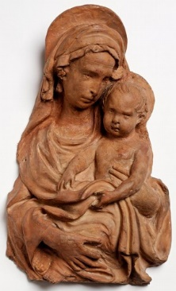  - Discuss facts about Daisy Makeig. such as she is from the children’s local community – Wath  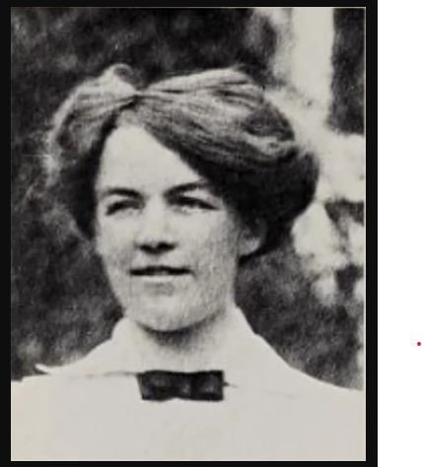  - Look at and discuss modern styles of pottery and old styles of pottery, including a trip to Tesco to look at modern styles of pottery.  - Recognise that Daisy Makeig style is linked to mythical creatures and to look at her specific pottery style and design.  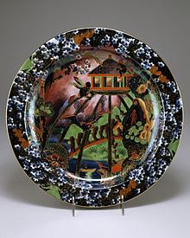  - Design and label a sculpture in the style of Daisy Makeig.  - Naming skills such as rolling, cutting, specific shape for a plate (circle), pinching and rolling a coil, attachment and slip.  - Decorate according to their design and evaluate against their design.  - Evaluate – have you..  - Made of 2 pieces of clay that are joined together  - used a coil  - made a Mythical creature  - made it bright and colourful  - considered how it could be improved.  Taught in Autumn 1 | Components:  - Explore textiles, looking at different materials such as felt, cotton, leather, wool and fur.  - Discuss the purpose and use of the skill of sewing such as joining 2 pieces of material together using a stich.  - Use countries that took part in World War 1 and their flags as their inspiration.  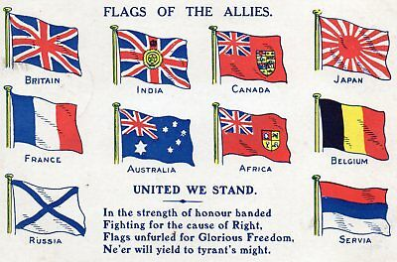  - Design and choose appropriate materials to make a flag.  - Join 2 pieces of material together using a running stich and a whip stich and be able to tie a simple knot.  - Evaluate:  Does it have:  - 2 pieces of material  - 2 stiches  - effective stitches  Taught in Autumn 2 | Components:  Clay plate  - Evaluate their product against set criteria such as:  - is it made of 2 pieces of clay  - is it joined together  - does it have a coil  - is it a Mythical creature  - is it Bright and colourful  Making a flag:  Evaluate:  Does it have  >2 pieces of material?  >2 stiches  > effectiveness of their stitches  Taught in Autumn 1  Box model  Evaluate;  - Does it match your design?  - what would you improve on next time?  - Did the wheels stay on and move?  - Did your model hold together?  Taught in Spring 1 |  | Components:  Food from Chile.  - Look and talk about all the different foods from Chile.  - Talk about the equipment needed to make a chicken salad wrap such as a chopping board, sharp knife and plate.  - Look at the ingredients and recipe needed to make a chicken wrap such as peppers, onions, lettuce, tomato, cooked chicken and tortilla wraps.  - Prepare the ingredients into slices.  - Make up the wrap choosing their own ingredients they like and eat.  Taught in Summer 2
Year 2  Children will know how to…. |  |  | Box modelling:  - Paint a recycled box in a bright colour.  - Decorate their design, using a range of materials such as tissue, straws, foil, crepe and embellishments.  - Make appropriately sized holes to thread a piece of doweling through to make a moving mechanism.  - Attach the wheels to the doweling  - Evaluate;  - Did it match your design?  - What would you improve on next time?  - Did the wheels stay on and move?  - Did your model hold together?  Taught in Spring 1
Year 3
Children will know how to….
Whole School Retrieval Question Map
 | Autumn 1 | Autumn 2 | Spring 1 | Spring 2 | Summer 1 | Summer 2
Smarties + F1 |  |  | Last taught in Spring 2 in Smarties: What colours can you see in spring flowers?  Last taught in Autumn 1 in F1 : What are our face parts called? | Last taught Autumn 2 in F1:  What did you make from Clay?  What did you use for spikes, eyes and mouth? | Last taught Spring in F1:  What do you know about the snowmen art work? | Last taught in Spring 2 in F1:  What are ingredients?  What did we need to make Gingerbread men?  Last taught Summer 1 in F1:  Who is Eric Carle?
F2 | Last taught Autumn 1 in F1:  What are the simple parts of the face?  Last taught Summer 1 in F1:  Who is Eric Carle? | Last taught Spring 2 In F1:  What do you know about sewing? | Last taught Autumn 1 in F2:  What are the detailed parts of the face called? | Last taught Autumn 2 in F2:  What did you make with clay?  What did you use to create patterns? | Last taught Summer 1 in F1:  Who is Eric Carle?  What vegetables did Oliver eat? | Last taught in Spring 2 in F2:  What sort of stich did you use when sewing your cross?
YR1 | Last taught Summer 1 in F2:  who is Van Gogh?  What famous art work did he paint?  Last taught Summer 1 in F2:  What fruit did you chop up to make the fruit salad? | Last taught Spring 2 In F2:  What stich did you use when making your cross?  Last taught Summer 1 in F1:  Who is Eric Carle? | Last taught Autumn 1 in Year 1:  Who is Henry Moore?  What do you know about Henry Moore? | Last taught Autumn 2 in Y1:  What sort of stiches did you use when making your finger puppet?  Last taught Summer 1 in F2:  who is Van Gogh?  What famous art work did he paint? | Last taught Spring 1 in year 1:  What do you know about making a rocket?  What did you use to cover the model? | Last taught Spring in year 1:  What did you make out of clay?  What did you use to attach parts?  How did you attach the parts?  What are primary colours?
YR2 | Last taught Summer 1 in year1: Who is Andy Warhol?  What sort of art did he produce?  Last taught in Summer 2 in Y1  What do you know about a Greek salad? | Last taught Autumn 1 in year 1: who is Henry Moore?  Last taught Autumn 2 in Y1:  What sort of stiches did you use when making your finger puppet?  Last taught Summer 1 in F2:  who is Van Gogh?  What famous art work did he paint? | Last taught Autumn 1 in year 2:  Who is Daisy Makeig Jones?  What can you tell me about Daisy MJ?  Why did you visit Tesco? | Last taught Spring 1 in year 1:  What do you know about making a rocket?  What did you use to cover the model?  Last taught Autumn 2 in year 2: What stiches did you use to join 2 Pieces of fabric?  What do you know about what you made? | Last taught Spring 1 in year :  What did you use to make moving parts? | Last taught Summer 1 in y2:  Who is Claude Monet?  What do you know about Claude Monet?  Last taught Autumn 1 in year 2:  Who is Daisy Makeig Jones?  What can you tell me about Daisy MJ?  Why did you visit Tesco?

