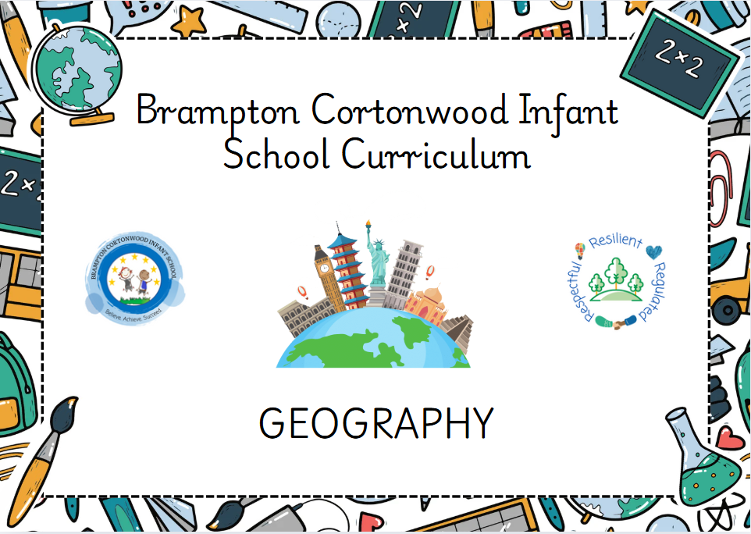

Progression of knowledge and skills within Geography
Each skill is developed within the specific geographical domain based on the geographical knowledge taught at each year groups.
A high-quality geography education will inspire in pupils a curiosity and fascination about the world and its people that will remain with them for the rest of their lives. Teaching will equip pupils with knowledge about diverse places, people, resources and natural and human environments, together with a deep understanding of the Earth’s key physical and human processes. As pupils progress, their growing knowledge about the world should help them to deepen their understanding of the interaction between physical and human processes, and of the formation and use of landscapes and environments. Geographical knowledge, understanding and skills provide the frameworks and approaches that explain how the Earth’s features at different scales are shaped, interconnected and change over time.
Pupils should develop knowledge about the world, the United Kingdom and their locality. They should understand basic subject-specific vocabulary relating to human and physical geography and begin to use geographical skills, including first-hand observation, to enhance their locational awareness.
In planning to ensure the progression described below through teaching about the locational knowledge, place knowledge, human and physical knowledge and geographical field work outlined below, teachers are often introducing pupils to geographical concepts that they will study more fully at key stages 2 and 3.
Intent
Our intent is that geography teaching will give children a good understanding of the world in which they live. This begins in the EYFS as children learn familiar places that are important to them such as their home and their school. In KS1 we aim to build on this foundation of knowledge extending beyond their locality to the country in which they live, building to the United Kingdom’s place in the wider world. Through teaching of geography children will become confident in recognising geographical features and through field work and exploration they can record their findings using maps, keys etc. Our geography teaching is supported by our history teaching which builds on a local, national and global theme all building children’s understanding of the world. Overall, our aim is to give children the best possible introduction to geography which will give them a good base to stick further knowledge to as they move through their education. Our aim is that children become confident, enthusiastic geographers who understand and respect the world in which we live.
Geography taught through a topic approach
The breadth of our topic-based learning curriculum is planned to give pupils appropriate experiences both in and out of the school environment to develop as confident and responsible citizens through the world they live in. It is designed to provide rich cultural capital and provide them with the knowledge and skills to succeed in the future working world. It is delivered in a coherent, structured, practical curriculum that leads to a sustained mastery for all and a greater depth of understanding for those who are capable.

Our topic-based curriculum design is based on evidence from cognitive science; three main principles underpin it:
- Learning is most effective by repetition.
- Interweaving helps pupils to discriminate between topics and aids long-term retention.
- Retrieval of previously learned content is frequent and regular, which increases both storage and retrieval strength.
In addition to the three principles, we also understand that learning can be invisible in the short-term and that sustained mastery takes time. Some of our content is subject specific, whilst other content is combined in a cross-curricular approach. Continuous provision, in the form of daily routines, replaces the teaching of some aspects of the curriculum (where appropriate) and in other cases, provides retrieval and practice for previously learned content.

The impact of our curriculum is that by the end of year 2, the vast majority of our pupils have sustained mastery of the content that is they remember it all through their learning experiences and are fluent in applying both learnt knowledge and skills to a wide variety of tasks and situations.

Geographical Domains
 | Locational knowledge | Place knowledge | Human and physical geography | Geographical skills and fieldwork
Smarties and F1  Children will know how to… | Composite:  (EYFS birth-three)  - Explore and respond to different natural phenomena in their setting and on trips  (EYFS three-four)  - Know that there are different countries in the world and talk about the differences they have experienced or seen in photos | Composite  (EYFS birth-three)  - Notice differences between people.  (EYFS three-four)  - Show interest in different occupations. | Composite:  (EYFS three-four)  - Begin to understand the need to respect and care  - for the natural environment and all living things. | Composite:  (EYFS three-four)  - Talk about what they see, using a wide vocabulary
Smarties and F1  Children will know how to… | Components:  - Discuss the country that we live in is England and is Brampton, which is part of the UK.  - Discuss that there are other countries in the world and share the different ways we can travel to these countries, including: car, ferry, ship and aeroplane.  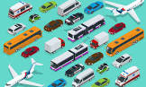  - Describe where they live, including what colour their front door is, what number their house is and describe the things they live near, such as local shops, the park, other houses and churches.  - Discuss who they live with in their house using their family names, such as: brother, sister, son, daughter, (step) father/dad/daddy, (step) mother/mum/mummy.  Components:  - Observe their local environment on a walk of the local area. Discuss things that they have seen, including: Brampton School, the park, the local corner shop, post office, chemist, park, mining memorial and houses (detached, semi-detached, terraced, flat and bungalow).  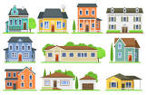  Taught in Autumn 1 | Components:  - Describe that David Attenborough is an explorer.  - Discuss his childhood interests, which are nature, animals and fossils.  - Discuss that he worked on television on an animal programme, which filmed animals in different parts of the world.  - Discuss the ways that we can look after our environment, including reducing waste and recycling.  - Become explorers through discovering resources, such as fossils and creatures using binoculars and magnifying glasses.  - Observe wildlife in print and other media, such as the BBC documentary,  and identify animals from parts of photographs (star fish, whale, dinosaurs, spider and a monkey).  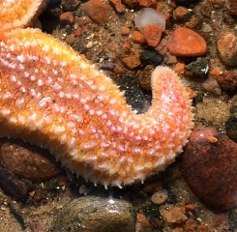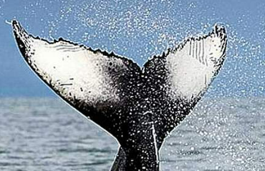  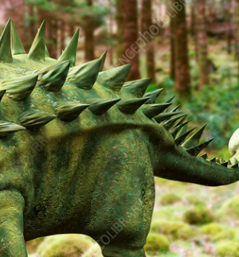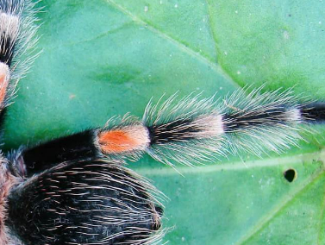  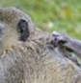  Taught in Summer 2 | Components:  - Compare animals that live on land (cows, sheep, horses and pigs) to animals that live in the sea (shark, whale, dolphin, sword fish, sting ray, lobster and crab).  - Discuss that by cleaning up and recycling that we are protecting our environment for all living things.  Taught in Summer 2 | Components:  - Describe their learning walk around our local area of Brampton.  - Discuss the familiar things that they see such as Dill’s, post office, park, school.  - Create a simple map of their walk and discuss how a map can be used to find where you are going.  Taught in Autumn 1
Smarties and F1  Children will know how to… | - Explore where China is on a world map and describe that is it a different country to the UK.  - Explore the celebration of Chinese New Year, including the types of food eaten, traditions such as giving red envelopes, making lanterns, dragon dancing, parades and eating food with chopsticks.  Taught in Spring 1
Smarties and F1  Children will know how to… | - Retell the story of Handa’s surprise and discuss that she lives in Africa, which is a different country.  - Compare the animals in the story (monkey, ostrich, zebra, elephant, giraffe and antelope) to animals found in the UK (cow, sheep, horses, chickens and pigs).  - Compare the exotic fruit that is in the story (pineapple, orange, guava, banana, avocado, mango, passion fruit, tangerine) to fruit more commonly grown in the UK (apples, grapes, strawberries, plums and cherries).  Taught in Summer 1 | - Discuss the different occupations that their parents and family members have and share the types of jobs they would like to have when they are older.  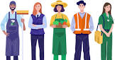  Taught in Autumn 1
F2  Children will know how to… | Composite:  (EYFS reception)  - Recognise some environments that are different from the one in which they live. | Composite:  (EYFS reception)  - Name and describe people who are familiar to them  - Recognise some similarities and differences between life in this country and life in other countries.  (ELG)  - Explain some similarities and differences between life in this country and life in other countries, drawing on knowledge from stories, non-fiction texts and – when appropriate – maps. | Composite:  (EYFS reception)  - Describe what they see, hear and feel whilst outside  - Understand the effect of changing seasons on the natural world around them.  (ELG)  - Describe their immediate environment using knowledge from observation, discussion, stories, non-fiction texts and maps; | Composite:  (EYFS reception)  - Draw information from a simple map
F2  Children will know how to… | Components:  - Observe their local environment on a walk of the local area. Discuss things that they have seen, including: Brampton School, the park, the local corner shop, post office, chemist, park, mining memorial and houses (detached, semi-detached, terraced, flat and bungalow).  Taught in Autumn 1 | Components:  - Name people in their family, such as:brother, sister, son, daughter, (step) father/dad/daddy, (step) mother/mum/mummy, grandmother (grandma/Nan), grandfather (grandad), aunt (auntie), uncle, cousin, niece and nephew.  - Draw a picture of people in their immediate family that live in their house.  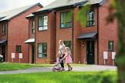  Taught in Autumn 1 | Components:  - Name all four seasons in a year (spring, summer, autumn and winter).  - Observe the changes across all the seasons over the year and describe key features and festivals that happen within each season. E.G. in Spring, it is common for it to rain. There is new life, which includes blossom on the trees and animals being born such as lambs and chicks. We also celebrate the Christian celebration of Easter, where it is tradition for people to give Easter eggs as a gift. In the summer, the weather is hotter and people often go on holiday. In autumn, the weather gets colder and the wind blows and the leaves fall off the trees. The days get shorter. Some animals, such as squirrels and birds adapt their behaviour and prepare for hibernation, or migration. In Winter, the weather gets colder and there may be ice or snow. Christmas is celebrated in the winter.  - Describe where they live, including the name of their street and door number.  Taught in Spring 1 | Components:  - Discuss what can be seen on a simple map of a farm (horses, pigs, cows, sheep and ducks). Program BeeBots to navigate a simple map. Children to use directional language, including forwards, backwards, sideways, diagonal, left and right to describe their journey.  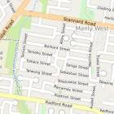  Taught in Spring 2
F2  Children will know how to… | - Compare their local environment to Arctic. Use a globe to explore and describe that Arctic is found on the Northern Hemisphere and is known as the North Pole and the positioning of it means that the weather is much colder due to the amount of sunlight it receives.  - Describe the types of animals that live in the Arctic, such as: polar bears, arctic foxes, arctic hare, caribou and whales. Compare these animals to those that are usually found in the UK, such as mouse, owls, badgers, squirrels and hedgehogs.  Taught in Spring 1 | - Describe that Floella Benjamin travelled from Trinidad to the UK by boat. Describe that Trinidad is another country and is in the Eastern Caribbean.  - Directly compare Trinidad to the UK by comparing the different climates. Describe that the UK has a temperate climate – it gets cool, wet winters and warm, wet summers. Whereas, Trinidad usually is hot, windy and overcast.  - Compare landscape photos of Trinidad, and the UK.  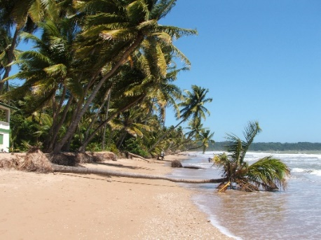  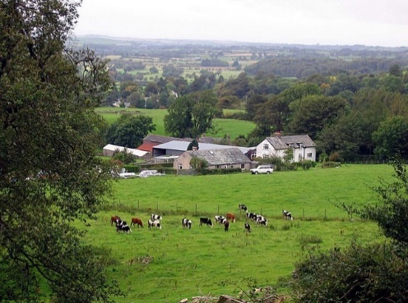  - Describe that Trinidad has a mixture of landscapes that include: jungles, forest reserves, waterfalls and swamps and compare this to the UK, which has: cities, towns, villages and woodlands.  Taught in Summer 2 | - Observe the different weather over the span of a week and create a weather log. Describe the different weather using language such as: sunny, cloudy, wind, raining etc.  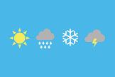  Taught in Spring 1
F2  Children will know how to… |  |  | - Describe what type of home they live in (bungalow, detached, semi-detached, terraced, town house, cottage, flat or chalet). Discuss features of their home, such as, garden, gate, stairs/staircase, bathroom, en-suite, bedroom, kitchen, conservatory, drive, garage etc. | - Create a simple map of their local walk by sticking on pictures and drawing lines to represent their walk.  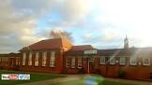
F2  Children will know how to… |  |  | - Describe their route to school using directional language such as left, right, forwards, straight, backwards.  Taught in Autumn 1  - Identify the familiar landmarks that they see, such as: the skate` park, shops, post office, church and bus stops.  Taught in Autumn 1
Year 1  Children will know how to… | Composite:  - Name, locate and identify characteristics of the four countries and capital cities of the United Kingdom and its surrounding seas. | Composite:  - Understand geographical similarities and differences through studying the human and physical geography of a small area of the United Kingdom, and of a small area in a contrasting non-European country. | Composite:  - Identify seasonal and daily weather patterns in the United Kingdom and the location of hot and cold areas of the world in relation to the Equator and the North and South Poles  - Use basic geographical vocabulary to refer to: key physical features, including: beach, cliff, coast, forest, hill, mountain, sea, ocean, river, soil, valley, vegetation, season and weather key human features, including: city, town, village, factory, farm, house, office, port, harbour and shop. | Composite:  - Use world maps, atlases and globes to identify the United Kingdom and its countries, as well as the countries, continents and oceans studied at this key stage.  - Use simple compass directions (North, South, East and West) and locational and directional language [for example, near and far; left and right], to describe the location of features and routes on a map  - Use aerial photographs and plan perspectives to recognise landmarks and basic human and physical features; devise a simple map; and use and construct basic symbols in a key  - Use simple fieldwork and observational skills to study the geography of their school and its grounds and the key human and physical features of its surrounding environment.
Year 1  Children will know how to… | Components:  - Use a map of the United Kingdom to label the 4 countries and capital cities of the United Kingdom.  - Locate where Brampton is on a map of the United Kingdom and which country Brampton is in. Compare the location of Brampton in relation to North, East, South, West when observing the capital cities of the United Kingdom  - Locate the nearest coastal town to Brampton on a map, which is Cleethorpes  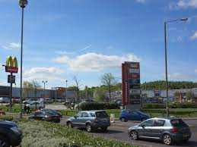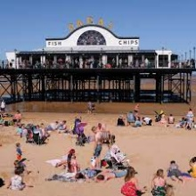  Taught in Autumn 1 | Components:  - Identify objects and animals that can be found by the sea or not by the sea. Such as shops, schools, houses, lighthouse, boats, farm animals, woods  - Categorise geographical building/features of Brampton such as houses (semi-detached, detached, terrace, bungalow and flats) transport (roads, streets, cars, buses and taxis) buildings (school, church, shops, post office)  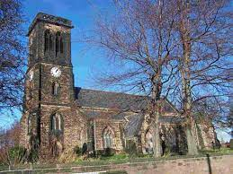  Taught in Autumn 1 | Components:  - Sort images of human and physical features of Brampton from the past and Brampton from the present. Human features will include: Cortonwood shopping centre, houses, roads/streets, mining pit head, bridges, churches. Physical features will include: weather, tress, woods and farming filed.  - Create a map of an imaginary island that will include human and physical features of the wider world. Including, physical: mountains, volcanos, rivers, hills, streams forests, cliffs. Include human features: stadiums, factories, theme parks, castles,  - Sort human and physical features of Brampton with non- Brampton, such as physical features = bus station, train station, airport, school, church, shops, houses, road. Human features = wood, forest, mountains, cliffs, trees, season.  - Compare human and physical features of Brampton against human and physical features of Cleethorpes (Cleethorpes nearest coastal town).  - Brampton human features are shops, play parks, skate park, school. Physical features are woods, RSPB wetlands and trees/shrubs.  - Human features of Cleethorpes are lighthouse, pier and harbour. Physical features are coastline, cliff, rock pools, shoreline and beach.  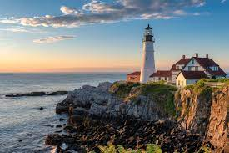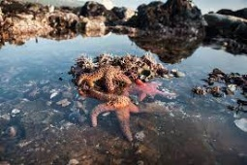  Taught in Autumn 1 | Components:  - Use a of the world and by using a key will be able to locate and name the 7 continents of the world and label the 5 oceans.  - Use their observation skills to discuss geographical features of Greece, such as:  Capital city: Athens  Population: 11 million  language: Greek  Currency: Euro  Climate: Hot Summer  Sea Coast: Mediterranean Sea.  Boarders: Turkey and Bulgaria  Largest island: Crete  Food: Olives, Feta cheese and moussaka.  - Identify the country’s flag  - Locate Greece on a map  (links with Design technology regarding making a Greek food salad)    Taught in Summer 2
Year 1  Children will know how to… |  | Component:  - Identify human and physical features of Brampton and compare tham to Greece, specifically Athens.  - Brampton human features = Morrisons, Post office( this is a recap from autumn term). Physical features= park/Manvers.  - Athens human features = Airport, Parthenos. Physical features = mountains, coastline/beach  - Compare 2 capital cities by identifying human and physical features of them.  London - physical features:  River Thames  Grasslands, parks and trees  Cold and warm weather  Human features:  Wembley Stadium  London Eye  Big Ben  Athens - Physical features:  Aegean Sea  warm and hot weather  mountains and trees  Human features:  Parthenon  Agora  Herod Atticus Odeon  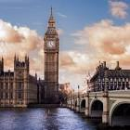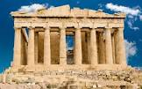  Taught in Summer 2
Year 2  Children will know how to… | Composite:  - Name, locate and identify characteristics of the four countries and capital cities of the United Kingdom and its surrounding seas. | Composite:  - Understand geographical similarities and differences through studying the human and physical geography of a small area of the United Kingdom, and of a small area in a contrasting non-European country. | Composite:  - Identify seasonal and daily weather patterns in the United Kingdom and the location of hot and cold areas of the world in relation to the Equator and the North and South Poles  - Use basic geographical vocabulary to refer to: key physical features, including: beach, cliff, coast, forest, hill, mountain, sea, ocean, river, soil, valley, vegetation, season and weather key human features, including: city, town, village, factory, farm, house, office, port, harbour and shop. | Composite:  - Use world maps, atlases and globes to identify the United Kingdom and its countries, as well as the countries, continents and oceans studied at this key stage.  - Use simple compass directions (North, South, East and West) and locational and directional language [for example, near and far; left and right], to describe the location of features and routes on a map  - Use aerial photographs and plan perspectives to recognise landmarks and basic human and physical features; devise a simple map; and use and construct basic symbols in a key  - Use simple fieldwork and observational skills to study the geography of their school and its grounds and the key human and physical features of its surrounding environment.
Year 2  Children will know how to… | Components:  - Use a map of the world to locate the seven continents of the world and 4 oceans.  - Identify where the United Kingdom is on a world map. Once the United Kingdom is located- identify neighbouring continents and oceans. Focus on finding Meru in Kenya along with Chile in order to begin a country study.  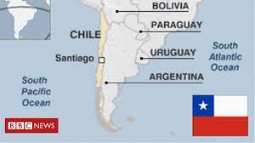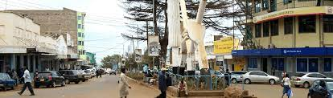    Taught in Autumn 1 | Components:  - Compare human and physical features of Barnsley with Meru (non-European country)  - Compare schools, homes, landscape and weather patterns.  - Record information about the similarities and differences of Barnsley and Meru. Focusing on population, housing, schooling, transport and leisure. Discuss why there are similarities and differences due to economic factors of the two areas.  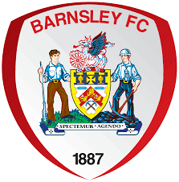  Taught in Autumn 1 | Component:  - Compare and discuss human and physical features of a local town (Barnsley) with our village Brampton.  Human features include: town centre, hospital, market, council buildings/town hall.  physical features include: soil, vegetation, lakes, seasonal weather patterns.  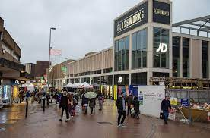  Taught in Autumn 1 | Component:  - Research geographical facts about a nearby town Barnsley. Focus on population/people, key places, types of education, housing and weather patterns.  Taught in Autumn 1
Year 2  Children will know how to… |  | Component:  - Compare physical features of Brampton and Chile  parks-mountains  rivers-lakes  hills-cliffs  - Compare human features of Brampton and Chile  shops-shopping centres  petrol stations -garages  funfairs-theme parks  terrace house-mansions  football grounds-stadium  - Discuss similarities and difference between England’s capital city (London) and Chile’s capital city (Santiago)  Similarities  markets  people  building  school  colleges  parks  Differences  beaches  mountains  coastline  language  population  weather  climate  Taught in Summer 2 | Component:  - Discuss the meaning of different natural disasters such as:  erupting volcano  avalanche  blizzard  tornado  earthquake  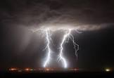  Taught in Summer 2 | Component:  - Use a map of the world and a key to locate the 7 continents and 5 oceans of the world. Children will use a coloured key to denote the correct continents of the world and label the 5 oceans.  - Research which animals are indigenous to the 7 continents of the world.  Europe = badger  Africa = lions, zebra, giraffe  Asia= tiger, leopard, panda, crocodile  America=rhino, brown bear, orangutan  Australia= kangaroo, funnel- web spider  Antarctica- wandering albatross, penguins  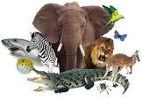  Taught in Spring 2
Component:
- Study the country Chile by:
Locating it on a map.
Distance in miles from England to Chile.
Population.
Environment.
Flag

- Use a compass to describe their directions when using a map of the school

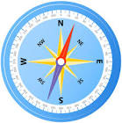
Taught in Summer 2
Year 3
Children will know how to….

Key = Autumn 1, Autumn 2, Spring 1, Spring 2, Summer 1, Summer 2
Key vocabulary is highlighted in yellow

Whole School Retrieval Question Map
 | Autumn 1 | Autumn 2 | Spring 1 | Spring 2 | Summer 1 | Summer 2
Smarties + F1 |  |  | Last taught in Autumn 1 in F1 :  Who are your family members?  What types of transport are there?  What places cane you name in our area?  What jobs do you know of? |  | Last taught Spring in F1:  What traditions happen at Chinese New Year?
F2 | Last taught Summer 1 in F1:  Where is Handa from Handa’s surprise from?  What is different from Handa’s country to ours? | Last taught in Summer 2 in F1:  Where did David Attenborough explore?  How can we take care of our world?  What animals can you name? | Last taught Autumn 1 in F2:  What types of houses can you name?  What places do you pass in our area on your way to school? |  | Last taught Spring 1 in F2:  What animals are found in cold places?  Name the four seasons of the year? | Last taught Spring 2 In F2:  What visuals may you see on a map?
YR1 | Last taught in Summer 2 in F2:  Where was Floella Benjamin from?  How is Trinidad different to our country? |  | Last taught Autumn 1 in Year 1:  Name all 4 countries of the United Kingdom?  Where is the nearest coastal town to Brampton?  What buildings would you find in our local area of Brampton? | Last taught Autumn 1 in Year 1:  What human and physical features would you find in Brampton?  What human and physical features would you find at Cleethorpes?
YR2 | Last taught in Summer 2 in Y1  Name differences between Brampton and Greece?  What is the capital city of Greece?  How does the capital city of Greece – Athens compare to our capital city – London? |  | Last taught Autumn 1 in year 2:  Name the 7 continents of the world.  Name the 4 ocenas of the world.  Name the neighbouring continents and oceans to the United Kingdom. | Last taught Autumn 1 in year 2:  Locate where Kenya, Meru and Chile are.  Name physical and human features of Barnsley.  Name human and physical features of Meru. |  | Last taught Spring 2 in Y2:  Name the animals that are indigenous to the 7 continents of the world.

