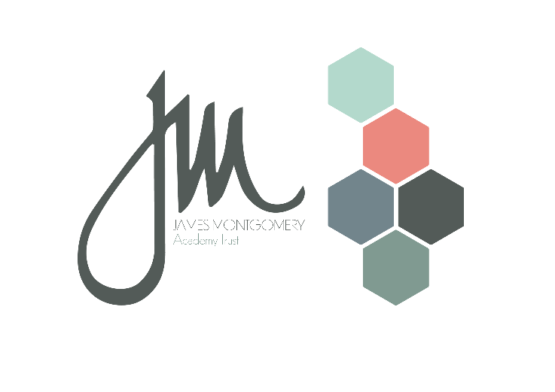

**Music Development Plan Summary****:**  
**Brampton Cortonwood Infant School**

## Overview

|  |  |
| --- | --- |
| Detail | Information |
| Academic year that this summary covers | 2025-2026 |
| Date this summary was published |  |
| Date this summary will be reviewed |  |
| Name of the school music lead | Toria Levitt |
| Name of school leadership team member with responsibility for music (if different) | Toria Levitt |
| Name of local music hub | Rotherham Music Hub  <https://www.rotherhammusic.co.uk/> |
| Name of other music education organisation(s) (if partnership in place) | N/A |

## Part A: Curriculum music

|  |
| --- |
| At Brampton Cortonwood Infant School, music is taught through the Charanga scheme following the ‘original scheme’ on a one-year cycle. The Charanga scheme has been chosen due to its progressive structure and because it is informed by the model music curriculum. Music is taught weekly in all classes, this may be split over a number of sessions. In addition to this the children have a weekly singing assembly. The lessons are designed to be progressive and build on prior learning allowing the children time to revisit, review, and refine their music vocabulary, knowledge, and skills. Lesson plans are adapted from the scheme to ensure they are inclusive, enabling all learners the opportunity to fully partake in music lessons, feel valued, and achieve their best. At Brampton Cortonwood Infant School all children will learn to sing songs and play untuned and tuned instruments through our weekly music lessons. Instruments include claves, shakers, drums, tambourines, and glockenspiels. There is planned progression with Foundation Stage children playing untuned instruments, and Year 1 and 2 children learning to play the glockenspiel. Additional information regarding the music intent at Brampton Cortonwood Infant School can be found on the school’s website in the curriculum section.  [Music | bramptoncortonwood](https://www.bramptoncortonwoodinfants.co.uk/music) |

## Part B: Co-curricular music

|  |
| --- |
| * All children have the opportunity to perform in annual events such as a nativity performance, the Easter Service and at special events such as the Year 2 leavers’ service, and when visiting local community areas (care homes). * Children in Years 1 and 2 have the opportunity to be members of the School Choir. When allocating places priority is given to pupil premium children. The choir also is provided with the opportunity to sing for the local care home. * The school benefits from a range of rehearsal spaces including the school hall for larger ensembles such as Choir, and additional learning spaces for children who may prefer to learn instruments in a quieter, less stimulating environment. * Being part of a wider school community, our infant children are able to participate in community music and movement festivals hosted by the local secondary academy. |

## Part C: Musical experiences, events and performances

|  |
| --- |
| * Choir performance at local care home and Christmas events * Nativity performance and Christmas concerts * Class assembly performances for parents and carers * Easter Service for parents and carers * End of Year, Y2 leavers celebration |

## In the future

This is about what the school is planning for subsequent years.

|  |
| --- |
| To further enrich the music offer to all children at Brampton Cortonwood Infant School the school intends to:   * Provide the opportunity for all children to perform rehearsed songs from the Charanga scheme of learning to an audience in termly assembly performances. This will include singing and playing an instrument as part of a whole class ensemble. * Have a half termly genre of music focus which the children will learn about, and listen to, during assembly time and during periods in the classroom. * Introduce music celebration certificates for our celebration assembly to celebrate any child who participate in extra-curricular music lessons. |