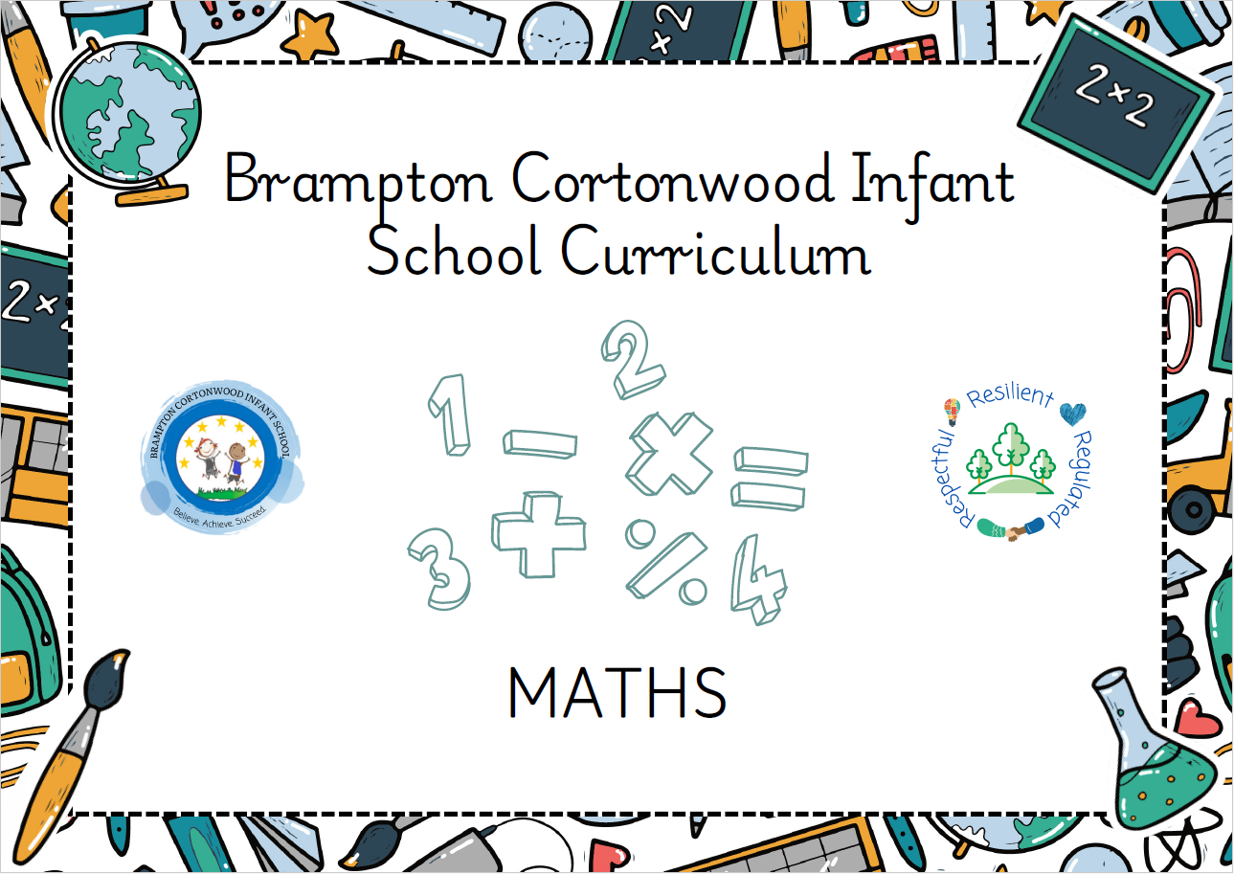

April 2025
Progression of knowledge and skills within Mathematics
Mathematics is an interconnected subject in which pupils need to be able to move fluently between representations of mathematical ideas. Pupils should make rich connections across mathematical ideas to develop fluency, mathematical reasoning and competence in solving increasingly sophisticated problems. They should also apply their mathematical knowledge to science and other subjects.
We use the White Rose Maths to support our teaching of maths. These materials develop children’s mathematical vocabulary alongside progression through concrete, pictorial and abstract representations of a range of mathematical skills and knowledge. Decisions about when to progress are always based on the security of pupils’ understanding and their readiness to progress to the next stage. Pupils who grasp concepts rapidly will be challenged through being offered rich and sophisticated problems before any acceleration through new content. Those who are not sufficiently fluent with earlier material will consolidate their understanding, including through additional practice, before moving on.
Our maths curriculum shows clear progression of skills as children move through school. It will provide children with the opportunity to build on their prior knowledge whilst building their resilience and confidence. Children will be engaged and enjoy learning in a challenging environment where they can actively take part in lessons. Children can confidently use different representations of mathematical concepts and are confident to talk about their maths learning. Assessment is effective and the use of monitoring ensures all children are supported.
Our detailed method progression policy helps support children through developing efficient strategies when solving world calculations, problems and reasoning tasks. Children are taught different methods to solve specific mathematical domain questions and are equally encouraged to apply the most efficient approach for the task given.
Our subject on a page gives clear detail regarding the high expectation of the delivery of mathematics at Brampton Cortonwood infant School.

Each skill is developed within the specific mathematical domain based on the mathematical knowledge taught at each year groups
Mathematical Domain | Nursery/Smarties (F1)  Children will know how to … | Reception (F2)  Children will know how to…. | Year 1  Children will know how to…. | Year 2  Children will know how to…. | Year 3  Children will know how to….
Counting, Number, Place Value  (Number) | Develop fast recognition of up to 3 objects, without having to count them individually (‘subitising’).  Recite numbers past 5 and say one number for each item in order: 1,2,3,4,5.  Know that the last number reached when counting a small set of objects tells you how many there are in total (‘cardinal principle’).  Show ‘finger numbers’ up to 5 and link numerals and amounts: for example, showing the right number of objects to match the numeral, up to 5 and experiment with their own symbols and marks as well as numerals. | Count objects, actions and sounds.  Learn to Subitise.  Link the number symbol (numeral) with its cardinal number value.  Count beyond ten.  Compare numbers.  Practise and improve skills in counting numbers with 1:1 correspondence  Count reliably with numbers.  Place and order numbers.  Use the language of: more than, less than.  Identify and represent numbers using objects and pictorial representations.  Mark, draw and write numbers.  Explore the composition of numbers to 10.  Automatically recall number bonds for numbers 0–5 and some to 10.  Verbally count beyond 20, recognising the pattern of the counting system; - Compare quantities up to 10 in different contexts. | Place numbers in orders.  Count to and across, forwards and backwards, from 0, 1 or any given number.  Read and write numbers.  Read and write numerals.  Count in multiples of 2s, 5s, 10s  Identify one more and one less than a given number.  Identify and represent numbers using concreate equipment and pictorial representations.  Use language of: equal to, more than, less than (fewer), most, least.  Partition numbers. | Count in steps of 2’s, 3’s and 5’s from 0 and in 10’s from any number – forwards and backwards.  Recognise the value of each digit in two-digit numbers.  Identify, represent and estimate numbers using different concrete and pictorial representations.  Compare and order numbers from using equality symbols.  Read and write numbers in numerals and words.  Solve problems including place value and number facts.  Partition numbers. | Count in multiples of 4, 8, 50 and 100 from 0.  Find 10 or 100 more or less than a given number.  Recognise the place value of each digit in a three-digit number.  Identify, represent and estimate numbers using different representations (concrete and pictorial).  Read and write numbers in numerals and words.  Solve problems including place value.  Begin to partition numbers with up to three-digits.
Reasoning Examples: | Which collection is the largest? How do you know?  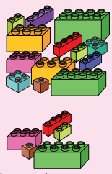  Do they look the same? Explain.  How do you know there are 3?  What do you notice? | How many have you got? How do you know?  Have you got less than… how do you know?  Which number is bigger/smaller? How do you know?  What is the same/different about these objects? | Who do you agree with? Why?  Explain the mistake that Tiny has made.  Tiny is counting to 10.  What mistake has he made?  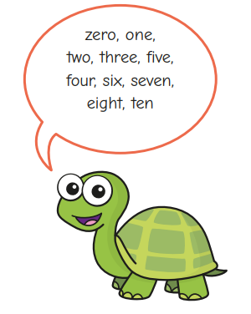  Is there more than one answer? Explain.  Which statement is true/false? | There are 43 straws…. what mistake has he made?  Explain the mistake he has made.  How many are there? How do you know?  Which is easier to count? Why?  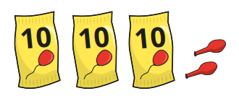  There are 5 balloons. Do you agree? Explain.  Is this statement true or false?
Problem Solving Examples: | Can you show me 1/2/3 in a different way?    Match the number to the buns  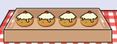 | How many ways can you make…?  How many different ways can you show…?  Can you find a number that is different to mine?  How many ways can they be sorted?  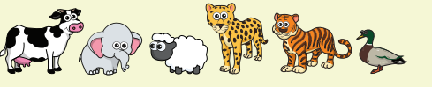 | Use the digit cards to complete the sentences  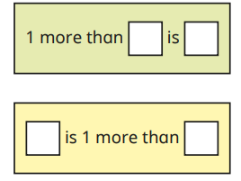  What do you notice?  Roll the dice and use the symbols < > = to compare  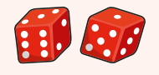 | There are 32 sweets in total. How many are covered up?  How many different ways can you partition each number?  Complete the part whole models to partition the number in different ways. What pattern can you see?
Addition and Subtraction  (Number) | Solve real world mathematical problems with numbers up to 5 and compare quantities using language: ‘more than’, ‘fewer than’. | Represent and use number bonds and related subtraction facts within 10.  Add and subtract one-digit numbers.  Add and subtract one-digit numbers.  Solve practical one-step problems using concrete resources.  Using quantities and objects, they add and subtract 2 single-digit numbers and count on or back to find the answer.  Begin to solve problems including doubling, halving and sharing. | Represent and use number bonds and related subtraction facts within 20.  Add and subtract one digit and two-digit numbers.  Read, write and interpret mathematical statements involving addition (+), subtraction (-) and equals (=) signs (appears also in Mental Calculation.  Solve one-step problems that involve addition and subtraction, using concrete objects and pictorial representations, and missing numbers. | Recall and use addition and subtraction facts fluently, and derive and use related facts up to 100.  Using concrete equipment and pictorial representations, add and subtract numbers including:  A two-digit number and ones  A two-digit number and tens  Add two two-digit numbers  Add three one-digit numbers  Begin to practise strategies for the development of mental calculation (particularly of number bonds)  Recognise and apply the inverse relationship between addition and subtraction and use this to check calculations and solve missing number problems.  To use concrete and pictorial representations to solve problems including addition and subtraction; quantities and measures. Children will be moving towards a written method. | Mentally add and subtract numbers including:  A three-digit number and ones  A three-digit number and tens  A three-digit number and hundreds  Use the formal written method of column addition and subtraction to add and subtract numbers with up to three-digits. Children will begin to exchange ones for tens and tens for hundreds using this method.  Estimate the answer to a calculation and use inverse operations to check answers.  Select efficient strategies to solve problems, including missing number problems (i.e.: using number facts, place value, and more complex addition and subtraction).
Reasoning Examples: | Do they look the same? Why?  Which is more than? Which has fewer? How do you know? | How many are there? How do you know?  How do you know there are 9?  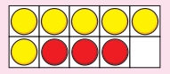  How many are left? How do you know? | Use cubes to show that he is wrong;  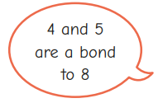  Which number bond is the odd one out? How do you know?  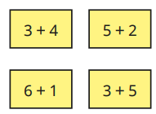  Is tiny correct? How do you know? | Tiny has found a pattern in the number bonds. What pattern has he found?  Max is subtracting 1s. What pattern can he see?  How many beads are covered? How do you know?  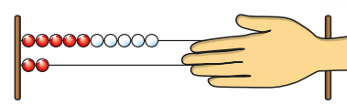  Tiny is working out the missing number. Explain the mistake he has made.
Problem Solving Examples: | Which collection has more/fewer?  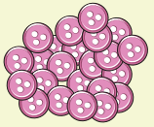 | How many cubes were added?  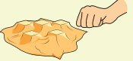  How many bottles were there at the start?  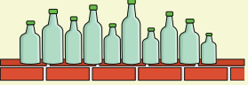  How many ducks were taken away?  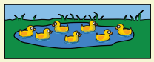 | 4 is the whole number.  How many different part whole models can you draw to show this?    How many different ways can you group the animals?  Use the number cards to write a sentence  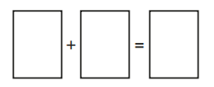 | Tom has 8 sweets. Ben gives him 7 more sweets. Kim gives him 2 more sweets. How many sweets does Tom have now?  Ann has 14 stickers. She gives some stickers to Ben. Now she has 6 stickers. How many stickers does she give to Ben? How do you know?  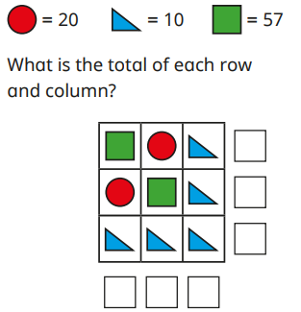
Multiplication and Division  (Numerical Patterns) | Talk about and identify the patterns around them. For example: stripes on clothes, designs on rugs and wallpaper. Use informal language like ‘pointy’, ‘spotty’, ‘blobs’, etc and Extend and create ABAB patterns – stick, leaf, stick, leaf. | Explore and represent patterns within numbers up to 10, including evens and odds, double facts and how quantities can be distributed equally.  Continue, copy and create repeating patterns | Count in multiples of 2’s, 5’s and 10’s – identifying patterns.  Understand language of ‘grouping’ and ‘sharing’.  Begin to double and halve quantities with support.  Use concrete equipment and pictorial representations (including arrays) to solve one-step problems involving multiplication and division. | Recall multiplication and division facts for the 2,5 and 10 multiplication tables.  Recall and recognise odd and even numbers – linking them to the multiplication tables.  Calculate mathematical statements for multiplication and division within the multiplication tables and write them using the multiplication (×), division (÷) and equals (=) signs  Understand and represent that the multiplication of two numbers is commutative and that division by another is not  Solve problems including multiplication and division using a range of concrete and pictorial representations. For example, arrays, repeated addition, mental strategies and known multiplication and division facts | Recall and apply multiplication facts for the 3, 4 and 8 multiplication tables.  Solve problems including missing number problems, involving multiplication and division.  Write and calculate mathematical statements for both multiplication and division using the known multiplication tables, including for two-digit numbers and one-digit numbers.  Use and apply mental methods for multiplication and division, moving towards formal written methods (beginning with expanded method)
Reasoning Examples: | What patterns do you notice?  What will come next in the pattern? How do you know?  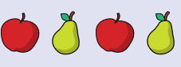  How have you copied my pattern?  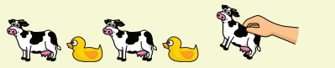 | Are these groups equal? How do you know?  Have we shared them equally?  How can you show me double ___? | Tiny is counting backwards in 2s. what mistake has he made? Who has made equal groups? How do you know?  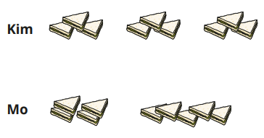  Do you agree with Tiny?  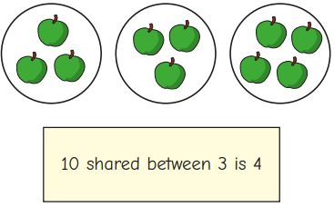 | There are 10 equal groups with 2 in each group. Do you agree? Explain.  Who has made equal groups? Explain why.  Do you agree with Mo? Why?  Am I correct? How do you know?  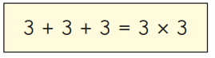
Problem Solving Examples: | Recreate my pattern  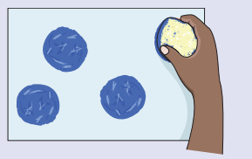  Can you make a pattern?  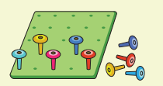 | How can we make it fair so that all children have the same size playdough?    Share the cookies between 2/3/4 people  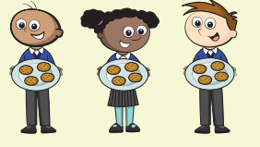  How many pots can we fill?  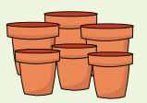  How many towers can you make?  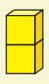 | 9 children are riding their bicycle. How many wheels are there in total?  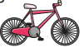  Tiny is counting backwards in 10s from 100. Which numbers will he say?  Ben and Tom each have the same number of sweets. Ben has 8 equal groups of 2 Tom puts his sweets into equal groups of 4 How many equal groups of sweets does Tom have? | Match the pictures and the labels  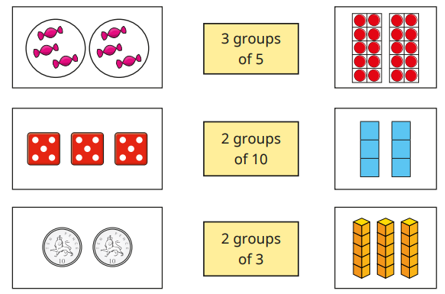  Which group belongs? Which does not belong? Explain why.  What could the multiplication number sentence be?  draw a picture to show 3 lots of 4.  Part of the array is hidden- what could the array be?  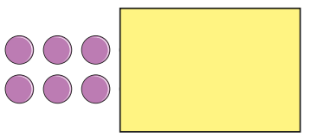
Fractions  (Numerical Patterns) | N/A | N/A | Recognise, find and name a half as one of two equal parts of an object, shape or quantity.  Recognise, find and name a quarter as being one of four equal parts of an object, shape or quantity.  Combine halves and quarters as parts of a whole.  Write 1/2, ¼ and some ¾ as fractions. | Recognise, find, name and write fractions – 1/3, ¼, 2/4 (½) and ¾ and apply to lengths, shapes, objects or quantities.  Write simple fractions. For example; ½ of 6 = 3.  Recognise the equivalence of 2/4 and ½.  Apply the language of grouping and sharing when finding fractions of amounts . | Count up and down in tenths; recognising that tenths arise from diving an object into 10 equal parts.  Divide one-digit numbers or quantities by 10.  Recognise, find and write fractions as a discrete set of objects: unit fractions and non-unit fractions with small denominators.  Recognise and use fractions as numbers, including where they sit on a number line.
Reasoning Examples: |  |  | Jo thinks she has coloured half of each shape. Do you agree?  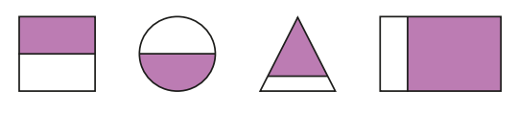  Which object has been cut into quarters? How do you know?  Tiny is trying to find ¼ of 24. What mistake has he made?  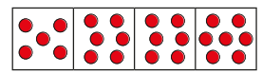 | 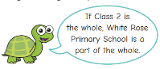  Here is a tower made of green, yellow and red cubes. How many different ways can you describe the parts?  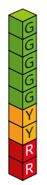  Tiny is thinking about parts and wholes. Explain Tiny’s mistake.  Who has split their square into equal parts? Explain  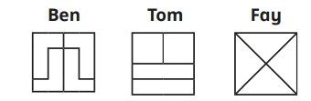
Problem Solving Examples: |  |  | Find 3 ways to split the square in half.  If 4 is the half, what is the whole?    If 2 is the half, what is the whole?  Complete the bar model to work out the whole  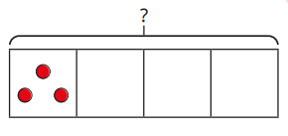 | Split the shapes so that they show equal parts.  Which shapes show equal parts?  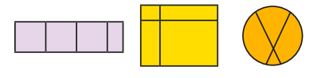  Whose strip of paper is longer? How do you know?  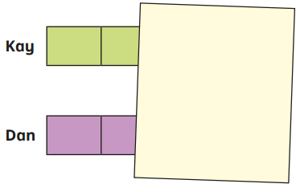
Measurement | Make comparisons between objects relating to size, length, weight and capacity and select shapes appropriately  Notice and correct an error in a repeating pattern and begin to describe a sequence of events, real or fictional, using words such as ‘first’, ‘then... | Compare length, weight and capacity | Measure and begin to record lengths/height, mass/weight, capacity/volume, time (seconds, minutes and hours).  Compare, describe and solve practical problems (including using the correct vocabulary) for:  Length/height (long/short, taller/shorter, double/half).  Mass/weight (heavy/light, heavier, lighter)  Capacity/volume: (full/empty, more than, less than, half full, quarter)  Recognise and know the value of different denominations of coins and notes.  Sequence events in chronological order using language of before and after, next, first, today, yesterday, tomorrow, morning, afternoon and evening.  Recognise and use language relating to dates (days of the week, weeks, months and years) .  Read and draw the time to the hour and half past the hour  Time: (quicker, slower, earlier, later). | Recognise and use the symbols for pounds (£) and pence (p).  Combine pounds and pence to make a given value.  Recognise and find combinations of coins that equal the same amount of money.  Solve problems in practical contexts involving the addition and subtraction of money of the same unit, including giving change.  Compare and order lengths, mass, volume/capacity and record the results using equality symbols.  Compare and sequence intervals of time.  Read and write the time to 5-minute intervals including quarter past/to the hour.  Recall the number of minutes in an hour and the number of hours in a day.  Choose and use an appropriate standard unit to estimate and measure length/height in any direction (cm/m); mass (g/kg); temperature(c); capacity (ml/l) to the nearest appropriate unit – using rulers, thermometers and measuring vessels. | Add and subtract amounts of money to give change; using both pounds and pence, in practical contexts. Children must use the correct units (£) (p).  Measure the perimeter of a 2-D shapes; writing out an appropriate calculation.  Record and compare times in seconds, minutes and hours.  Use vocabulary such as o’clock, a.m., p.m., morning, afternoon, noon and midnight.  Recall the number of seconds in a minute and days in each month, year and leap year.  Compare durations of events.  Measure, compare, add and subtract measurements: lengths, mass, volume/capacity, including the use of the appropriate units (mm/cm/m, g/kg, ml/l).
Reasoning Examples: | Which one is bigger? How do you know?  Which shape doesn’t belong in the pattern? | Which object is heavier/lighter? How do you know?  Which holds the most? How do you know?  How can you find out? | Kay thinks that the pencils are the same length. How could you check?  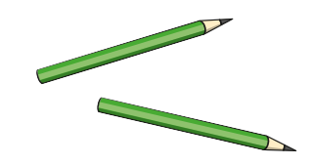  What mistake has Mo made?  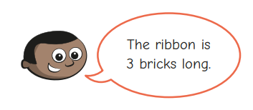  Which object is heavier? How do you know?  I have drawn 3 o clock.  What mistake has he made?  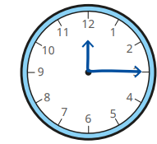 | Sam uses a ruler to measure the length of her toy train. Do you agree with her? Explain why.  The height of the classroom is about 3cm. what mistake has he made?  The time is quarter past 2. Is Tiny correct?
Problem Solving Examples: | Can you find something in the room longer than this pencil? | Find someone who has a longer/shorter piece of ribbon than you    What size person could live in your house/tower?  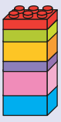  Make different size playdough balls and compare their mass | How long could sam’s ribbon be?  What is the mass of the teddy bear? How do you know?  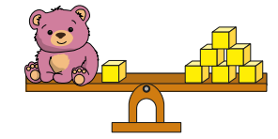  How many more days are you at school than not at school?  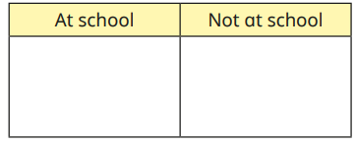 | Ron and Jo want to measure the length of the string. Explore with pieces of string.  Measure an object. Find something that is longer/shorter/the same length.  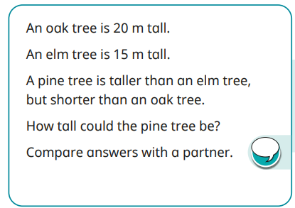
Geometry (properties of shape) | Talk about and explore 2D and 3D shapes (for example, circles, rectangles, triangles and cube, cone and sphere) using informal and mathematical language: ‘sides’, ‘corners’; ‘straight’, ‘flat’, ‘round’. | Select, rotate and manipulate shapes to develop spatial reasoning skills.  Compose and decompose shapes so that children recognise a shape can have other shapes within it, just as numbers can. | Recognise and name common 2-D shapes including rectangles, squares, circles and triangles.  Recognise and name common 3-D shapes including: cubes, cuboids, pyramids and spheres.  Recognise the common 2-D and 3-D shapes in different orientations.  Recognise the similarities and differences between common 2-D and 3-D shapes. | Identify and describe the properties of 2-D shapes, including the number if sides and vertical/horizontal lines of symmetry .  Identify and describe the properties of 3-D shapes including the number of edges, vertices and faces.  Identify 2-D shapes on the surface of 3-D shapes.  Compare and sort common 2-D and 3-D shapes and everyday objects.  Read shape names (suitable for their word reading and spelling).  Draw lines and shapes using rulers. | Draw 2-D shapes and make 3-D shapes using modelling materials.  Recognise and describe 3-D shapes in different orientations.  Recognise angles as a property of shape or description of turn.  Identify right-angles, recognise that two right-angles make a half-turn, three make three quarters of a turn and four make a complete turn.  Identify whether angles are greater than or less than a right-angle.  Identify and name horizontal and vertical lines.  Identify and name pairs of parallel and perpendicular lines.  Understand symmetrical and non-symmetrical polygons and polyhedral.  Use vocabulary such as obtuse and acute to describe angles.  Connect decimals and rounding to drawing and measuring straight lines
Reasoning Examples: | Why have you chosen each shape?  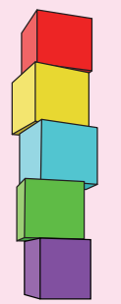  Will the shape fit in the slot? How do you know?  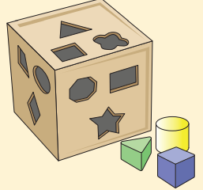  What do you notice about these shapes?  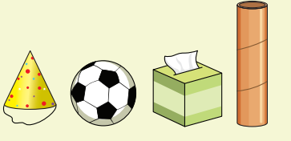 | What do you notice about your shape?  How do you know they are the same/different?  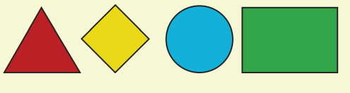  What do you notice?    Which shape could have made the footprint? How do you know?  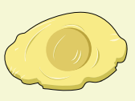 | This shape must be a cube. How do you know?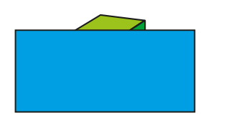  I have sorted these 3d shapes. Am I correct? How do you know?  Is this pattern correct? How do you know?  Who do you agree with? Why?  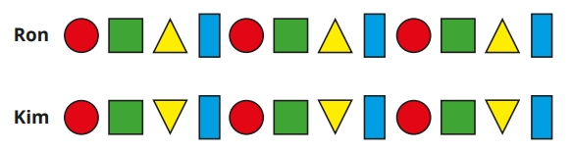 | Which shape is the odd one out?  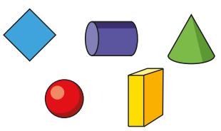  All these shapes are triangles. Do you agree with Tiny? Why?  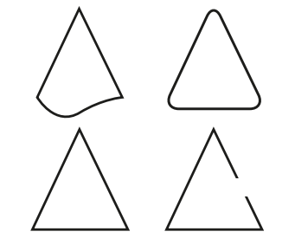  This shape is a square. Do you agree?  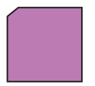  Does the picture have a line of symmetry? How do you know?
Problem Solving Examples: | Which two shapes are the same?  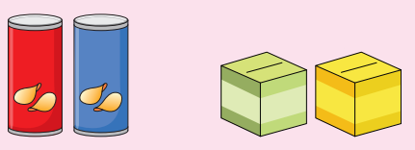 | Find a shape that is the same as mine  How many sticks will you need to create a triangle?  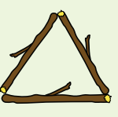 | Draw straight lines to complete the shape  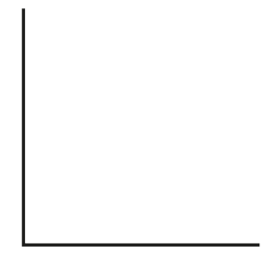  How many ways can you do it?  How many different ways can you sort the shapes?  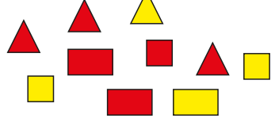 | Give the children 18 lollipop sticks. How many hexagons can you make?  Is this statement true/sometimes true/never true?  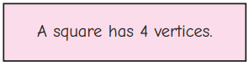
Geometry (position and direction) | Understand position through words alone – for example, “The bag is under the table,” – with no pointing and describe a familiar route and Discuss routes and locations, using words like ‘in front of’ and ‘behind’. | Select, rotate and manipulate shapes to develop spatial reasoning skills. | Describe position and movement including language of: whole, half, quarter and three-quarter turns. Make connections between turns and movement on a clockface.  Use language of left, right, top, bottom, on top of, in front of, above, between, around, near, close, far, up, down, forwards, backwards, inside and outside. | Order and arrange combinations of mathematical objects (counters, cubes) in patterns and sequences.  Recognise and recall patterns and sequences.  Continue given sequences; using the recognised pattern.  Recognise patterns in different orientations.  Use mathematical language to describe position, direction and movement in a straight line.  Distinguish between rotation as a turn and in terms of right angles for quarter, half and three-quarter turns.  Use language of clockwise and anti-clockwise). | N/A
Reasoning Examples: | Can the car go through the tunnel or over it? Why do you think that?  If I put the book under the table, can we still see it- why/why not?  Which one is in the middle? How do you know it’s in the middle? | What can you see? If you move to a different position, what can you see now? | Sam is waving her left hand. Sam is waving her right hand. Who do you agree with? Explain.  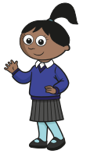 | How many ways can you describe the position of the 2p coin?  Jo is describing turns. Do you agree with Jo? Explain your reasoning.  Describe the turns the shapes could have made.  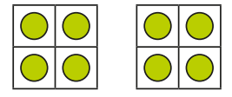
Problem Solving Examples: | The ball rolled behind the sofa- how can we get it back?  The puzzle pieces are under the rug. What can we do to find them?  We want to get to the playground but there is a cone in the way. What could we do? | What will these animals be able to see?  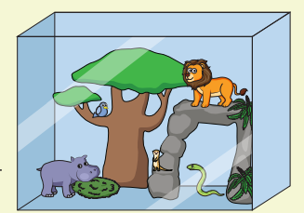 | Kim is trying to get to the pond. How many different ways could she get there?  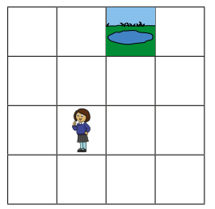  Find two ways to describe the turn the arrow makes.    Use the clues to work out the order of the children.  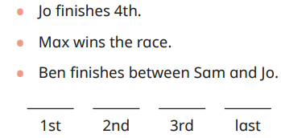 | Draw arrows to show the new position of the children.  Use the words to help the bee get to the beehive  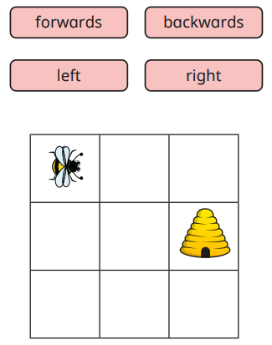  How can the ant get to the flower? How many ways can you find?  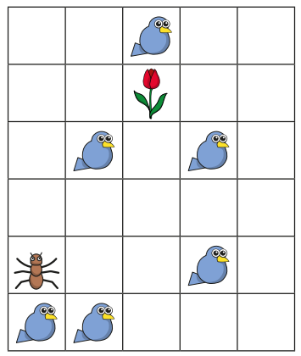
Statistics | N/A | N/A | N/A | Read and interpret simple pictograms, tally charts, block diagrams and simple tables.  Understand how to read a given key.  Construct simple pictograms, tally charts, block diagrams and simple tables.  Ask and answer simple questions by counting the number of objects in each category and sort categories by quantity.  Ask and answer questions about totalling and comparing categorical data. | Interpret and present data using bar charts, pictograms and tables.  Solve one-step and two-step problems including comparison, sum and difference using information presented in scaled bar charts, pictograms and tables.
Reasoning Examples: |  |  |  | What is the same/different about each chart?  What mistake has tiny made when filling in his block chart?  The most popular colour is blue. Do you agree? Explain.
Problem Solving Examples: |  |  |  | Correct Tiny’s mistake in the tally chart.  Complete the tally chart using the clues;  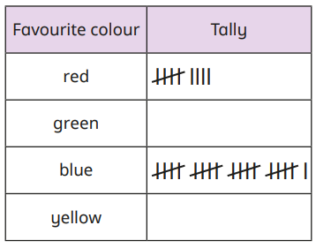  Yellow is the least popular colour, the number of children who like green is greater than red.  Match the tables to the block diagrams.  Use a tally chart to complete a pictogram.

Reception small steps
Autumn term
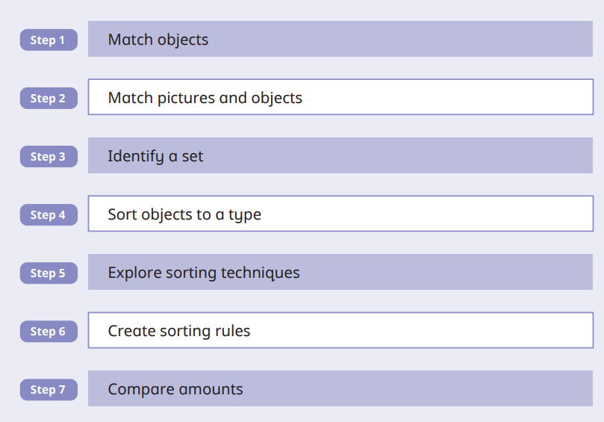  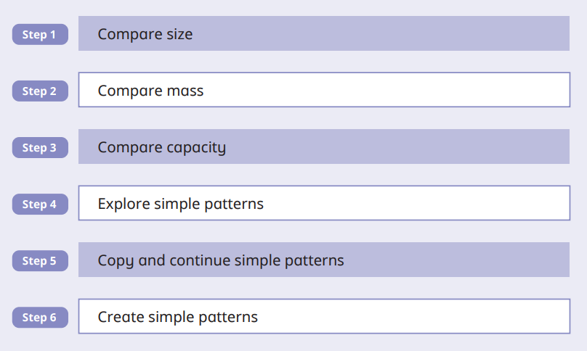 | 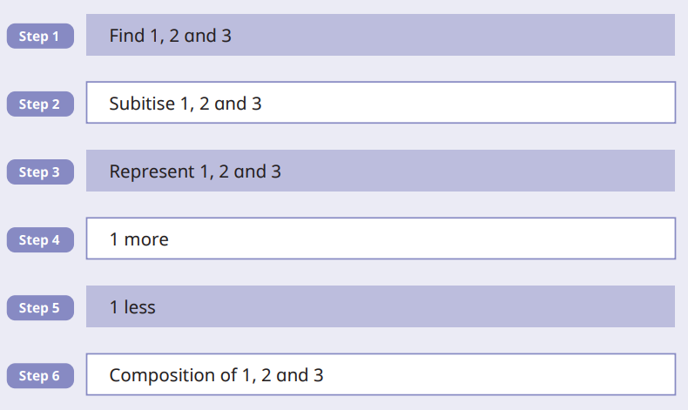  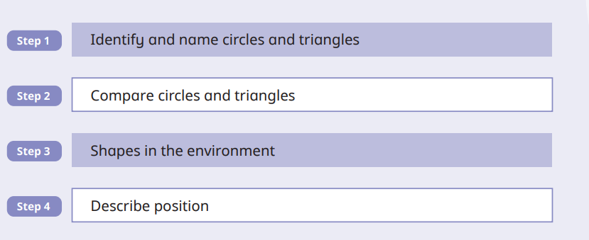 |  | 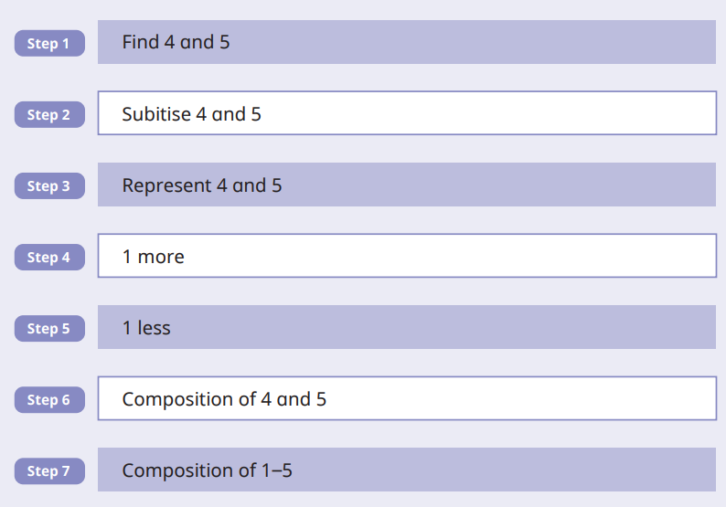  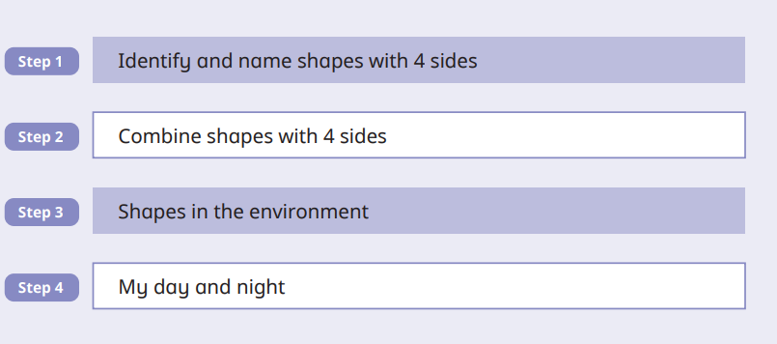
Spring term
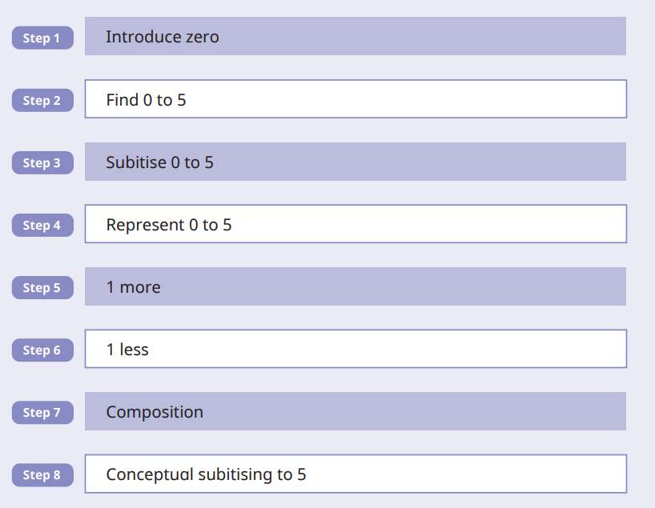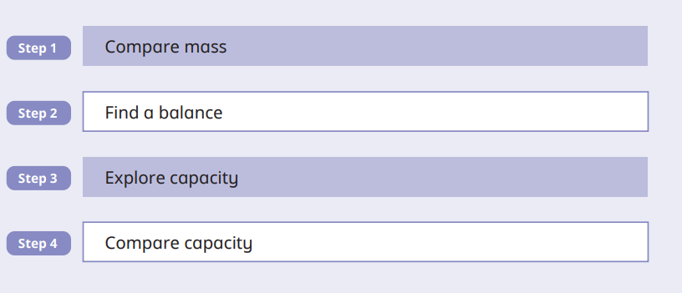 | 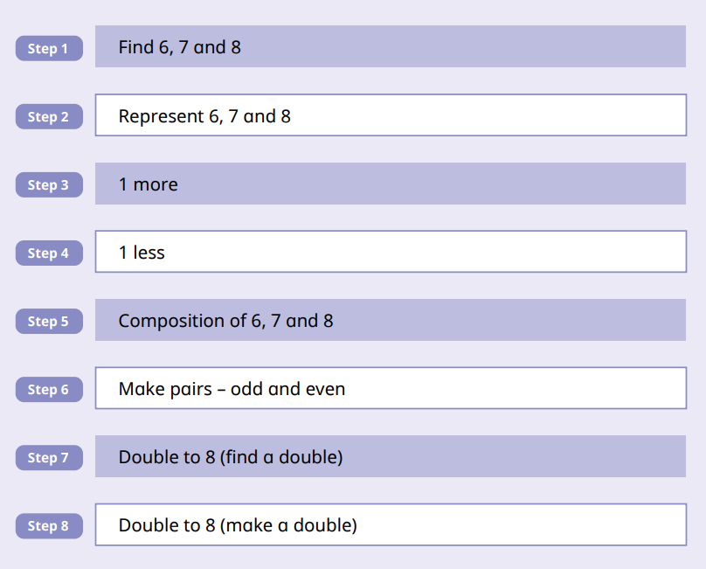  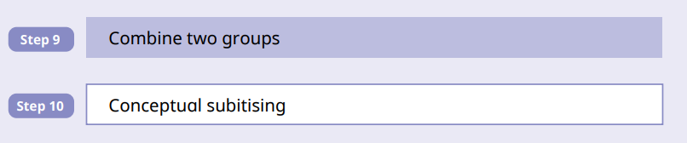 |  | 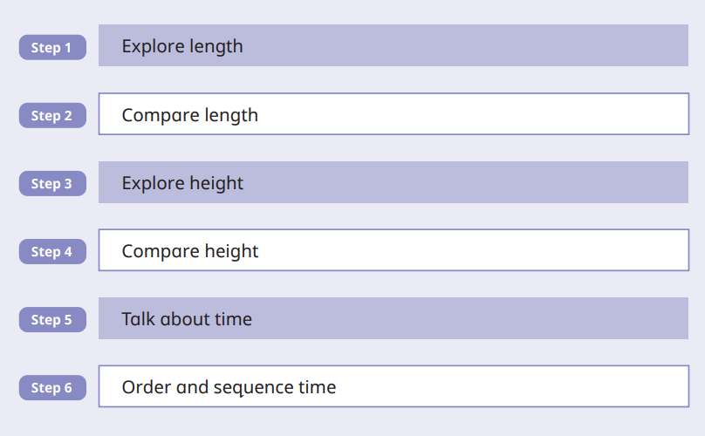  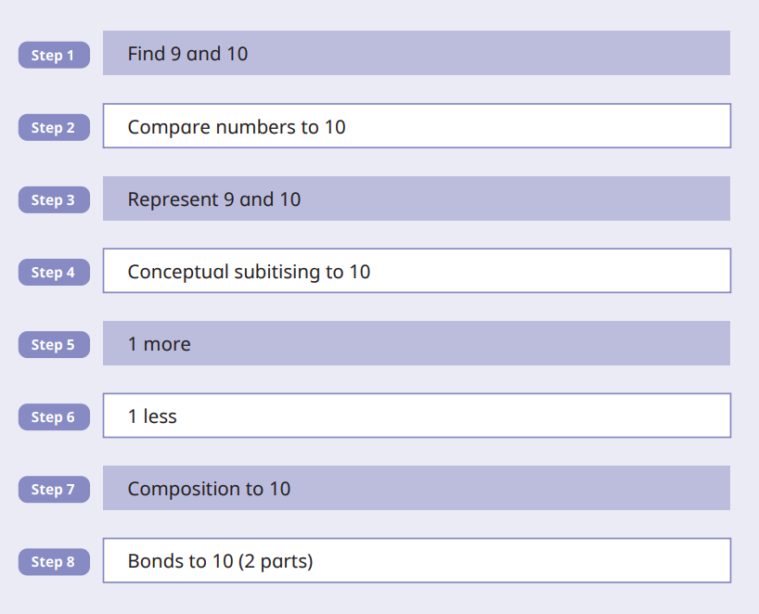  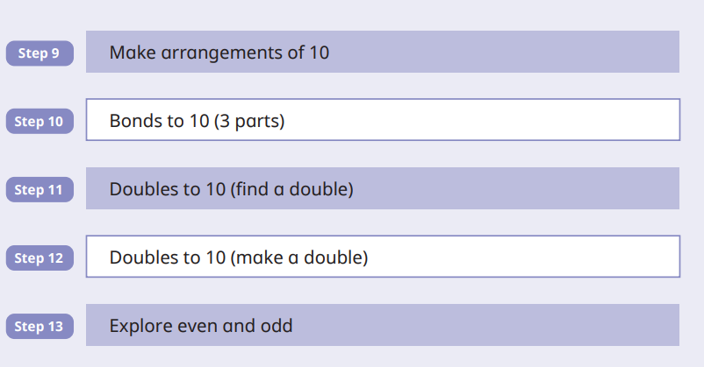
Summer term
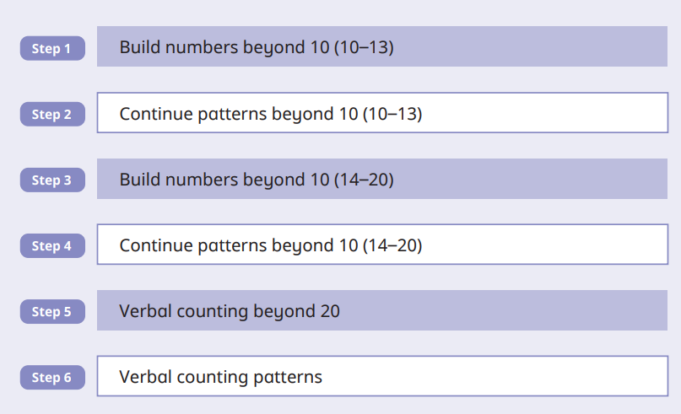  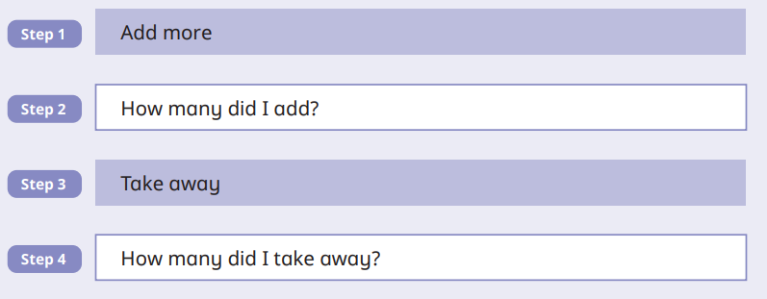 | 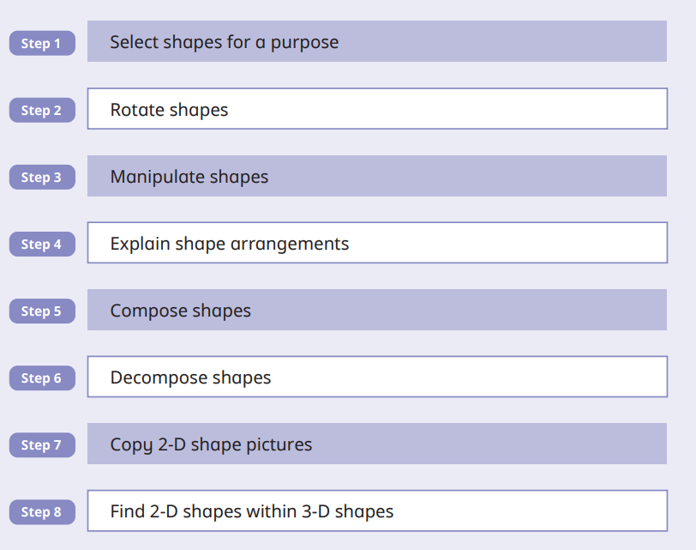  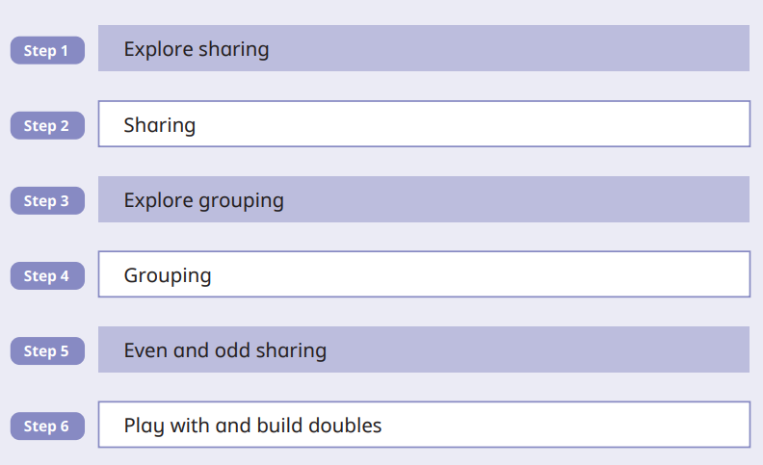 | 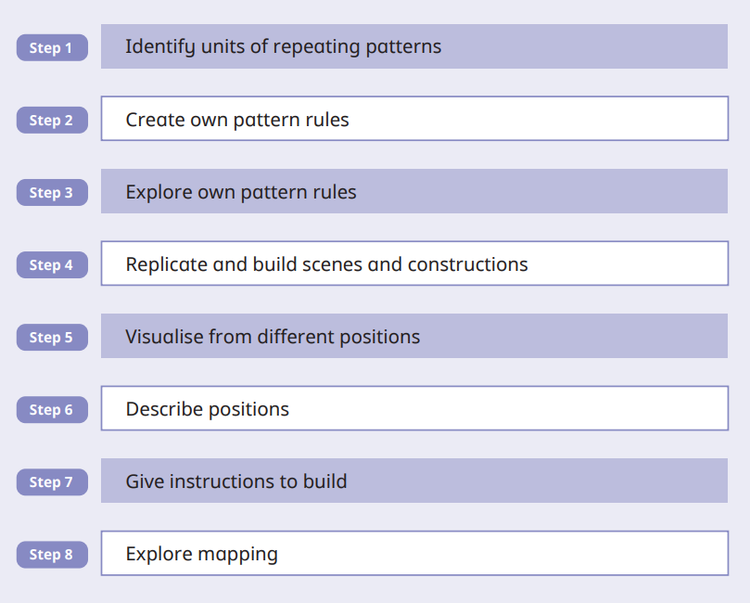  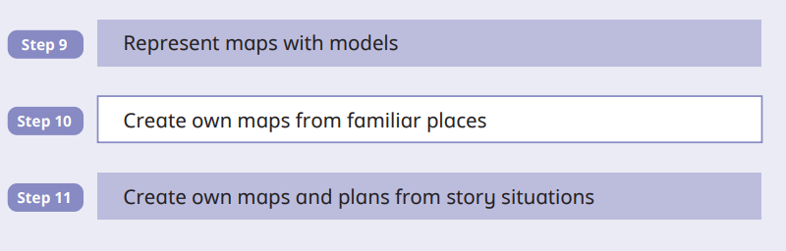  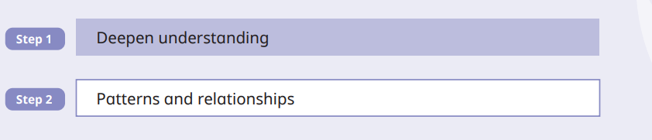

Year 1 small steps
Place value within 10 | Addition and subtraction within 10 | Shape
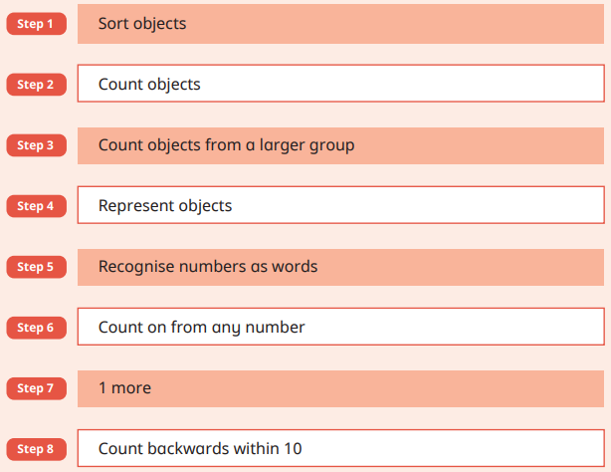  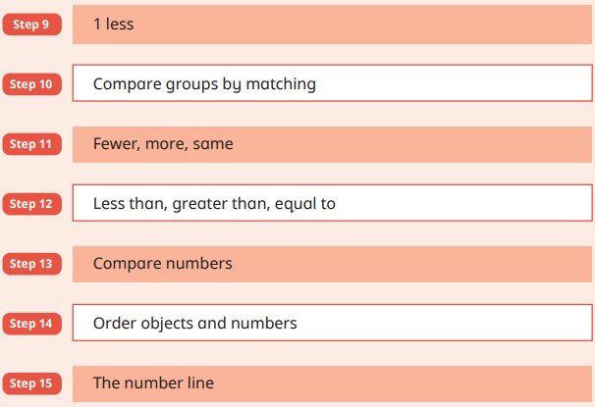 | 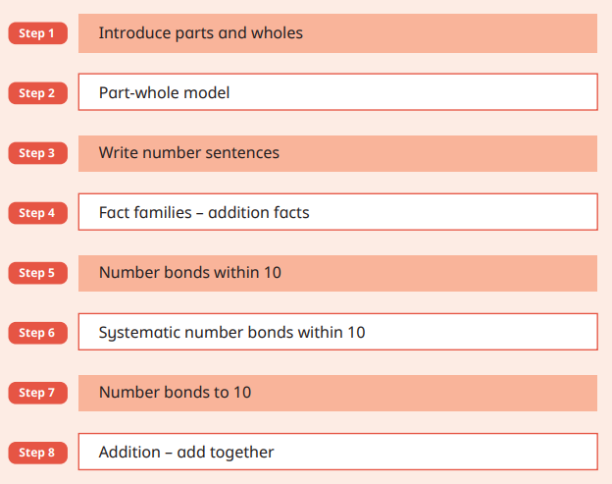  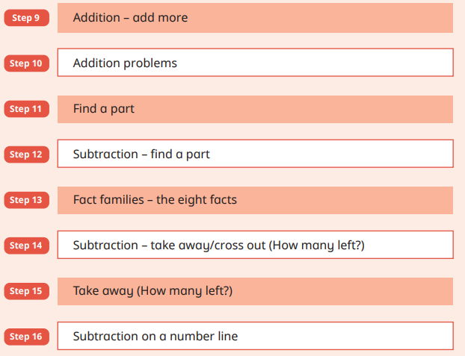 | 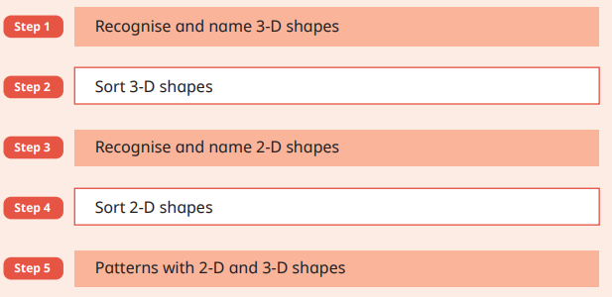
Place value within 20 -50 | Addition and subtraction within 20 | Length and Height
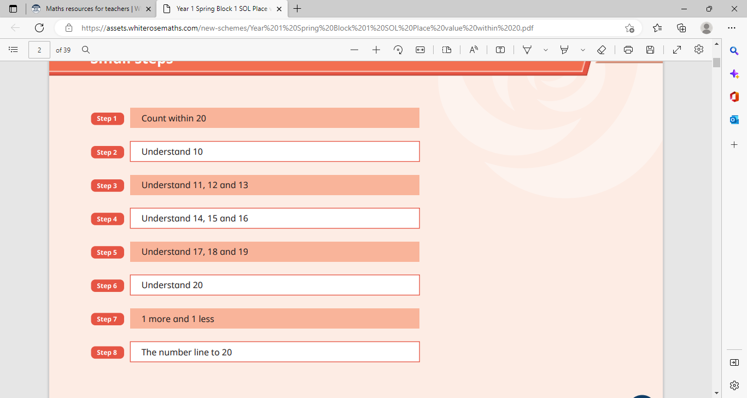  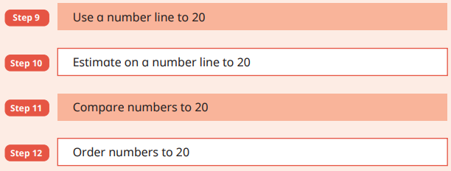  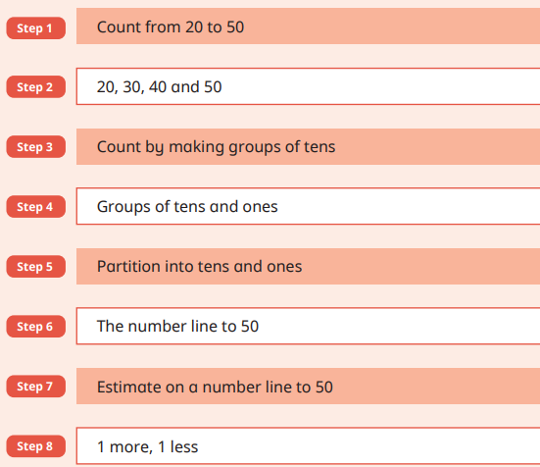 | 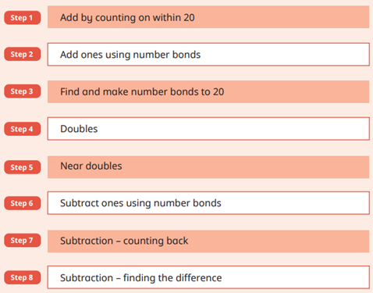 | 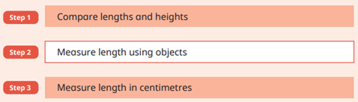
Place Value within 100
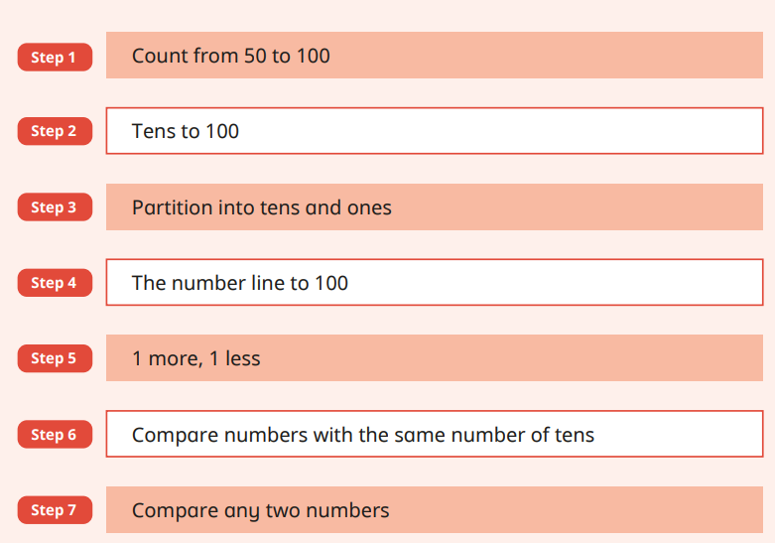

Multiplication and division | Fractions | Weight and volume
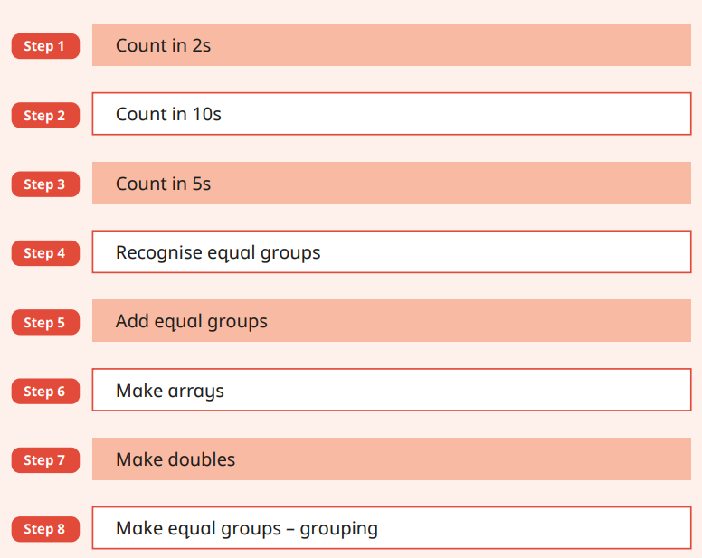 | 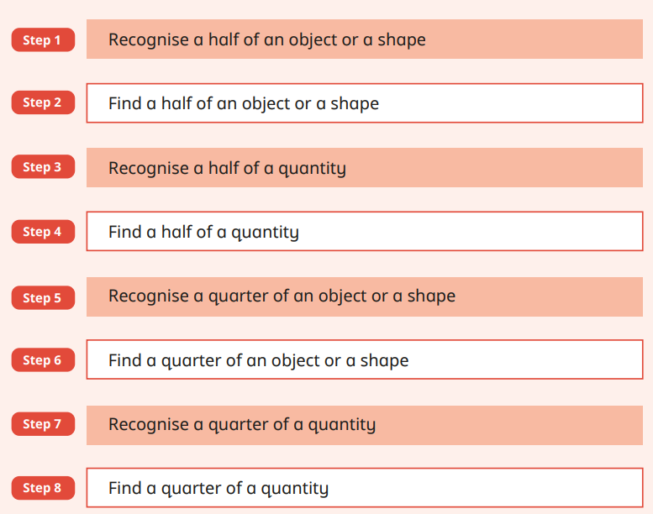 | 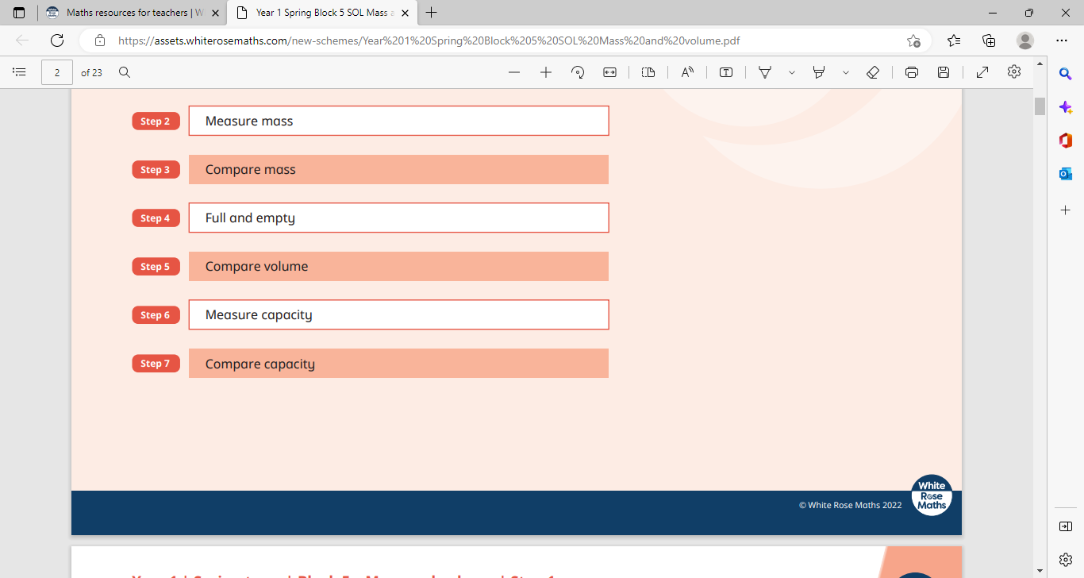
Money | Time | Position and Direction
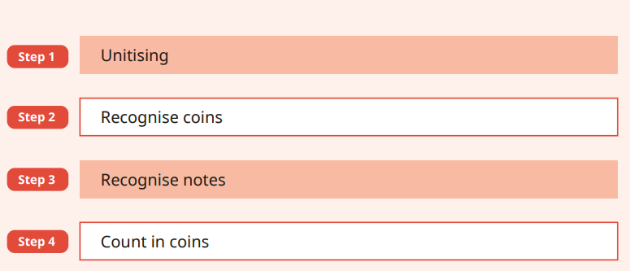 | 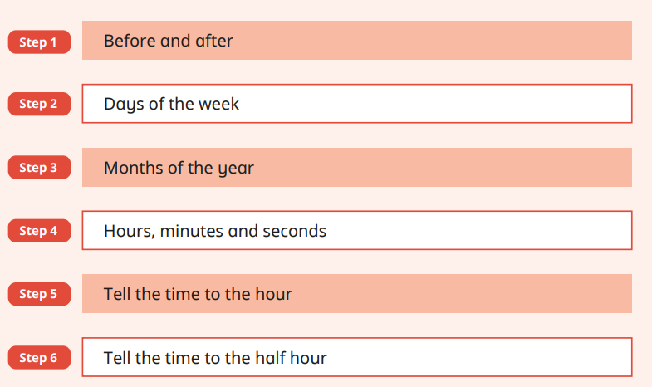 | 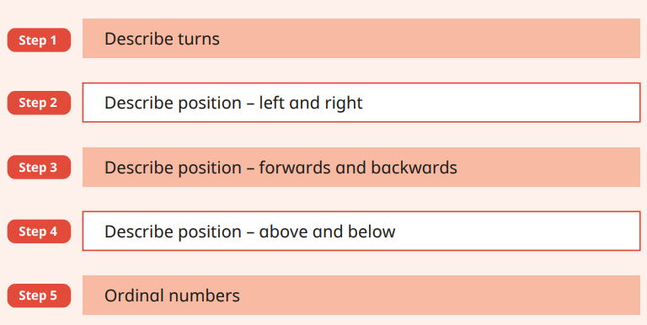
Year 2 small steps
Place value within 100 | Addition and subtraction | Money
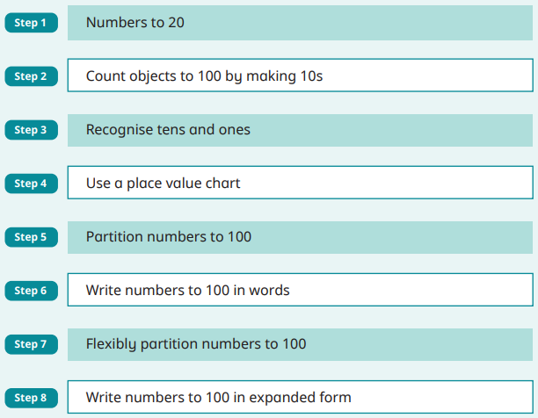  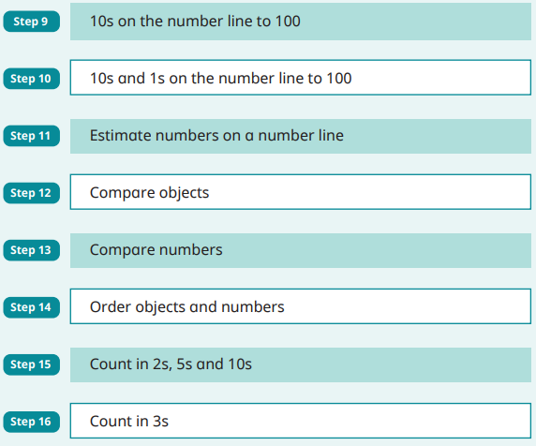 | 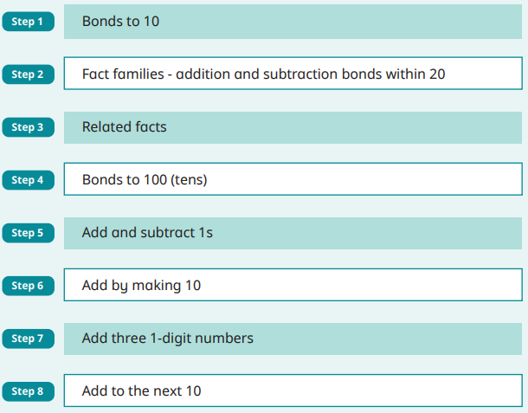  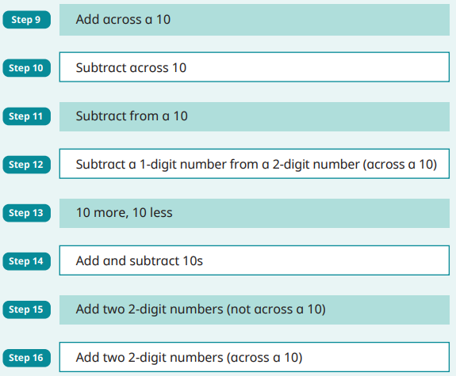  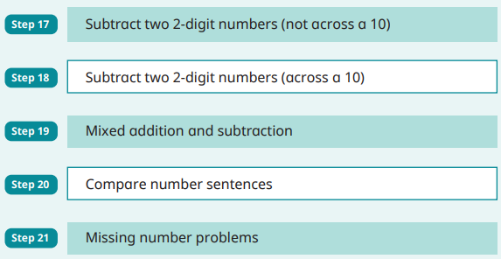 | 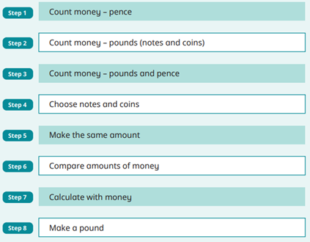  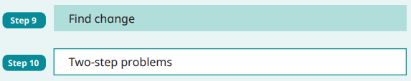
Multiplication and division | Statistics | Length and Height
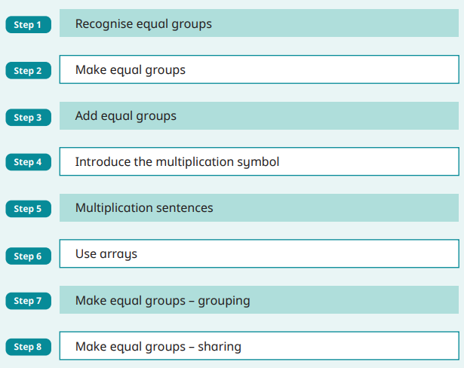  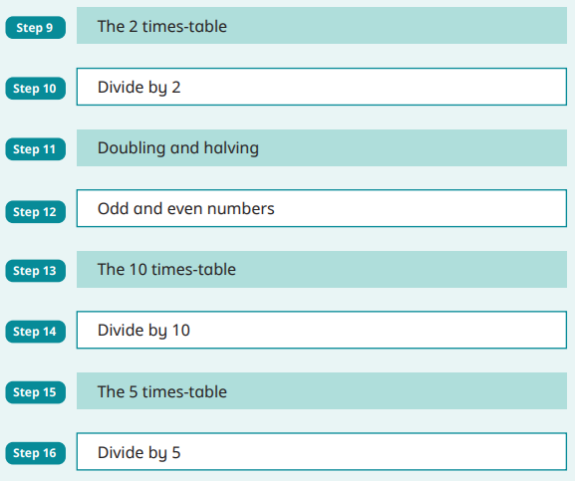  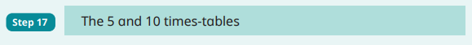 | 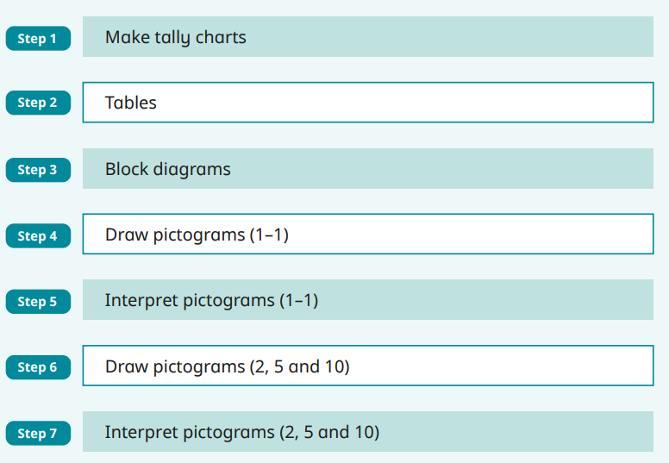 | 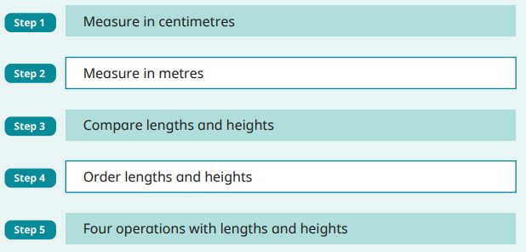
Shape | Fractions | Weight and volume
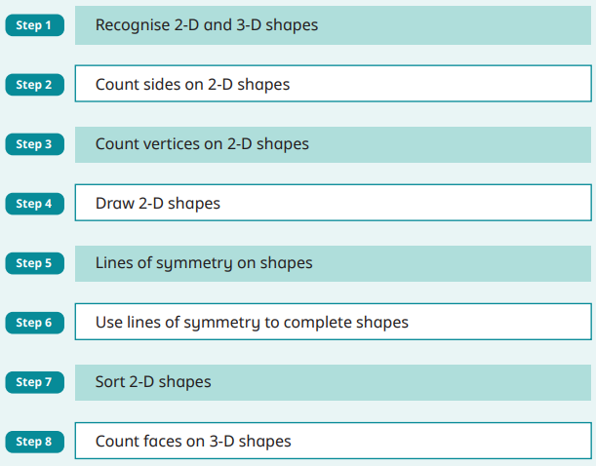  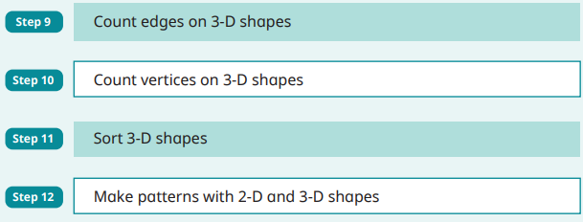 | 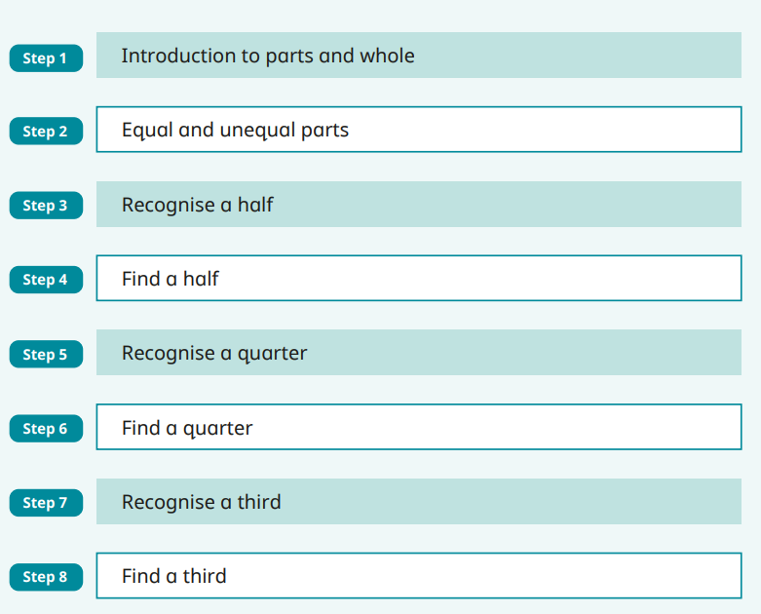  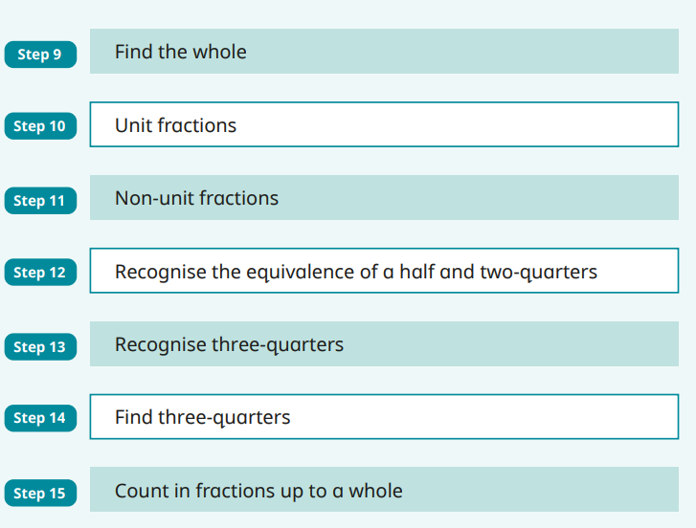 | 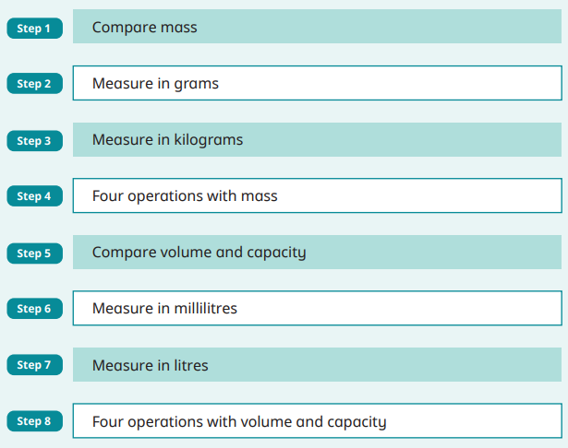
Time | Position and Direction
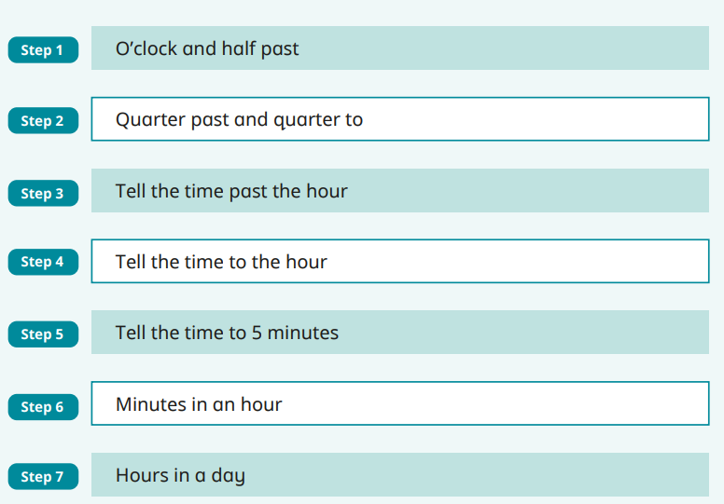 | 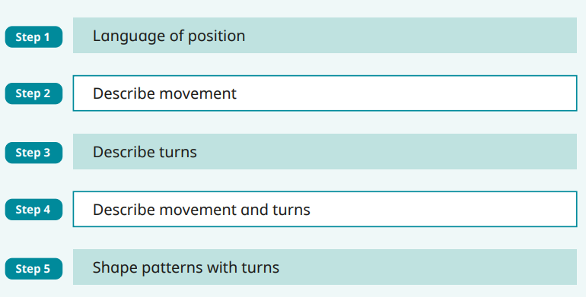

Smarties and F1
Autumn 1 | Autumn 2 | Spring 1 | Spring 2 | Summer 1 | Summer 2
Number rhymes and actions to 5.  Counting forwards and backwards 0-5 | Recognise and compose numbers 1-5 and link the number to the corresponding shape  Subitising  Explore numbers in the environment  . | Composition of numbers to 5 using a variety of concrete materials  Counting a quantity from a larger group  Biggest and smallest  More and less  Shapes – circle, square, triangle, rectangle and pentagon  Introduce the number line | Shapes in the environment  Patterns – AB  Patterns – descriptive language e.g. spotty stripy  Prepositions  opposites | Introduce number 6  Part, part whole model – with concrete materials numbers 2-5  Matching patterns  Size - order 3 objects and use mathematical language to describe  3D shapes – Cone, cube and sphere. | Describe a familiar route  Sequential langue – first, second, next and last.  3D shapes in the environment+  Consolidation time
Ongoing daily:
Revisit numbers daily
Register Maths – weather, day of the week, seasons, shape and number

Reception
Autumn 1 | Autumn 2 | Spring 1 | Spring 2 | Summer 1 | Summer 2
Recognise and compose numbers 0-5 (numerals)  Verbal counting 0-15  Represent numbers to 5  Compare numbers to 5  Recognise, match and sort objects  compare amounts and subitise to 5 | Recognise and compose numbers 0-10 (numerals) 1-8  Verbal counting 0-20  Represent number 6-10  Compare numbers 6-10  compare amounts and subitise to 5  Combine two amounts  making pairs  Shape – patterns and repeated patterns | Counting forwards and backwards from a given number, forwards within 20, backwards within 10. Stopping at a given number  Verbal counting 0-20, 10-0  Bonds to 5  Addition/subtraction= combine 2 groups to make a total and removing a given amount from one group.  Missing number to 10 alongside greater than, less than, the same as  1 more, 1 less to 10  Doubling | 2D and 3D shapes  Addition/subtraction= combine 2 groups to make a total and removing a given amount from one group. (add and subtract within 10)  Addition part-part whole 0-10  Comparing number to 10  recall bonds to 5  Bonds to 10  Halving numbers within 10  Odds and evens within 10  Verbal counting 1-30, 15-0 | Addition/subtraction= combine 2 groups to make a total and removing a given amount from one group, applying recall skills of bonds to 5 (add and subtract within 10)  Recall bonds to 10  Recall number facts 0-5 (bar models)  Verbal counting 1-40, 20-0  Recall and develop bond knowledge to 10  Length and height- comparing  Capacity-comparing capacity and mass | 2D and 3D shapes/ manipulation  Verbal counting 1-50, 20-0- stopping and starting at a given number.  Bonds to 10  Sharing equally between groups.  Recognise and compose numbers 0-10  depending understanding patterns and relationship.
Ongoing daily:
Time
Days of the week, seasons and sequencing
2D and 3D shape

Year 1
Autumn 1 | Autumn 2 | Spring 1 | Spring 2 | Summer 1 | Summer 2
Number: Place Value (within 10)  Number: Addition and Subtraction (within 10) | Number: Addition and Subtraction (within 10)  Geometry: Shape | Number: Place Value (within 20)  Number: Addition and Subtraction (within 20) | Number: Place Value (within 50) (Multiplies of 2,5,and 10 included)  Measurement: Length and Height  Measurement: Mass and Volume | Number: Multiplication and Division (Reinforce multiplies of 2,5 and 10 included)  Number: Fractions  Geometry: Position and Direction | Number: Place Value (within 100)  Measurement: Money  Measurement: Time
Year 2
Autumn 1 | Autumn 2 | Spring 1 | Spring 2 | Summer 1 | Summer 2
Number: Place Value (within 100)  Number: Addition and Subtraction (within 100) | Number: Addition and Subtraction (within 100)  Geometry: Properties of Shape | Measurement: Money  Number: Multiplication and Division | Measurement: Length and Height  Measurement: Mass, Capacity and Temperature | Number: Fractions  Measurement: Time | Statistics  Geometry: Position and Direction

