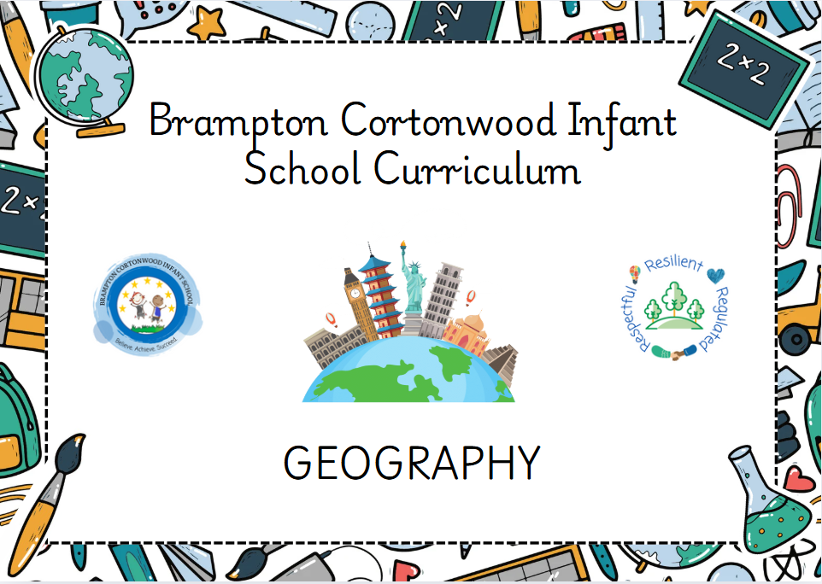
Cortonwood Infant and Nursery School

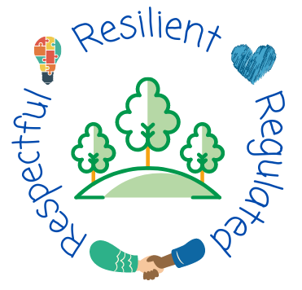
HANDWRITING
Handwriting progression of knowledge and skills across Early Years and Key Stage One

Sep 2023
Progression of knowledge and skills within Handwriting
July 2025

Handwriting
 | Physical fine motor skills
Smarties and F1  Children will know how to… | Composite:  >Pass things from one hand to the other. Let go of things and hand them to another person, or drop them. (EYFS Birth-Three)  >Build independently with a range of appropriate resources. (EYFS Birth-Three)  >Use large and small motor skills to do things independently, for example manage buttons and zips, and pour drinks. (EYFS Birth-Three)  >Show an increasing desire to be independent, such as wanting to feed themselves and dress or undress. (EYFS Birth-Three)  >Use one-handed tools and equipment, for example, making snips in paper with scissors. (EYFS Three to Four)  >Use a comfortable grip with good control when holding pens and pencils.(EYFS Three to Four)  >Show a preference for a dominant hand. (EYFS Three to Four)  >Be increasingly independent as they get dressed and undressed, for example, putting coats on and doing up zips. (EYFS Three to Four)  >Write some or all of their name. (EYFS Three to Four)  >Write some letters accurately. (EYFS Three to Four)
Smarties and F1  Children will know how to… | Components:  Practice writing their name using big chalks, large rollers, large paintbrushes.  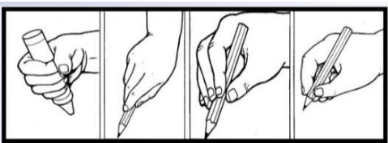  Complete funky finger activities including pincers, tweezers, scissors and weaving.  Complete dough disco sessions and squiggle while you wiggle.  Write some letters and learn that letters are part of families.  Practice putting on their coats and unzipping them before and after outdoor provision.  Use a palmer grasp, leading into early tripod grip, and tripod grip.  Access a writing table with name cards, tracing sheets and letter formation mats  *Children will be introduced to the movements associated with each letter family through mark making/squiggle while you wiggle
  Autumn  Curly caterpillar- c o a g q d e s f | Spring  Ladder letters- i u y l t j | Summer  One armed robot- r n m h b k p  Zigzag letters- v w x z
F2  Children will know how to… | Composite:  >Develop their small motor skills so that they can use a range of tools competently, safely and confidently. Suggested tools: pencils for drawing and writing, paintbrushes, scissors, knives, forks and spoons. (EYFS Reception)  >Use their core muscle strength to achieve a good posture when sitting at a table or sitting on the floor. (EYFS Reception)  >Develop the foundations of a handwriting style which is fast, accurate and efficient. (EYFS Reception)  >Form lower-case and capital letters correctly. (EYFS Reception)  > Hold a pencil effectively in preparation for fluent writing – using the tripod grip in almost all cases. (ELG)  >Use a range of small tools, including scissors, paint brushes and cutlery (ELG)  >Begin to show accuracy and care when drawing. (ELG)
F2  Children will know how to… | Components:  Use a range of tools (scissors, paintbrushes, pencils, knives, forks and spoons).  Sit at tables when writing to achieve good posture.  Practice handwriting and know the letters of each letter family;  Participate in ‘dough discos’ and ‘squiggle while you wiggle’.  Practice handwriting in provision.  Handwriting lessons ___ times per week where children will be taught how to write on a line and how to form each letter correctly  Model letter formation using correct terminology
  Autumn  Letter formation sessions to compliment phonics teaching.  s a t p i n m d g o c k e u r h b f l ll ss  j v w x y z zz qu ch sh th ng | Spring  Curly caterpillar- c o a g q d e s f  Ladder letters- i u y l t j  One armed robot- r n m h b k p  Zigzag letters- v w x z  *once all letters and words have been taught, staff should go back and teach a one-off lesson with all the letters from each family eg. c o a g q d e s f * | Summer 1  Cc Oo Aa Gg Qq Dd Ee Ss Ff Ii Uu Yy Ll Tt Jj Rr Nn Mm Hh Bb Kk Pp Vv Ww Xx Zz | Summer 2  car, oak, aim, goat, quiz, deep, ear, sort, fight, igloo, under, yell, look, town, join, ring, night, main, hair, barn, kerb, push, wow, zoom
Year 1  Children will know how to… | Composite:  cat, on, am, go, dog, egg, sat, fan, it, up, yet, leg, tap, jump, red, no, man, hat, bag, kick, pan, van, win, mix, zap  > sit correctly at a table, holding a pencil comfortably and correctly.  >Begin to form lower-case letters in the correct direction, starting and finishing in the  right place.  >Form capital letters.  >Form digits 0-9.  >understand which letters belong to which handwriting ‘families’ (i.e. letters that are  formed in similar ways) and to practise these.
Year 1  Children will know how to… | Components:  Complete handwriting lessons, 4 times a week whilst sitting upright at a table.  Form lower case letters and use the letter families to help with their position and direction.  Form capital letters through handwriting practice.  Practice writing number digits the correct way around.  Form and Position ‘tall ascenders’ and ‘long descenders’  Ensure correct seating position Bottom Back in Chair  Model letter formation using correct terminology
  Autumn  Curly caterpillar- c o a g q d e s f  Ladder letters- i u y l t j  One armed robot- r n m h b k p  Zigzag letters- v w x z  come, of, are, go, quiz, do, ear, said, full, into, under, you, love, they, jump, road, no, my, he, be, ask, push, where, visit, x ray, zoom  *once all letters and words have been taught, staff should go back and teach a one off lesson with all the letters from each family eg. c o a g q d e s f * | Spring  Cc Oo Aa Gg Qq Dd Ee Ss Ff Ii Uu Yy Ll Tt Jj Rr Nn Mm Hh Bb Kk Pp Vv Ww Xx Zz  Carl, Oliver, Adam, Glen, Dale, Erin, Sam, Finn, Indie, Una, Yasmin, Lee, Tom, Jay, Rose, Nick, Matt, Hope, Ben, Karl, Paul, Vera, Wilma, Zane  Names, places, months, days | Summer 1  play, cake, hatch, sea, happy, bear, Pete, cried, ice, toes, grow, rose, glue, rescue, flew, news, tube, flute, boys, bird, yawn, launch, count, sink, drive, scare, stayed, wheel, phone, bread, shield, sore | Summer 2  Plurals  Prefix ‘un’ words  Common exception words  High frequency words
Year 2  Children will know how to…. | Composite:  > Form lower-case letters of the correct size relative to one another.  > Start using some of the diagonal and horizontal strokes needed to join letters and  understand which letters, when adjacent to one another, are best left un-joined.  >Write capital letters and digits of the correct size, orientation and relationship to one  another and to lower case letters.  >use spacing between words that reflects the size of the letters.
Year 2  Children will know how to…. | Components:  Complete handwriting lessons, 4 times a week whilst sitting upright at a table.  Form lower-case letters and use the handwriting ‘families’ to ensure letters are formed correctly and in the correct position.  Practice forming their letters with ‘tall ascenders’ and ‘long descenders’  Join up some letters using the cursive script if greater depth  Identify letters that don’t require a join and know that capital letters don’t need a leading stroke or join.  Ensure correct seating position. Model letter formation using correct terminology
  Autumn  Curly caterpillar- c o a g q d e s f  Ladder letters- i u y l t j  One armed robot- r n m h b k p  Zigzag letters- v w x z  class, old, after, gold, queen, door, every, should, find, improve, unhappy, yellow, last, today, jogging, running, nodded, mind, hour, because, kind, pretty, water, vowel, mixture, zebra  *once all letters and words have been taught, staff should go back and teach a one off lesson with all the letters from each family eg. c o a g q d e s f * | Spring  Cc Oo Aa Gg Qq Dd Ee Ss Ff Ii Uu Yy Ll Tt Jj Rr Nn Mm Hh Bb Kk Pp Vv Ww Xx Zz  Charlie, Oliver, Alex, Grace, Drew, Edward, Summer, Fletcher, India, Umar, Yasmin, Lucy, Theo, James, Ruby, Nancy, Morgan, Harry, Bruce, Kevin, Paul, Victoria, Willow, Zack  Names, places, months, days | Summer 1  playing, cakes, hatched, eating, lucky, bears, compete, cried, likes, tomatoes, yellow, roses, clues, rescuing, chewing, newspaper, June, cubes, enjoyed, skirts, yawning, haunted, counting, gloves, scared, spotted, whales, phoning, bread, thieves, chores | Summer 2  Contracted words  Homophones  Suffix ending words  Plurals  Prefix ‘un’ words  Common exception words  High frequency words

