SEND Policy
A Graduated Response

Updated for: | September 2026
Next review: | September 2027

James Montgomery Academy Trust


SEND Policy
A Graduated Response

1. Statement of intent
The James Montgomery Academy Trust (JMAT) is committed to ensuring that all children, including those with Special Educational Needs and Disabilities (SEND), receive a high-quality, inclusive education that enables them to achieve their best possible outcomes and prepares them for life.
We will:
- Use our best endeavours to meet the needs of all children with SEND
- Ensure children with SEND participate fully in school life
- Promote equality of opportunity in line with the Equality Act 2010
- Work in partnership with parents, carers, and external agencies
- Ensure children’s views are central to decision-making
This policy operates in conjunction with the individual school’s SEND Information Video which is displayed on individual school websites and is linked to the LA local offer.
This policy complies with:
- Children and Families Act 2014
- SEND Code of Practice: 0–25 years (2015)
- Equality Act 2010
- SEND Regulations 2014
- Keeping Children Safe in Education (latest version)
- Working Together to Safeguard Children
The policy has regard to Working Together 2026 and Keeping Children Safe in Education (KCSiE) 2026. Where SEND and safeguarding intersect, the DSL and SENDCo will coordinate actions in line with statutory guidance.
2. Identifying SEND
JMAT has a clear approach to identifying and responding to SEND. We recognise the benefits of early identification: identifying need at the earliest point and then making effective provision improves long term outcomes for the child.
Teaching staff, supported by the senior leadership team, make regular assessments of progress for all children. These seek to identify children making less than expected progress given their age and individual circumstances.

Identification will draw on- concerns raised by staff or parents, termly tracking of progress, standardised and diagnostic assessments, information from previous settings and external professionals and observation. All identification must be recorded on the child’s SEND file.
3. Definition
The SEND Code of Practice states that all children should have access to ‘high quality teaching that is differentiated and personalised, which will meet the individual needs of the majority of children and young people. Some children and young people need educational provision that is additional to or different from this. This is special educational provision under Section 21 of the Children and Families Act 2014. Schools and colleges must use their best endeavours to ensure that such provision is made for those who need it. Special educational provision is underpinned by high-quality teaching and is compromised by anything less.’
A child has SEND if they have a learning difficulty or disability that calls for special educational provision to be made for them. The Code of Practice breaks down SEND into four broad areas:

- Communication and Interaction needs.
- Cognition and Learning difficulties.
- Social, Emotional and Mental Health Difficulties.
- Sensory and or Physical needs.
4. Graduated approach
We use a graduated approach (Assess → Plan → Do → Review) to support children with SEND.
The JMAT graduated approach involves the following processes:
- Assess: gather and record multi-source evidence including teacher assessment, screening/diagnostic tools, behaviour and attendance data, and views of parents/child.
- Plan: produce an individual plan that is outcome focused, specifying short-term targets, provision, staff responsible and review date.
- Do: deliver and record targeted provision, interventions and reasonable adjustments; ensure class teacher remains responsible for day-to-day provision.
- Review: evaluate impact at least termly (three times a year) and update the plan. Where progress is not sufficient, convene an earlier review and consider an EHC needs assessment.

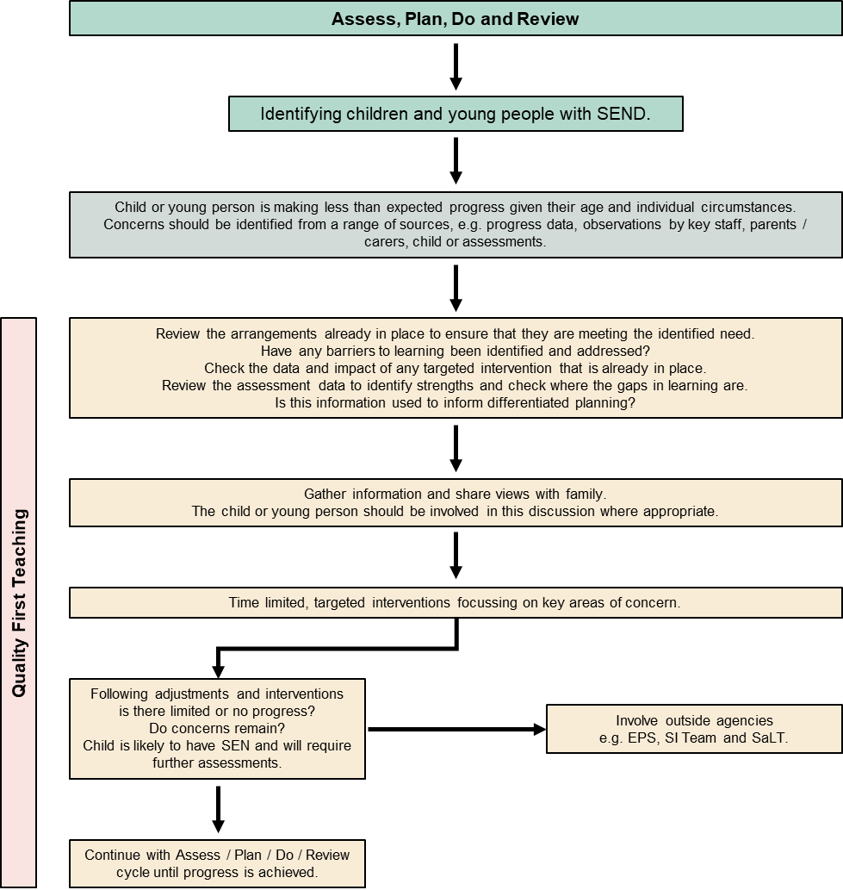

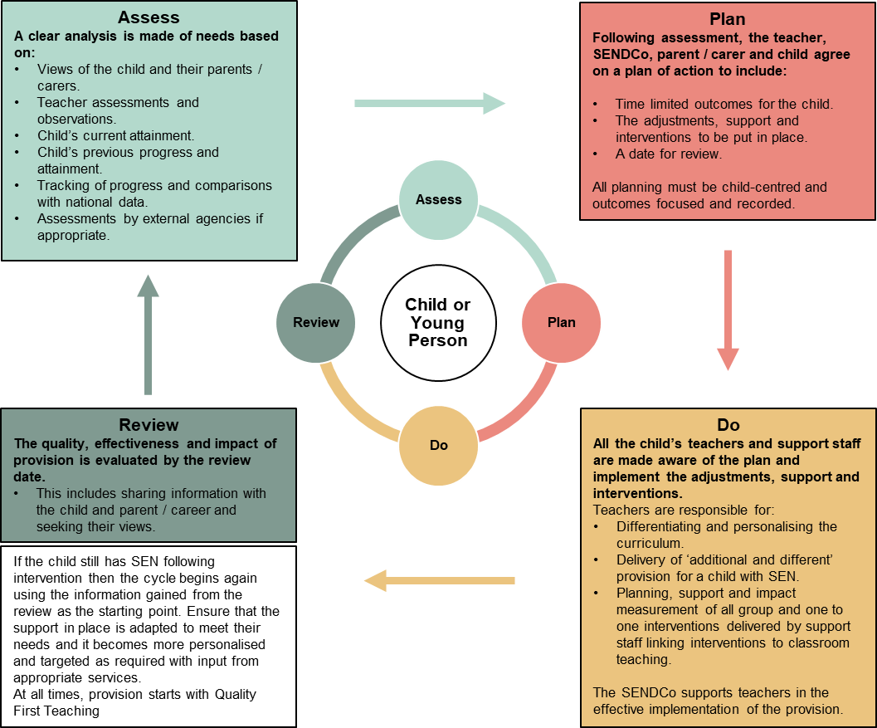

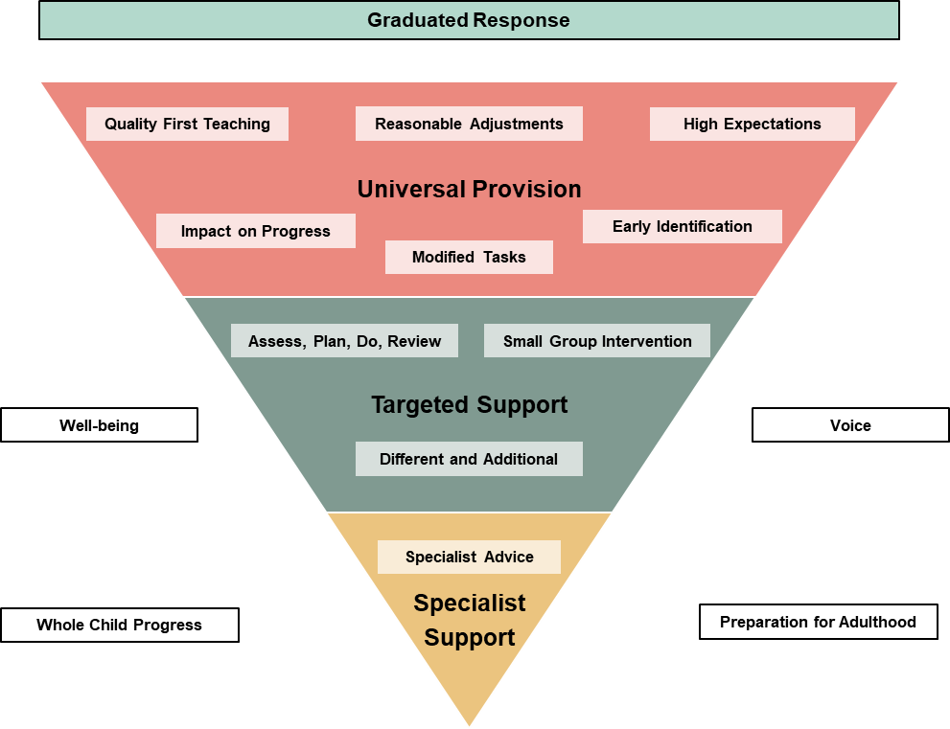
All recording of plans and assessments is completed and compliant with the JMAT GDPR policy.
Within JMAT, schools will endeavour to use the following graduated response in providing support for children:
Universal provision (High-Quality Teaching)
- Adapted curriculum and inclusive teaching
- High expectations for all children
- Reasonable adjustments implemented
Targeted support
- Time-limited small group or individual interventions
- Additional support beyond classroom adaptations
Individualised / specific support
- Individualised support plans
- External agency involvement
Education Health Care Plan (EHCP)
Where a child’s progress continues to be a concern under formal support, a request can be made to the Local Authority which may result in an Educational Health Care Plan- https://www.rotherhamsendlocaloffer.org.uk/education-and-health-care-plans/ . These plans are statutorily reviewed annually in conjunction with the Local Authority. The SEND support plan, part of the support structure of (EHC) will continue to be reviewed termly.
All school based individual plans must record-baseline attainment, assessed need, agreed outcomes, planned provision (what, who, how often), staff responsible, review date and evidence of impact. Plans must be reviewed at least termly and formally three times per year; annual reviews for children with EHC plans will be carried out within statutory timescales. The SENDCo will ensure all documentation supporting an EHC needs assessment is maintained and available.
All support plans, whether SEND or EHCP must be reviewed and amended in sufficient time prior to children moving between key phases of education.
5. Identifying SEND
We identify SEND through:
- Teacher assessment and ongoing monitoring
- Progress data and attainment gaps
- Observations and concerns raised by staff, parents, or pupils
- Screening tools and specialist assessments
We ensure:
- Early identification
- Accurate differentiation between SEND and other factors e.g. English as an Addition Language (EAL)
- Where a child is identified as requiring additional support, the class teacher and SENDCo will agree time limited interventions and monitoring. All interventions must be recorded on the Trust provision map and evaluated for effectiveness.
All JMAT schools have a SEND Information Video on the website (link). This video explains how SEND provision is implemented. Where outcomes are not being achieved, provision is reviewed and adjusted. All children with SEND are included in trips, clubs and wider school life.

6. Involving parents, carers and children
We are committed to co-production. We will:
- Involve parents/carers at all stages of decision-making
- Provide clear communication about support and progress
- Hold regular review meetings
- Ensure pupils' views are captured and acted upon
- Use person-centred planning approaches
- Ensure parents receive copies of plans, evidence of impact and invitations to review at least termly. The school must record parental contributions and any external advice provided by parents and include it with the child’s records.
7. Roles and responsibilities
Trust SEND and Inclusion Lead
- Ensure statutory compliance
- Monitor effectiveness of SEND provision
Headteacher
- Overall responsibility for SEND provision
- Ensure policy implementation and resource allocation
The Special Educational Needs and Disability Co-Ordinator (SENDCo)
- Hold the National Award for SEN Coordination (NASENCo or NPQSEN) or be enrolled on the qualification and working towards it within an agreed timescale; the SENDCo must be allocated protected time to carry out statutory duties
- Lead and manage SEND provision
- Advise staff and liaise with external agencies
- Maintain SEND register and records
- Co-ordinating support for children with SEND which includes any technology, accessibility tools, or environmental adaptations.
- Liaising with other school SENDCos to ensure smooth transitions.
- Liaising with external specialist support services.
- Keeping up to date with legislation and policy changes.
- Ensuring their CPD by keeping up to date with relevant developments and LA initiatives.
- The SENDCo is the key operational lead for EHC needs assessment submissions, annual reviews and multi-agency liaison. Contact details for each school SENDCo must be published in the school’s SEN Information Report on the website
Class teachers
- Responsible for the progress of all children
- Deliver high-quality, inclusive teaching
- Implement SEND support and interventions
- Having an awareness and understanding of the SEND Policy.
- Raising concerns with the school SENDCo and working to address these concerns.
- Liaising with support staff to deliver specific and targeted interventions.
- Keeping records related to the concerns raised, noting interventions, actions, consultations and evaluations.
- Giving feedback to parents/carers and children and young people related to issues of SEND and general progress.
- Delivering interventions in co-ordination with the SENDCo and Specialist Support Services.
Teaching assistants / support staff
- Being aware of the SEND Policy and procedures.
- Liaising with class teachers to discuss support packages, procedures and child’s response to interventions.
- Ensuring that the support offered encourages independence.

Safer recruitment and staff checks:
All staff working with children with SEND must appear on the Single Central Record (SCR) with evidence of relevant checks (DBS, identity, right to work). The school will ensure records of training and competency for specialist provision (e.g. moving and handling, behaviour support techniques) are retained.
8. Managing SEND Support
All children receiving SEND support will have:
- A clear plan outlining needs, provision, and outcomes
- Regular Assess-Plan-Do-Review cycles
- Monitoring of progress and impact
- Adjustments made as needed
Records and confidentiality:
All SEND documentation (plans, reviews, external reports) will be stored securely on the child’s file in accordance with UK GDPR and Trust retention schedules. Parents have the right to access their child’s records and the school will provide copies within statutory timescales.
9. Accessibility and Inclusion
JMAT schools comply with the Equality Act 2010 by:
- Making reasonable adjustments
- Providing inclusive learning environments
- Maintaining an Accessibility Plan (published separately)
- Each school will publish its Accessibility Plan and review it annually- the Trust SEND and Inclusion Lead will monitor implementation. Accessibility considerations must be included in individual plans where relevant.
10. Safeguarding and SEND
We recognise that children with SEND may be more vulnerable. We will:
- Ensure safeguarding procedures consider SEND needs
- Train staff to recognise additional risks
- Link SEND provision to the safeguarding policy
- Where SEND and safeguarding concerns overlap, the SENDCo and DSL will coordinate actions and ensure information is shared lawfully with social care as appropriate (Working Together 2026 / KCSiE 2026).
11. Supporting children with medical needs
We will:
- Follow DfE guidance on supporting children with medical conditions
- Use the Trust's ‘supporting children with medical needs and procedures policy’
- Implement individual healthcare plans where required
- Healthcare plans will be cross-referenced with SEND plans where necessary and retained on both the medical and SEND record. Parental permission for medical treatment and medicine administration will be recorded and retained.
12. Working with external agencies
We work collaboratively with:
- Local Authority services
- Educational psychologists
- Health professionals
- Social care teams
The SENDCo will coordinate external involvement and retain clear records of all reports and advice used to inform school plans. Where disagreements occur, the school will follow the school to dispute resolution and mediation processes and advise parents of SENDIASS and LA appeal routes.
13. Transition arrangements
We support children through key transitions:
- Early Years to primary
- Year-to-year progression
- Primary to secondary
This includes:
- Sharing information with receiving settings
- Additional visits and transition support plans
For transfer to secondary the SENDCo will ensure:
(a) transfer meeting with receiving setting held in Y6 spring term
(b) SEND folder (plans, assessments, medical info) shared with parental consent
(c) additional visits and social stories arranged
(d) named contact at receiving setting confirmed.
Transfers between MAT schools must follow JMAT’s transfer process and ensure planned review prior to moving.
14. Monitoring and evaluation
We monitor the quality of SEND provision through:
- Data analysis
- Provision mapping
- Work scrutiny
- Child and parent feedback
- Trust SEND review every 2 years.
The SENDCo will provide numbers on SEND register, numbers with EHCPs, progress against targets, attendance and exclusions for children with SEND, staff training completed and external agency involvement. The Trust SEND and Inclusion strategic lead will conduct sampling audits.
15. Complaints procedure
If parents/carers have concerns:
- Speak to the class teacher
- Contact the SENDCo
- Escalate to the Headteacher
- Follow the school’s formal complaints policy
Support is also available via:
- Local Authority SEND services:
Rotherham Local Offer: Rotherham SEND Local Offer – Here you will find help, advice and information about the services available for your child or young person from birth to 25 years with a Special Educational Need or Disability (SEND).
Barnsley Local Offer: Special educational needs and disabilities (SEND)

- SEND Information, Advice and Support Services (SENDIASS):
Rotherham SENDIASS - Homepage – Rotherham SENDIASS
Barnsley SENDIASS - Barnsley SENDIASS
- Where complaints relate to EHC needs assessments or annual reviews, parents will be advised of mediation services and statutory appeal routes to the SEND Tribunal.
16. Monitoring and review
This policy will be reviewed annually by the Strategic Lead for SEND and Inclusion and the review date is September each year. Any substantive changes to statutory guidance will trigger an immediate policy update. The policy and each school’s SEN Information Video will be published on the school’s website.
17. Document history
Previous versions archived in accordance with document retention requirements.
Issue | Author/ Owner | Date  Reviewed | Reviewed  by | Approved by  A&R Committee  (date) | Comments/ Changes
V1 | JMAT | July 2025 | PRG | 08/07/25 | - Section 6 – removal of governor responsibilities.  - Change of title – addition of ‘A graduated response’
V2 | JMAT | July 2026 | PRG | 09/07/26 | - SENDCo NASENCO made explicit (SEND Code expectation and inspection focus).  - Added mandatory fields and termly review requirement so evidence for EHC requests is auditable.  - Record keeping, GDPR, transition and cross-referencing to health plans: clarified storage, sharing and review responsibilities.  - Cross-referenced KCSiE and Working Together 2026 where SEND and safeguarding interact.  - Personalised at school level.

Key:
PRG – Policy Review Group
A & R Committee – Audit and Risk Committee

