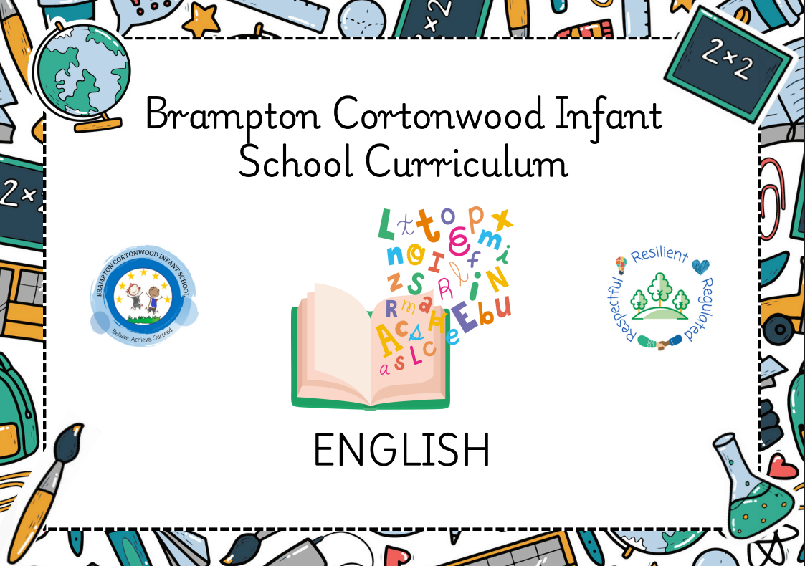
Nursery (F1)

Term | Autumn 1 |  |  |  |  |  |  |  | Autumn 2
Topic | Incredible Me |  |  |  |  |  |  |  | Celebrations
 | Poetry Basket - Leaves are Falling |  |  |  |  |  |  |  | Poetry Basket- Breezy Weather
Weeks | 1 | 2 | 3 | 4 | 5 | 6 | 7 |  | 1 | 2 | 3 | 4 | 5 | 6 | 7
Text/Stimulus | Whiffy Wilson- A wolf that wouldn’t go to school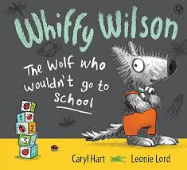 | Harry and the dinosaurs go to school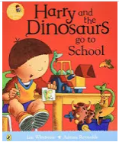 | Colour monster goes to school  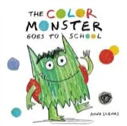 | Making friends  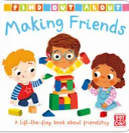 | Families  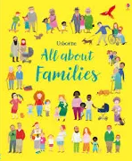 | My amazing body  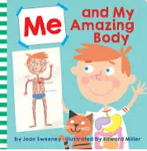 | Whiffy Wilson  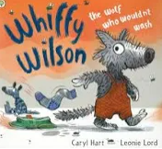 |  | Room on a broom  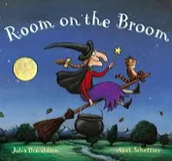 | We’re going on a leaf hunt  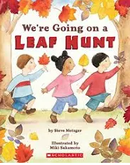 | Leaf Man  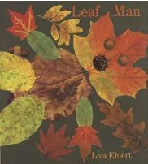 | How to catch a star  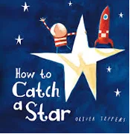 | It was a cold dark night  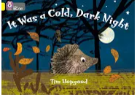 | Nativity  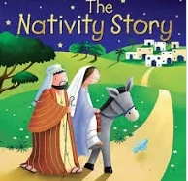 | Stickman  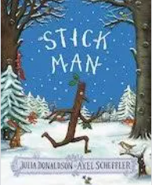

Term | Spring 1 |  |  |  |  |  |  |  |  | Spring 2
Topic | Winter Wonderland |  |  |  |  |  |  |  |  | Traditional Tales
 | Poetry Basket - Popcorn, I can Build a Snowman |  |  |  |  |  |  |  |  | Poetry Basket - Pancakes
Weeks | 1 | 2 | 3 | 4 | 5 | 6 | 7 |  | 1 |  | 2 | 3 | 4 | 5 | 6 | 7
Text/Stimulus | Say hello to the snowy animals  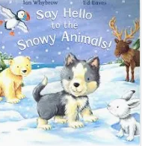 | Jack Frost  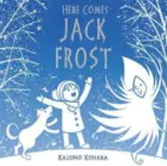 | Gruffalo’s child  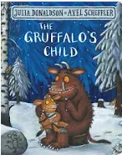 | Ridiculous  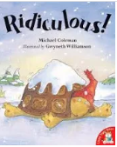 | Harry and the snow king  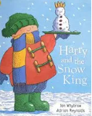 | Chinese New Year  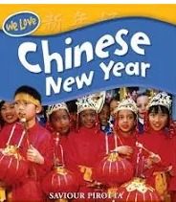 | Linked to children’s interest |  | Mr Wolf’s pancakes  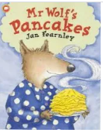 |  | Once upon a time  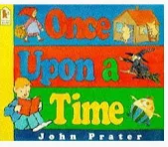 | The three little pigs  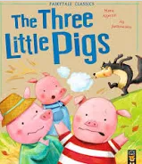 | The gingerbread man  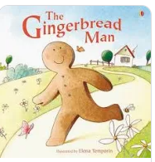 | Goldilocks and the three bears  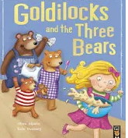 | Magic Key adventures  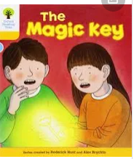

Term | Summer 1 |  |  |  |  |  |  |  |  | Summer 2
Topic | Roots, Shoots and Juicy Fruits |  |  |  |  |  |  |  | Under the Sea
 | Poetry Basket - Five little Peas |  |  |  |  |  |  |  | Poetry Basket- Buzzy Bees
Weeks | 1 | 2 | 3 | 4 | 5 | 6 | 7 |  |  | 1 | 2 | 3 | 4 | 5 |  | 6 | 7
Text/Stimulus | Oliver’s vegetables  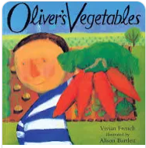 | Titch  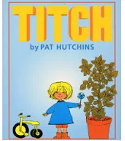 | Tiny seed  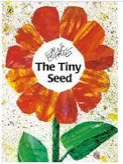 | Bee  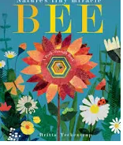 | Hungry caterpillar  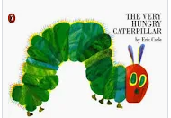 | Handa’s surprise  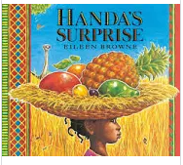 | Which food will you choose?  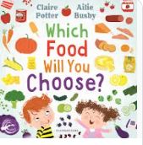 |  |  | Commotion in the ocean  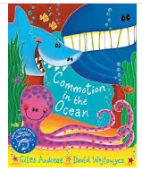 | Little people, big dreams David Attenborough  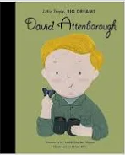 | Sharing a shell  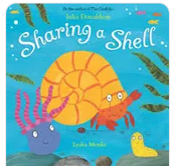 | Snail and the whale  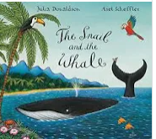 | What the ladybird heard at the seaside  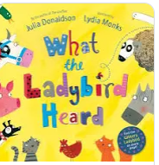 | The lighthouse keeper’s lunch  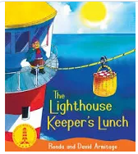

Reception (F2)
Term | Autumn 1 |  |  |  |  |  |  |  |  |  |  |  |  |  |  |  |  | Autumn 2
Topic | Marvellous me! |  |  |  |  |  |  |  |  |  |  |  |  |  |  | Celebrations
 | Poetry Basket- a basket of apples |  |  |  |  |  |  |  |  |  |  |  |  |  |  |  | Poetry Basket - Five little pumpkins
Weeks | 1 |  | 2 |  | 3 | 4 |  | 5 |  | 6 |  |  |  |  |  |  |  | 1 |  |  |  |  | 2 |  | 3 |  |  | 4 |  |  | 5 | 6
Text/Stimulus | What makes me a ‘me’?  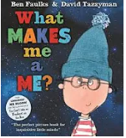 |  | Home  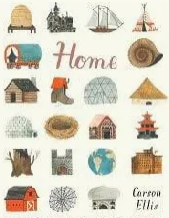 |  | The Little Red Hen  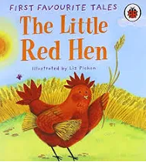 |  |  | Owl Babies  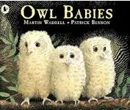 |  | Pumpkin soup  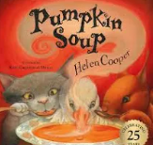 |  |  |  |  |  |  |  | Bonfire Night- Non-fiction  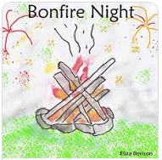 |  |  |  |  | Rama and Sita  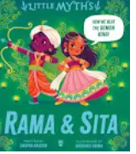 |  | The Squirrels who Squabbled  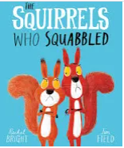 |  |  | The Christmas story  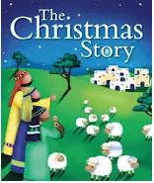 |  |  | Jolly Christmas Postman  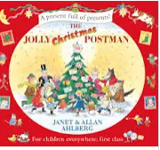
Term | Spring 1 |  |  |  |  |  |  |  |  |  |  |  |  |  |  |  |  |  | Spring 2
Topic | Amazing animals in winter |  |  |  |  |  |  |  |  |  |  |  |  |  |  |  | Down on the Farm
 | Poetry Basket - Furry Furry Squirrel |  |  |  |  |  |  |  |  |  |  |  |  |  |  |  | Poetry Basket - Spring Wind
Weeks | 1 | 2 |  | 3 |  |  | 4 |  | 5 |  | 6 |  |  |  |  |  |  |  |  |  | 1 | 2 |  | 3 |  | 4 | 5 |  |  | 6
Text/Stimulus | Lost and found  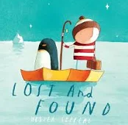 |  |  | Animals in winter  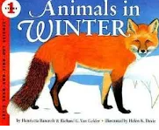 |  |  | The Great explorer  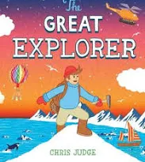 |  | Harry and the bucketful of dinosaurs  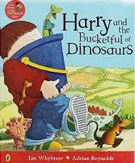 |  | Mary Anning  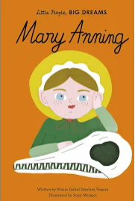 |  |  |  |  |  |  |  |  | What the ladybird heard  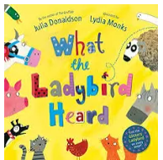 |  |  |  | What the ladybird heard next  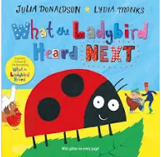 |  | The three Billy goats gruff  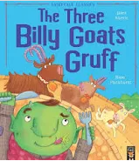 |  |  | 1001 things to spot on the farm  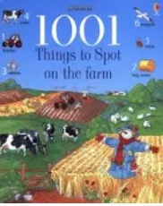

Term | Summer 1 |  |  |  |  |  |  |  |  |  | Summer 2
Topic | Plants |  |  |  |  |  |  |  | Across the sea
 | Poetry Basket - Five little Owls |  |  |  |  |  |  |  |  | Poetry Basket - Dance
Weeks | 1 | 2 | 3 | 4 | 5 | 6 | 7 |  |  |  |  | 1 | 2 | 3 | 4 | 5 | 6
Text/Stimulus | Jack and the Beanstalk  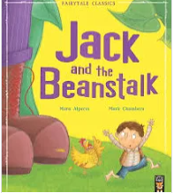 |  | Oliver’s fruit salad  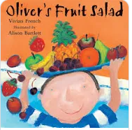 |  | Mabel’s magic garden  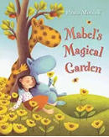 | From seed to sunflower  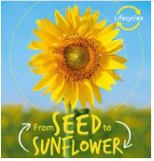 | From egg to chicken  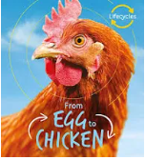 |  |  |  |  | The Three Little Pigs  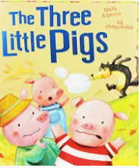 |  | Zog  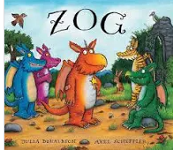 | Coming to England  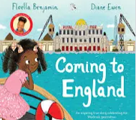 | Transition  Revisiting favourite texts from the year

Year 1
Term | Autumn 1 |  |  |  |  |  |  |  |  |  |  |  |  |  |  |  |  | Autumn 2
Topic | Myself and my community- Our Village Brampton |  |  |  |  |  |  |  |  |  |  |  |  |  |  | Celebrations- Let’s Celebrate
Weeks | 1 |  | 2 | 3 |  |  | 4 | 5 |  | 6 |  |  | 7 |  |  |  |  | 1 |  | 2 |  |  | 3 |  |  | 4 |  |  | 5 | 6 |  |  | 7
 | Poetry- Down in Brampton Village |  |  |  |  |  |  |  |  |  |  |  |  |  |  |  |  | Poetry- Five Little Senses all in a Row (Andrew Peters)
Text/Stimulus | All About Me  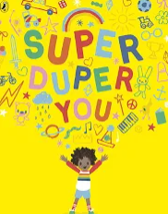 |  | Town is by the sea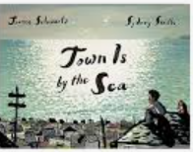 |  |  |  | The Smile Shop  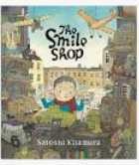 | In every house on every street  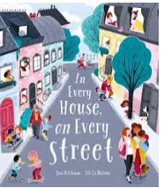 |  | The Street Beneath my Feet  Local Walk  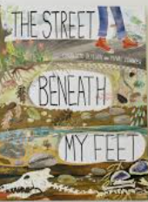 |  |  |  |  |  |  |  | Bonfire night  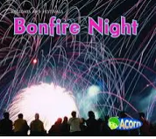 |  | When I was a child  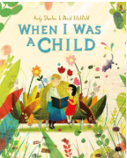 |  |  | Daisy Saves the Day  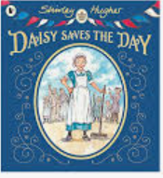 |  |  |  |  |  | Pantomime  Jack and the beanstalk  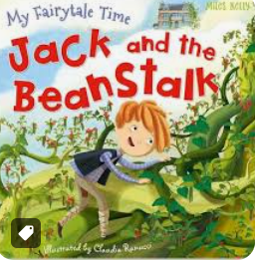
Genre | Writing simple sentences about myself using ‘I’ |  | Setting description  Character description  Written in 1st person  (I have a thin body and I have tiny, black freckles)  Story retell in first person  (I woke up early in the morning and the sun was shining brightly) |  |  |  | Character description in first person  Setting description  (There is a brown, creepy wolf. There is a steaming fire. There is a gloomy forest). |  |  | Character description  (I can see a…)  Story Retell in 3rd person  (First the boy, then she, next he) |  |  |  |  |  |  |  | Character description about Guy Fawkes written in 3rd person (Guy Fawkes had a tall hat and he had a scraggy shirt).  Recount of an experience in 1st person linking to the five senses (I can see sparkly fireworks, I can hear…) |  |  |  |  | Setting description in 1st person  (In my bedroom I have… and I have…)  Story retell in 1st person (First I go to London and I start my new job). |  |  |  |  |  | Letter with personal description and instructions to Santa from yourself  Character description written in 3rd person  (The giant had black, matted hair and a large nose)  Narrative- story of Jack and the Beanstalk
Term | Spring 1 |  |  |  |  |  |  |  |  |  |  |  |  |  |  |  |  |  | Spring 2
Topic | Explore- Ready for Take Off! |  |  |  |  |  |  |  |  |  |  |  |  |  |  |  | Animals- All Creatures Great and Small
Weeks | 1 | 2 |  |  |  | 3 |  | 4 | 5 |  |  | 6 |  |  |  |  |  |  | 1 | 2 |  | 3 |  | 4 |  |  | 5 |  |  |  | 6
 | Poetry- Aliens Stole my Underpants (Brian Moses) Neil Armstrong (John Foster) |  |  |  |  |  |  |  |  |  |  |  |  |  |  |  |  |  | Poetry- Penguins on ice (Celia Warren)  Easter Poem- This Easter Time
Text/Stimulus | Look up  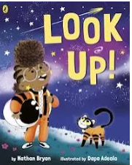 |  |  |  | Astrogirl  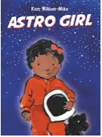 |  |  | The Way Back Home  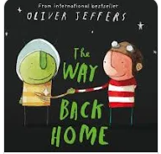 |  |  | The Snail and the Whale  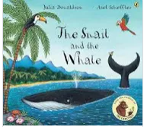 |  |  |  |  |  |  |  | Lost and Found  Yorkshire Wildlife Park  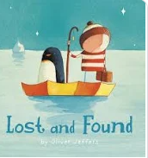 |  | Non-fiction texts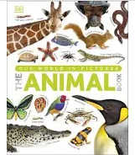 |  |  |  | How to heal a broken wing  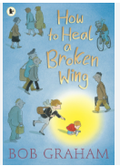 |  |  | Meercat Mail  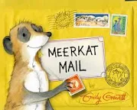 |  |  |  | Gorilla  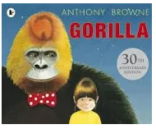
Genre | Fact file about the Wright brothers  -who are they?  -what did they do?  -when did it happen?  -how far did they fly?  Design a character and write a character description in 3rd person  (Betsy is an astronaut and she has blonde hair)  Story in the style of your created character (Betsy loves to look up and see the stars) |  |  |  | Setting description in 2nd person (you will see… you can see)  Advert advertising space  (In space you will see)  Letter to friend from ‘Neil Armstrong’ |  |  | Section of a story in 1st person (I found a red aeroplane in the cupboard)  List- 10 things I would take to space in my rocket  Letter written in the past tense to a family member from yourself (I found a red aeroplane but suddenly the plane started to splutter)  Instructions for how to make a shape rocket  Instructions for how to fix the spaceship |  |  | Diary entry from the perspective of a character with verb phrases (screeching seagulls, flashing lightening, growling bear) |  |  |  |  |  |  |  | Descriptive poster in 1st person  (I have found a penguin. He has a black body and he is feeling sad).  Descriptive writing  (It has eight legs and it is a carnivore). |  | Newspaper report about a animal experience they have had (On Monday some animals came to Cortonwood) |  |  |  |  |  |  | Character description in 3rd person (On Monday Sunny went to his uncle Bob’s house but…)  Recount from a characters perspective (On Monday I met up with my cousin and I…)  Postcard to mum and dad from Sunny (I arrived at Uncle Bob’s house) |  |  |  | Setting description in 3rd person  (Hannah could see a ….)  Narrative- story  Create their own character and write a character description  (He has…, he lives in)  Instructions  How to wash the character they created (First put him in the bath, Then…)

Term | Summer 1 |  |  |  |  |  |  |  |  |  | Summer 2
Topic | Plants- Seeds, Soil and Sunshine |  |  |  |  |  |  |  |  | Our World- Brilliant Beaches
Weeks | 1 | 2 | 3 |  |  | 4 | 5 | 6 |  |  |  | 1 | 2 | 3 | 4 | 5 | 6
 | Poetry- The Caterpillar Fair (Irene Rawnsley) |  |  |  |  |  |  |  |  |  |  | Poetry- The Seaside (Jo Peters)
Text/Stimulus | Butterfly life cycle project  Non-fiction books 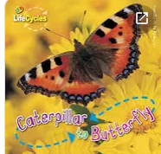 | A seed is sleepy  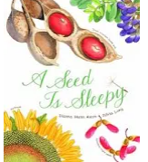 | Jim and the beanstalk  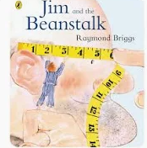 |  | The oak tree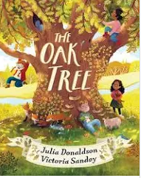 |  | Traction man  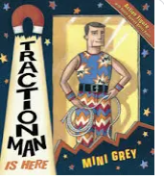 |  |  |  |  | Clean up!  Seaside Trip  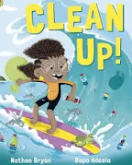 |  | What a waste  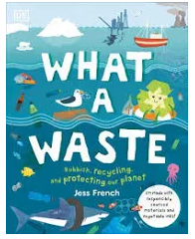 |  | Where the sea meets the sky  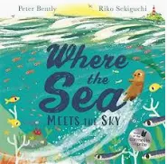
Genre | Non-fiction report about butterflies  -appearance  -habitat  -diet  (butterflies have a…) |  | Character description (Jim)  -appearance  -personality  -background  (Jim is…)  Letter including instructions to the Giant from Jim  (thank you for the coins…  Instructions to keep your new teeth clean…) |  |  |  | Setting description of a garden in the past tense  (On a cold day traction man was walking…)  Story retell of traction man  -opening  -build up  -dilemma  -resolution  -closing  (There once was a brave action figure who…)  Recount of a trip  (time adverbials, noun phrases, verb phrases) |  |  |  |  | Setting description (in the sea there is… On the beach there is…)  Acrostic poem (BEACH)  Beach poem (orange sand burning, golden starfish floating) |  | Non-fiction report (How can you save the planet?) |  | Story  Trip recount

Year 2
Term | Autumn 1 |  |  |  |  |  |  |  |  | Autumn 2
Topic | Myself and My Community- Near and Far |  |  |  |  |  |  |  |  | Celebrations- Let’s Remember!
Weeks | 1 | 2 |  | 3 | 4 | 5 | 6 | 7 |  | 1 | 2 | 3 | 4 | 5 | 6 | 7
 | Poetry- Magic Meru |  |  |  |  |  |  |  |  | Poetry- Remembrance Day Poem
Text/Stimulus | The truth about my unbelievable summer  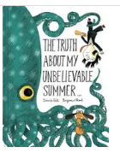 |  | Lila and the Secret of Rain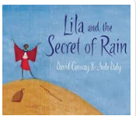 |  | Last stop on market street  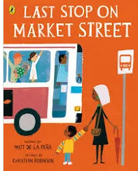 | The Wooden Camel  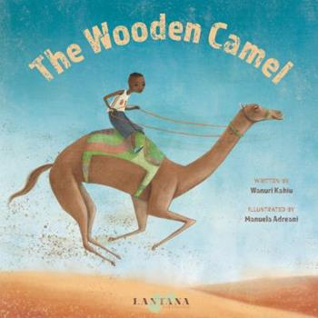 |  | The Queen’s Handbag  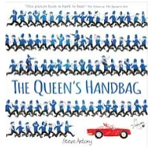 |  | Non-fiction  Local Walk to Cenotaph  The day war came  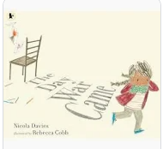 |  | Where the Poppies Now Grow  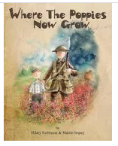 |  | War dogs Pantomime  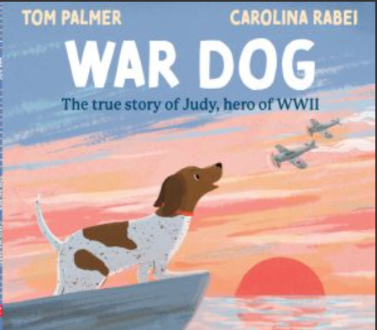 | A Christmas Truce  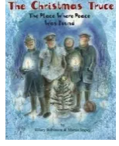
Genre | All About me  Recount in 1st person | Setting description  (There is a…)  Character description in 1st person  (I have large, brown eyes and I have a small head).  Story in 3rd person  (once upon a time there was a beautiful, young girl called Lila and she…) |  |  |  |  |  | Non-fiction report about the Queen  Instructions  How to get your flying hat back |  | Information sheet about WW1  -when it started  -when it ended  -why did it start?  -who joined in?  -when they fought  -deaths  (WW1 started on…)  Celebrations non-fiction  -what?  -why?  -How?  -when?  (we say thank you to the soldiers by… we go to the cenotaph at…) |  | Setting description of Flander’s field  Character description of Ben and Ray in 3rd person  (Ben had round clear glasses but ray doesn’t)  Letter to parents from Ray  Diary from the perspective of Ben or Ray in 1st person  -event, details, feelings  (we rode the horse all the way down the street. We were terrified!) |  | Fact file about Prince Harry and his links to the war in 3rd person  (He was born in…)  Recount of experience (pantomime)  (First we wandered into the hall and we sat down on the long, hard benches). | Letter to Santa to explain to him how to deliver your presents  (first quietly open the door and step inside my house. Next silently eat the cookie I have left out for you)

Term | Spring 1 |  |  |  |  |  |  |  | Spring 2
Topic | Explore- Expeditions |  |  |  |  |  |  | Animals- Sea, Soil or Sky?
Weeks | 1 | 2 | 3 |  | 4 | 5 |  |  | 1 | 2 | 3 | 4 |  |  | 5 |  | 6
 | Poetry-I am brave (Laura Mucha) |  |  |  |  |  |  |  | Poetry - Walking with my Iguana (Brian Moses)  Easter Poem- Spring Has Sprung
Text/Stimulus | I am Sacagawea  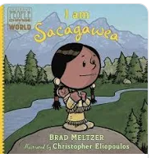 | The boy who sailed the world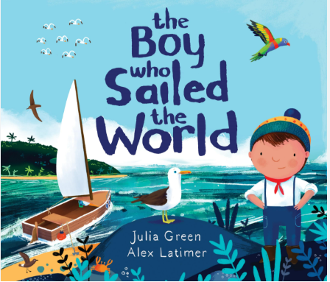 |  | What we’ll build  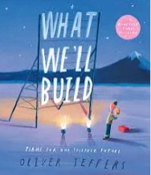 | Poles Apart  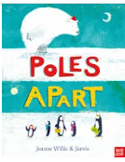 |  |  |  | The Dancing Turtle  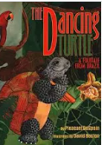 |  | The Journey home  Woodland walk  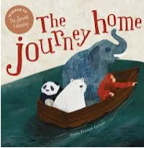 | Up and down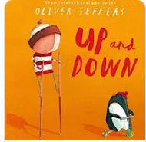 |  | The sea below my toes 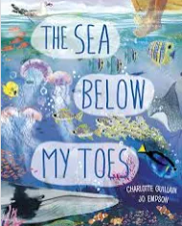 |  | Tadpoles promise 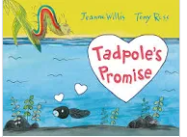
Genre | Recount of Christmas experience  Biography about Sacagawea written in past tense (Sacagawea was born in and died in…) | First person recount about Scott’s expedition to the Antarctic (I couldn’t get warm and I knew I was running out of time) |  | Non-Chron Report comparing three explorers, Sacagawea, Captain Scott and Attenborough (She was an explorer from the past and she was inspirational because…) | Setting description (In this setting there is… I can see a….)  Instructions for how to arrive at the south pole  (Find a friendly, white polar bear and tell him you are lost)  Retell of the story in 3rd person (Once upon a time there was…) |  |  |  | Character description of the turtle in 3rd person (He has short, brown hair and …)  Write an opening of the story  Substitution story  -character  -musical instrument |  | Non-fiction text about a woodland habitat  -which animals would you find there?  -how do they get their food?  -what does this habitat provide? (science links) |  |  |  |  | Letter to the caterpillar from the tadpole in 1st person from the characters perspective  (I’m writing to you to express my anger and annoyance. How could you do that to us?)  Book review

Term | Summer 1 |  |  |  |  |  |  | Summer 2
Topic | Plants- Rainforest Adventure |  |  |  |  |  | Our World- Weird Weather
Weeks | 1 | 2 | 3 | 4 | 5 |  |  | 1 | 2 | 3 | 4 | 5 | 6
 | Poetry- Deep in the rainforest (Sue Perks) |  |  |  |  |  |  | Poetry- The Hurricane (Kids Poetry Club)
Text/Stimulus | Frog life cycle project  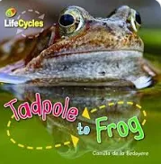 | Oi, frog!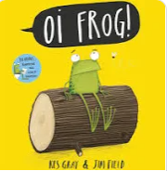 | Buddy’s rainforest adventure  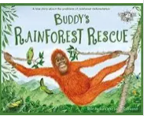 | The Great Kapok Tree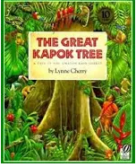 | Howard the average Geko  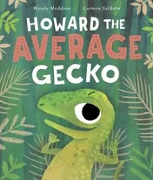 |  |  | Blown away  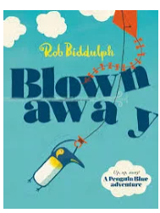 | Dear Earth  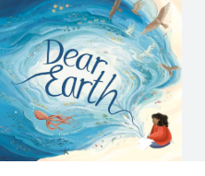 |  | The Storm Whale  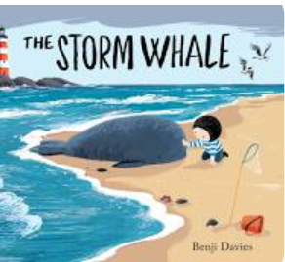 | Storm  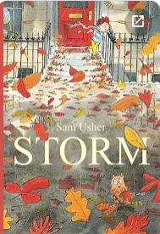 | The day the crayon’s quit  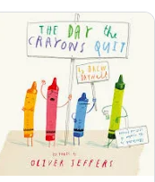
Genre | Non chronological report of a butterfly  -introduction  -Appearance  -Habitat diet  -other facts  (butterflies have a straw-like proboscis) | Recount of an experience in 1st person, past tense  (Last week we trekked to B&Q to find…)  Instructions for how to plant a sunflower seed | Instructions  -How to save a rainforest orangutan  (First search for him swooping and swinging through the vines…) | Retell a familiar story in past tense  (Once upon a time two men wandered into the rainforest and they….)  Persuasive letter in 1st person  (I’m writing to share my opinion on deforestation…) |  |  |  | Fact file about Claude Monet in 3rd person  (He was a famous artist who…) |  |  | 1st person recount of day from Noi’s perspective  (I wandered outside and I couldn’t believe my eyes…)  Instructions for how to look after a whale in distress  (First kneel down and check for a heartbeat. Then pour water over him to make sure he is hydrated) | poetry  (swirling silver hurricane, twirling huge tornado) | Letters to new teachers (transition)

Oliver Jeffers
Who school author/illustrator
Foundation Stage 1  The Crayons Christmas  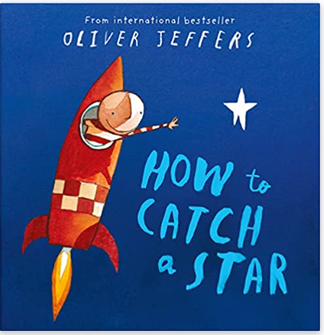 |   Foundation Stage 2  Lost and Found  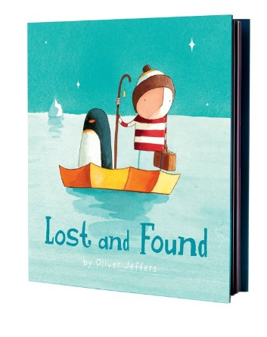
Year 1  The Way Back Home  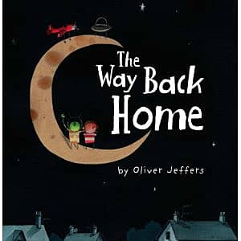 | Year 2  Up and Down  