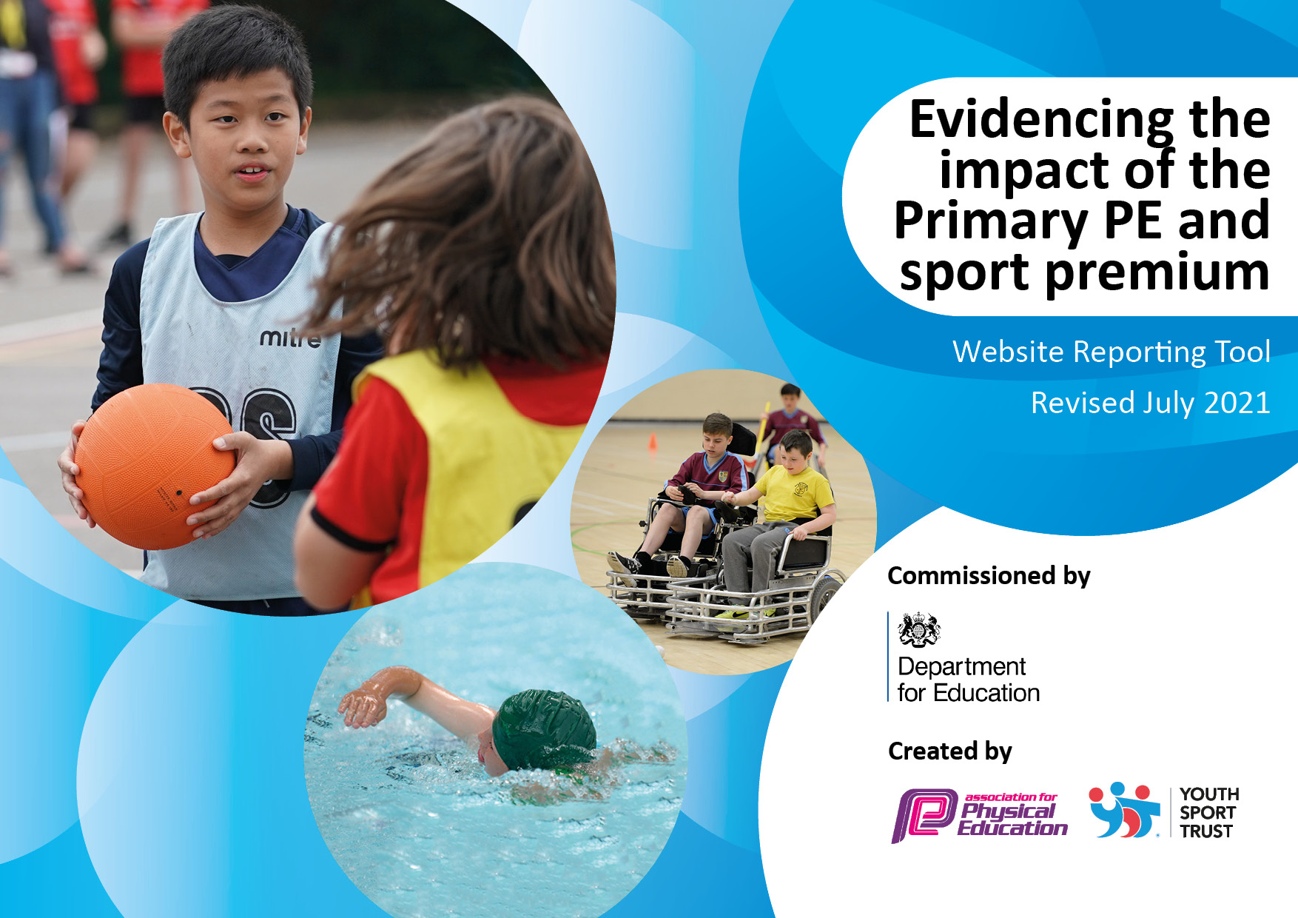
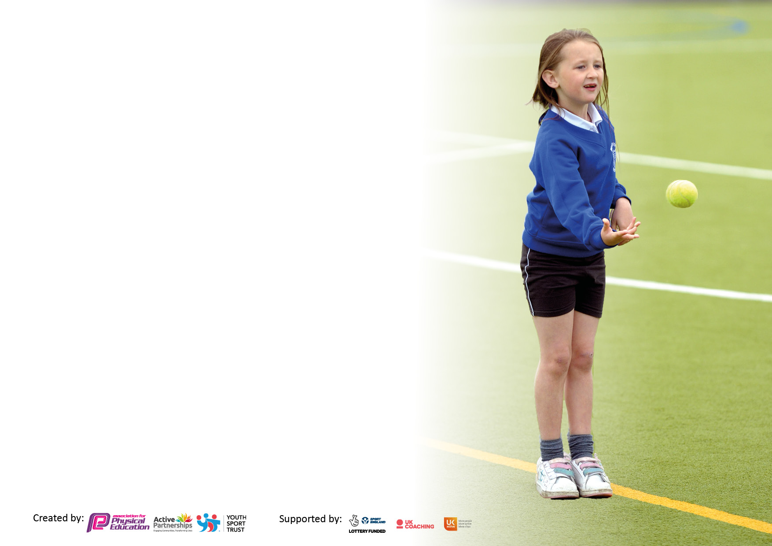

It is important that your grant is used effectively and based on school need. The Education Inspection Framework makes clear there will be a focus on ‘whether leaders and those responsible for governors all understand their respective roles and perform these in a way that enhances the effectiveness of the school’.

Under the Quality of Education Ofsted inspectors consider:
Intent - Curriculum design, coverage and appropriateness
Implementation - Curriculum delivery, Teaching (pedagogy) and Assessment
Impact - Attainment and progress

To assist schools with common transferable language this template has been developed to utilise the same three headings which should make your plans easily transferable between working documents.

Schools must use the funding to make additional and sustainable improvements to the quality of Physical Education, School Sport and Physical Activity (PESSPA) they offer. This means that you should use the Primary PE and sport premium to:

- Develop or add to the PESSPA activities that your school already offer
- Build capacity and capability within the school to ensure that improvements made now will benefit pupils joining the school in future years
- The Primary PE and sport premium should not be used to fund capital spend projects; the school’s budget should fund these.

Pleasevisitgov.ukfortherevisedDfEguidanceincludingthe5keyindicatorsacrosswhichschoolsshoulddemonstrate animprovement.Thisdocumentwillhelpyoutoreviewyourprovisionandtoreportyourspend.DfEencouragesschools to use this template as an effective way of meeting the reporting requirements of the Primary PE and sport premium.

We recommend you start by reflecting on the impact of current provision and reviewing the previous spend.

Schools are required to publish details of how they spend this funding, including any under-spend from 2020/2021, as well as on the impact it has on pupils’ PE and sport participation and attainment. All funding must be spent by 31st July 2022.

We recommend regularly updating the table and publishing it on your website throughout the year. This evidences your ongoing self-evaluation of how you are using the funding to secure maximum, sustainable impact. Final copy must be posted on your website by the end of the academic year and no later than the 31st July 2022. To see an example of how to complete the table please click HERE.

Details with regard to funding
Please complete the table below.

Total amount carried over from 2019/20 | £0
Total amount allocated for 2020/21 | £17270
How much (if any) do you intend to carry over from this total fund into 2021/22? | £ 1,031
Total amount allocated for 2021/22 | £16,830
Total amount of funding for 2021/22. To be spent and reported on by 31st July 2022. | £16,830
Swimming Data
Please report on your Swimming Data below.

Meeting national curriculum requirements for swimming and water safety.

N.B. Complete this section to your best ability. For example you might have practised safe self-rescue techniques on dry land which you can then transfer to the pool when school swimming restarts.
Due to exceptional circumstances priority should be given to ensuring that pupils can perform safe self rescue even if they do not fully meet the first two requirements of the NC programme of study
What percentage of your current Year 6 cohort swim competently, confidently and proficiently over a distance of at least 25 metres?  N.B. Even though your pupils may swim in another year please report on their attainment on leaving primary school at the end of the summer term 2020.  Please see note above | %
What percentage of your current Year 6 cohort use a range of strokes effectively [for example, front crawl, backstroke and breaststroke]?  Please see note above | %
What percentage of your current Year 6 cohort perform safe self-rescue in different water-based situations? | %
Schools can choose to use the Primary PE and sport premium to provide additional provision for swimming but this must be for activity over and above the national curriculum requirements. Have you used it in this way? | Yes/No

Action Plan and Budget Tracking
Capture your intended annual spend against the 5 key indicators. Clarify the success criteria and evidence of impact that you intend to measure to evaluate for pupils today and for the future.

Academic Year: 2021/22 | Total fund allocated: £17,861 | Date Updated:
Key indicator 1: The engagement of all pupils in regular physical activity – Chief Medical Officers guidelines recommend that primary school pupils undertake at least 30 minutes of physical activity a day in school |  |  |  | Percentage of total allocation:
 |  |  |  | 88.1%
Intent | Implementation |  | Impact
Your school focus should be clear what you want the pupils to know and be able to do and about  what they need to learn and to  consolidate through practice: | Make sure your actions to achieve are linked to your intentions: | Funding allocated: | Evidence of impact: what do pupils now know and what can they now do? What has changed?: | Sustainability and suggested next steps:
We want our children to access PE lessons with sports coaches which enables our children to fully embed skills and also support our teaching staff.  We want our children to be active at break and lunchtimes to meet the daily 30 minutes.  We want our children to have an increased awareness on the games they can play at break and lunchtimes and are given support for this.  We want to raise the profile of after school clubs and offer a wider range of sporting clubs for all children.  We want our children in our EYFS year groups to have access to equipment appropriate to their physical needs.  We want all our children to have access to high quality equipment.  We want our children to assess outdoor equipment in our forest areas safely on a weekly basis.  We want our children to be able to enjoy and get involved in dance lessons well with appropriate music for lessons and events. | Coach Nathan to support, deliver and increase opportunities for skill development linked to learning within high quality PE lessons.  PE coach for JMAT to provide support, deliver and increase opportunities for skill development linked to learning within high quality PE lessons.  Equipment trolley set up for break and lunchtimes.  Basket ball net and footballs bought for breaktimes and lunchtimes.  Playgroup supervisors to encourage and promote and healthy active lifestyle.  Implementing a well-balanced after-school sporting program of study. All clubs to be monitored to ensure they are successfully delivered and received all year-round.  Mini Kixxs - all year round F2-Y2  Movement evening – Spring 1  Shooting stars – Summer 2  Equipment bought for these classes.  Equipment audited and purchased.  Yearly outdoor climbing equipment check.  Removal and replacement of unsafe equipment.  Speakers purchased. | £3,810  £6,000  £273  £1,635  £0  £1462  £723  £270  £1124  £435 | Pupils are benefiting from lessons that they enjoy and make consistent and sustained progress each year.  Staff are gaining confidence and developing their ability to teach high quality PE.  Children are more active during break times accessing football, basketball and other playground games.  Clubs have continued to be successfully received by all pupils. Clubs offer wider opportunities to experience different forms of PE  EYFS children now have access to a wider range of resources tailored to their needs.  Children are now using safe and appropriate resources in PE lessons, breaktimes and sports day.  The outdoor climbing equipment passed its safety check so now all children can carry on using it safely. Other unsafe pieces to be removed. | All KS1 and F2 classes within the next academic year will be accessing a weekly PE lesson delivered by a coach. PE lead to monitor the success of this and check on the delivery of the entire curriculum.  PE lead to check on playtime trolley going forward and replenish/circulate the different resources available.  CPD delivered to playground supervisors in the next academic year to support further with promoting an active break.  Within the next academic year, we will continue to run Mini Kixxs throughout the year as an afterschool club.  Movement evening will continue to be an afterschool club if the vent continues to go ahead.  PE lead to help support EYFS staff with selecting the correct resources to have out in their areas at different times of the year. The progression model will have created will also help support this.  Children will now be able to access the safe equipment. To continue to monitor safety of all existing equipment.  Speakers will enable all classes throughout school to take part in active dance brain breaks where necessary. They will be used during movement evening dance practice.
Key indicator 2: The profile of PESSPA being raised across the school as a tool for whole school improvement |  |  |  | Percentage of total allocation:
 |  |  |  | 0%
Intent | Implementation |  | Impact
Your school focus should be clear what you want the pupils to know and be able to do and about  what they need to learn and to  consolidate through practice: | Make sure your actions to achieve are linked to your intentions: | Funding allocated: | Evidence of impact: what do pupils now know and what can they now do? What has changed?: | Sustainability and suggested next steps:
We want to raise and embed the profile of PE and well-being across the school and wider school community.  We want to raise the engagement of physical activities and aspirations in our children. | Implement a fixed yearly program of study that is in line with the National Curriculum and school curriculum outcomes for EYFS and KS1.  Para Olympian visit in Summer 2. Children fundraised and raised money for school and for the organisation. Then joined in with circuits and motivational Q&A. | £0  £0 | Increased fitness of pupils and knowledge surrounding health.  Progression of knowledge is clear for all pupils and is built upon each year.  Children were inspired by the event and have gained knowledge surrounding Para Olympic events. | This progression model will enable all staff and visitors through school to be able to see what is being taught, when and why. The document will be given to external coaches to allow them to plan their sessions in line with our curriculum.  The money school raised has provided us with a voucher which we will spend on further updating our EYFS areas in the Autumn term.

Key indicator 3: Increased confidence, knowledge and skills of all staff in teaching PE and sport |  |  |  | Percentage of total allocation:
 |  |  |  | 10.6%
Intent | Implementation |  | Impact
Your school focus should be clear | Make sure your actions to | Funding | Evidence of impact: what do | Sustainability and suggested
what you want the pupils to know | achieve are linked to your | allocated: | pupils now know and what | next steps:
and be able to do and about | intentions: |  | can they now do? What has
what they need to learn and to |  |  | changed?:
consolidate through practice:
We want to improve the quality of teaching and learning within physical education.  We want staff to feel they are supported and have up to date knowledge on how to provide the best PE lessons to the children.  We want the PE lead to gain knowledge and be upskilled. | Foresteers training/ Level 3 qualification undertook by a class teacher. Forest school promotes being active within our school. Children access an afternoon a week and it is a huge part of our ethos.  Staff to access weekly coaches’ lessons as CPD.  PE lead accesses courses and support through our academy.  Cover is provided when out of class.  PE lead attended PE JMAT meeting as well as working alongside JMAT coach and Sports coordinator for our academy. | £895  £0  £1000 | Staff member is now fully trained within delivering forest school sessions and will cascade their knowledge to other staff to ensure all forest schools achieve the desired outcomes.  Staff have access to up to date CPD, which has developed their knowledge, skills and confidence when teaching all areas of PE  PE lead has collaborated more within our academy and is continuing to upskill herself, providing her with the knowledge and skills needed to support other staff and cascade appropriate training to teaching staff. | Training to be passed on to other colleagues in the Autumn term to allow the rest of school to be using techniques learnt.  This will continue into the next academic year. PE lead to monitor when CPD has been made use of.
Key indicator 4: Broader experience of a range of sports and activities offered to all pupils |  |  |  | Percentage of total allocation:
 |  |  |  | 0.6%
Intent | Implementation |  | Impact
Your school focus should be clear | Make sure your actions to | Funding | Evidence of impact: what do | Sustainability and suggested
what you want the pupils to know | achieve are linked to your | allocated: | pupils now know and what | next steps:
and be able to do and about | intentions: |  | can they now do? What has
what they need to learn and to |  |  | changed?:
consolidate through practice:
We want to increase sporting opportunities through extra-curricular activities and wider school prospects.  We want our children to access a range of sporting events. | Celebration of different sports in school through movement evening. Costume bought for event.  Children have had access to attend these different events:  Shooting stars’ girls football event  Movement evening  Hoopla festival  Multi skills festival  Football festival | £109  £0 | Movement evening was successful and aspirational to those who took part, it offered a wider experience within PE for children who may not receive these experiences in their home life  Children who have attended these events have had the opportunity to work as a team and against others school. | Continue to access these events in 22/23.

Key indicator 5: Increased participation in competitive sport |  |  |  | Percentage of total allocation:
 |  |  |  | 0.7%
Intent | Implementation |  | Impact
Your school focus should be clear | Make sure your actions to | Funding | Evidence of impact: what do | Sustainability and suggested
what you want the pupils to know | achieve are linked to your | allocated: | pupils now know and what | next steps:
and be able to do and about | intentions: |  | can they now do? What has
what they need to learn and to |  |  | changed?:
consolidate through practice:
We want to engage pupils and parents within local community events involving taking part in school-on-school tournaments  We want our children to take part in competitive sports, learning about the importance or building resilience and being part of a team. | Children to take part in our extracurricular tournaments and events within our academy trust.  Football shirts bought for the children a football event.  Children to take part in sports day.  Sports day medals and stickers purchased to celebrate achievements. | £40  £85 | Pupils and parents are understanding the importance of competing against others in order to build resilience, tolerance and respect, resulting in changed behaviours which will continue in future years.  Sports day was successful and all children took part. It was great having parents and carers on school grounds for a sports day after the pandemic. Children and parents now have a greater understand of competitive sports within Infant children. | There will be further opportunities in the next academic year to take part in extracurricular tournaments, festivals and competitions within our academy.

Signed off by
Head Teacher: | Miss Finley
Date: | 17.7.22
Subject Leader: | A.McNeill
Date: | 17.7.22
Governor: | Mrs Williams
Date: | 17.7.22

