Cortonwood Infant and Nursery School
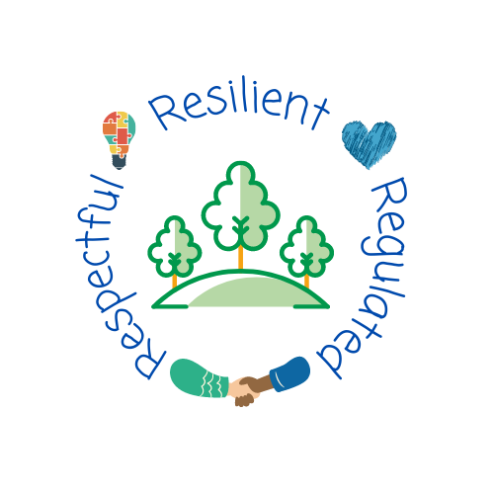
History progression of knowledge and skills across Early Years and Key Stage One

Sep 2022
Progression of knowledge and skills within History
Each skill is developed within the specific historical domain based on the historical knowledge taught at each year groups.
Pupils should develop an awareness of the past, using common words and phrases relating to the passing of time. They should know where the people and events they study fit within a chronological framework and identify similarities and differences between ways of life in different periods. They should use a wide vocabulary of everyday historical terms. They should ask and answer questions, choosing and using parts of stories and other sources to show that they know and understand key features of events. They should understand some of the ways in which we find out about the past and identify different ways in which it is represented.
In planning to ensure the progression described above through teaching about the people, events and changes outlined below, teachers are often introducing pupils to historical periods that they will study more fully at key stages 2 and 3.
Intent
Our intent is that history teaching will help our young children develop a good understanding of the past. It is important for our children to understand their own history as a foundation to build upon, allowing them to learn about people and events in history both locally and globally and events within and beyond living memory, reflecting on how these have shaped the world they live in today. We teach carefully sequenced and progressive lessons rooted in knowledge with opportunity for application of historical skills. We aim to build our children’s experience of what life was like in the past through visitors to school and visits to historical places. Our aim is to ensure that our children are given the best possible introduction to history and become knowledgeable and skilled historians who are curious to know more about the past.
History taught through a topic approach
The breadth of our topic based learning curriculum is planned to give pupils appropriate experiences both in and out of the school environment to develop as confident and responsible citizens through the world they live in. It is designed to provide rich cultural capital and provide them with the knowledge and skills to succeed in the future working world. It is delivered in a coherent, structured, practical curriculum that leads to a sustained mastery for all and a greater depth of understanding for those who are capable.

Our topic based curriculum design is based on evidence from cognitive science; three main principles underpin it:
- Learning is most effective by repetition.
- Interweaving helps pupils to discriminate between topics and aids long-term retention.
- Retrieval of previously learned content is frequent and regular, which increases both storage and retrieval strength.
In addition to the three principles, we also understand that learning can be invisible in the short-term and that sustained mastery takes time. Some of our content is subject specific, whilst other content is combined in a cross-curricular approach. Continuous provision, in the form of daily routines, replaces the teaching of some aspects of the curriculum (where appropriate) and in other cases, provides retrieval and practice for previously learned content.

The impact of our curriculum is that by the end of year 2, the vast majority of our pupils have sustained mastery of the content that is they remember it all through their learning experiences and are fluent in applying both learnt knowledge and skills to a wide variety of tasks and situations.

Historical Domains
 | Significant historical events, people and places | Significant historical events beyond living memory  Significant historical events, people and places in their own locality | Changes within living memory
Smarties and F1  Children will know how to… | Composite:  >Make connections between the features of their families  (EYFS – Birth to Three) | Composite  >Talk about what they see (EYFS- Three and Four)  >Begin to make sense of their own life-story and family history  (EYFS- Three and Four)
 | Components:  > Discuss the people that live in their house by using their family names, such as brother, sister, son, daughter, (step) father/dad/daddy, (step) mother/mum/mummy.  > Describe the people in their wider family by sharing family photographs as a stimulus and use their names, such as grandmother (grandma/Nan), grandfather (grandad), aunt (auntie), uncle, cousin, niece and nephew.  >Discuss how different family members are related. For example, “I am my Mum’s daughter/son, or that is my Grandma, she is Mummy’s mum.”  >Compare similarities and differences between their own family and others through sharing photographs and discussion. For example, “You have a brother and I have a sister.”  >Act out familiar customs and routines from their own family life, such as making tea and going to the shops.  >Draw pictures of their own family and engage in discussion about what they have drawn. | Components:  > Discuss that David Attenborough is a famous natural historian who has presented documentaries about nature for many years.  > Compare the differences between the old and current photographs of David Attenborough. Describe how he looks older now. Explain that the photograph is black and white because there were no colour photographs when he was younger. Understand that in the past, photographs used to be printed.  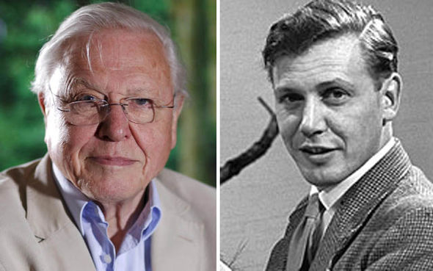
>Understand that something that has happened previously, for example at the weekend, is in the past.
> Describe in detail a personal or familiar event, such as their weekend or holiday news. Children should speak in full sentences and use the correct tense.
> Describe past events that are not within living memory, such as Christmas, use language such as ‘a long time ago’
F2  Children will know how to… | Composite:  >Compare and contrast characters from stories including figures from the past (EYFS)  >Talk about the lives of the people around them and their roles in society (ELG)  >Understand the past through setting characters and events encountered in books read in class and story telling. | Composite:  >Compare and contrast characters from stories including figures from the past (EYFS)  >Comment on images of familiar situations from the past.  >Know some similarities and differences between things in the past and now drawing on their experiences and what has been read to them. | Composite:  >Know some similarities and differences between things in the past and now drawing on their experiences and what has been read to them.
 | Components:  >Identify characters from stories including those from the past such as Mary Anning who discovered fossils in England.  >Act out historical factual events such as recreating the life story of Mary Anning. Children will use dressing up props, images and artefacts.  >Discuss that she was not allowed to attend university because she was a woman. However, her knowledge was so strong that she was informing male professors about her findings.  >Discuss that fossils are developed over time linking to environmental impacts, such as the weather and environmental factors, including, building house, roads and shops.  > Compare changes such as images of characterised dinosaurs and actual dinosaur skeletons that are seen in museums such as the National History Museum in London. | Components:  >Research Bonfire Night and understand that it is an annual celebration that takes place on 5th November.  >Act out, using props, the events of  Guy Fawkes when he tried to blow up King James I in the Houses of Parliament, but was caught before he blew the Houses of Parliament up.  >Discuss and compare the different ways that we celebrate Bonfire Night, including, lighting bonfires, making and burning a ‘guy’ and setting off fireworks.  >Make artwork to represent the exploding fireworks and annotate with appropriate onomatopoeia words such as bang, pop, fizz. | Components:  >Compare and share their own family life story through role play and news sharing.  >Compare their own baby photographs to current photographs and discuss the visible, physical changes – for example their size and how they have grown.  >Discuss changes to their abilities and skills over time, such as talking, walking and being able to take care of their own needs (toileting, feeding and dressing) more independently.  >Discuss that every adult was once a baby and compare adult and baby photographs of people who are familiar to them, such as parents and teachers, and discuss how they have physically changed over time, such as they are now taller and the changes in their facial features.  > Make a representation of their own family tree and discuss the order of events e.g. “Grandma was born first, then Mummy was next and then finally me.” Know that people who were born first are older than people who are born later, who are younger. Be able to organise events chronologically, recognising that things happened before they were born. For example, older siblings/cousins being born, relatives that have passed away, parents getting married, previous family holidays and other special memories that can be shared in photographs before they were born.  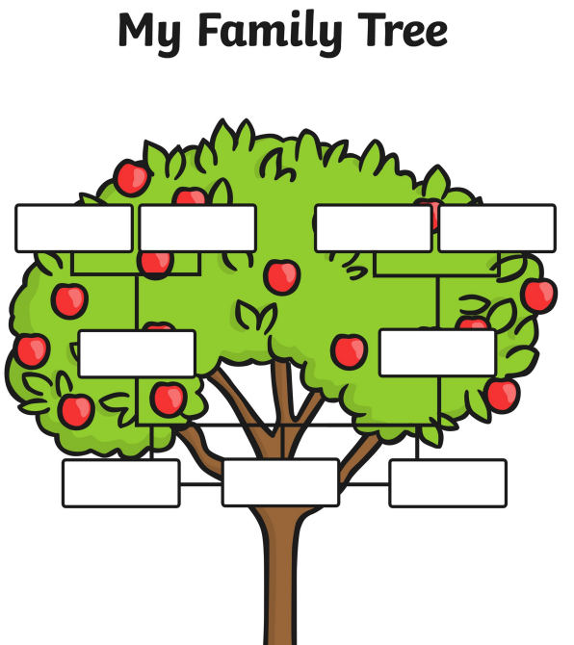  > Understand and discuss that things that have happened before are in the past. For example, discussions around weekend and holiday news. Ensuring that children are using the past tense correctly when discussing something that has already happened. E.G ‘At the weekend I went/helped/played…”  >Describe significant events and traditions within their own family life, such as a birthday party. Discuss features of a birthday party, which include celebrating a person being one year older, having a cake, blowing out candles and singing happy birthday. Discuss that it is traditional to receive presents and cards to celebrate being older. Compare birthday activities such as parties, family meals and games such as pass-the-parcel. Understand that it is custom to receive a party invitation before going to the party, which will tell you the time, date and location of the party.  >Identify the past and present in everyday contexts and be able to plot these on a simple timeline, including a visual timetable of the day. Sequencing what has already happened and what will come next.
Component:
> Discuss that Remembrance Day takes place on i the 11th November every year and it is an event that commemorates the men and women who fought in both World Wars.
> Make a poppy and discuss that it is a symbol, as they grew in the battlefields after World War 1, where many people died over a hundred years ago.
>Describe that a poppy is a red flower.
 |  | > Discuss that Christmas Day is on the 25th December and the day after Christmas (26th December) is called Boxing Day because long ago people collected donations in boxes for the poor.  > Compare and contrast presents from the past to gifts that are exchanged today, specifically a spinning top and a wooden pull along dog toy from the past, to an Xbox and a battery-operated game. Explore that toys from the past were often made of wood and did not use electricity, compared to toys today that are made from plastic and are often electronic.  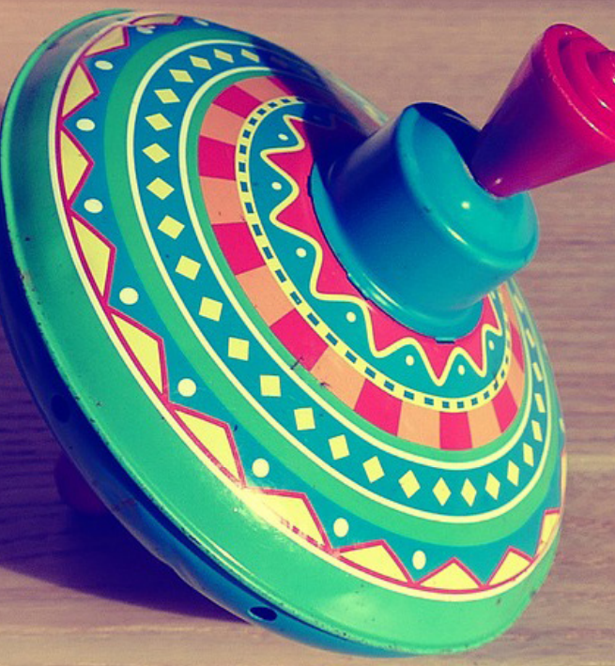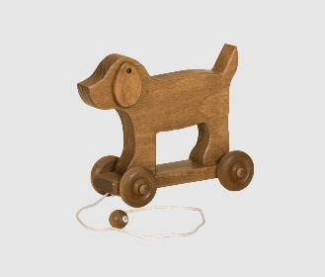  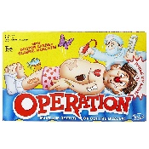  > Compare and contrast between the types of decorations used and the difference in the way people dress between the past and present. For example, homes being lit up by candles instead of electricity, and children wearing long and flowing gowns rather than jeans and tops/shirts.  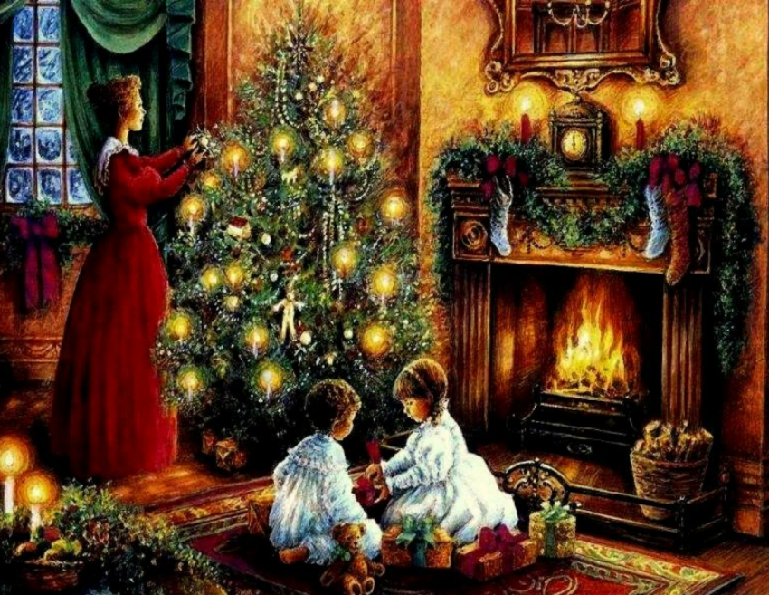  >Discuss a tradition and know this it is a custom that is passed along and repeated. Describe special events and traditions within their own families, which could include:  - Decorating the home with holly, ivy and mistletoe  - Putting up a decorated Christmas tree  - Singing Christmas carols  - Exchanging gifts  - Eating Christmas dinner  - Listening to the Queen’s speech  - Watching a pantomime  >Write about their own Christmas experienced and engage in discussion about their experiences with their class. | >Discuss that Floella come to the UK from Trinidad a long time ago in 1960 by boat, when she was ten years old. She dreamed of being a teacher, but did not have the right qualifications so she worked in a bank and studied in a night school. She was worried her ambition of becoming the first black female bank manager would not happen, so she auditioned to be in a musical.  >Describe that she has appeared in many musicals, TV programmes and presented many shows, such as playdays. She was the first person in Britain to present on TV with beads in her hair, which was not usually seen on television. Floella carries out a lot of work to support charities and has been recognised and honoured for her hard work. When she was 50, she promised to run 10 London Marathons for the charity Barnardo’s, and she did.
Year 1  Children will know how to… | Composite:  > The lives of significant individuals in the past who have contributed to national and international achievements, some should be used to compare aspects of life in different periods.  > Significant historical events, people and places in their own locality. | Composite:  > Events and changes beyond living memory that are significant nationally or globally. | Composite:  > Changes where appropriate, should be used to reveal aspects of change in national life.
 | Components:  >Create a fact file about local artist Henry Moore and his connection to mining. For example, Moore was born in Castleford, West Riding of Yorkshire, England, to Mary (née Baker) and Raymond Spencer Moore. His father was Irish and became pit deputy and then under-manager of the Wheldale colliery in Castleford. Determined that his sons would not work in the mines, he saw formal education as the route to their advancement. Henry was the seventh of eight children in a family that often struggled with poverty. He attended infant and elementary schools in Castleford. Henry Moore created a painting called the ‘Pit boys’ (to be studied during art)  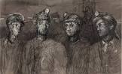 | Components:  > Understand that Whole families used to work in coal mines, including children who would have had the jobs of hurrier, thruster and trapper.  >Compare Coal mining equipment/tools through the changes over time with the invention of new machinery. For example, the first mines were dug by hand and with basic equipment such as an pickaxe and a Davey lamp . More modern mines were dug using large machinery.  Discuss Horses (pit ponies) were used for a long time in coal mines to help to pull machinery and coal tubs mines were dangerous places to work and eventually children were not allowed down anymore.  > Compare and understand how equipment improved over time. The Davy lamp was a safe way of warning miners of dangerous gasses in the mine. Before this, canaries were used. Safety helmets were introduced to protect the miners’ heads.  > Coal mines were an important source of employment within the local area of Brampton at Cortonwood Colliery and that in 1986 Cortonwood Mines were demolished after years of protests to keep them open. Cortonwood Shopping centre was built years later on the old Colliery grounds.  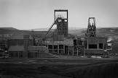 | Components:  >Compare Victorian toys to toys used today. Using a timeline denoting the Victorian era, 20 years ago and today to plot on toys from those time periods,  Victorian ere =  cup and ball  wooden doll’s house  diabolo  20 years ago =  stretch Armstrong  etch-a-sketch  tamagotchi  Today =  play station  LOL surprise  Minecraft  >Discuss how toys have changed within their own memory and why.  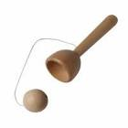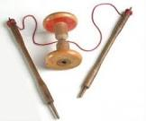
 | Component:  >Discuss key facts about Guy Fawkes, such as he was part of a group of Plotters who wanted to blow-up the Houses of Parliament in London.  >Discuss that King James I was the King of England in 1605 when Guy Fawkes and the Plotters put 36 barrels of gunpowder under the Houses of Parliament.  > Discuss that Robert Catesby was the organiser of the plotters and many people thought it was Guy Fawkes. Robert Catesby escaped the King’s Guards and went to Holbeche House but later was found and executed alongside all the other plotters.  > Identify and label key artefacts and images linked to the Gunpowder plot. For example, King James I, Guy Fawkes, Warning letter, Robert Catesby, House of Parliament, Armed Guards.  >Sequence the Plotters events leading up to November 5th and understand why it is still celebrated today.  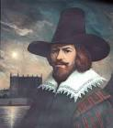 | Component:  >Compare their home to that of a Victorian home by using a table. Compare artefacts and objects such as, candle and lamp, carpet beater and hoover, iron and electric iron, tin bath to plumbed bath, weighing scales to digital scales.  >Compare their school to that of a Victorian school by using a Venn diagram. Compare artefacts and objects such as, tables and desks, dojo, dunce hat and cane, books and slate boards, pencil and chalk, fire and radiators. Things that are similar are: bells, chairs and uniforms.  >Identify true or false statements about objects/artefacts found in a Victorian home and School compared to present day. blackboards, tin bath, cane, candle, iron, dolly, range, carpet beater.  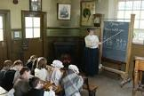  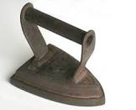
Component:
>Identify key fact about Queen Victoria such as; She became queen at 18 years old. She was the first Queen to live in Buckingham Palace. She had 9 children with her husband Prince Albert and was deeply saddened when he died. Vowing to only wear black. She was Queen during the invention/ growing use of electricity, flashing photographs and steam trains.
>Compare Queen Victoria I and Queen Elizabeth II. Know Queen Victoria was Queen during the Victorian era and became Queen when she was 18 years old. She married Prince Albert who died before her in 1861. They had 9 children. Prince Albert introduced the Christmas tree to England. Queen Victoria died 1901.
>Queen Elizabeth II became Queen at 27 years old. She had 4 children. She married Prince Philip who died in 2021. Prince Philip create the Duke of Edinburgh project in England. Queen Elizabeth II is our longest reigning monarch to-date.
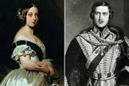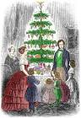
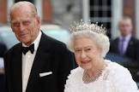
Component:
>Record facts about the Wright brothers. Such as where they were both mechanical engines, they were born in America and were the first people to invent and fly a motorised aircraft. To know their first flight was in December 1903 and they flew for 3 metres. To know which facts are true or false about the Wright brothers, such as where they live, what they invented and how far and when they travelled.
>Recall facts about Amelia Earhart such as she took her first flying lesson at the age of 23. She took her first passenger flight on 28th December 1920. She bought her first plane in 1921 and nicknamed it the canary because it was yellow. She was the first women to fly solo across the Atlantic Ocean in May 1932.
>Compare Amelia Earhart and The Wright Bothers. Compare the fact that they were both born in America. The Wright brothers were the first to invent and fly a motorised air craft. They had their first flight on 17th December 1903. Amelia Earhart took her first flight as a passenger on 28th December 1920, She bought her first plane in 1921 and was the first women to fly solo across the Atlantic Ocean in 1932.
>Use a map to plot on the historical journeys Amelia Earhart took. The map will include plotting her solo flight, non-stop flight and her final flight that she never returned from.
>Discuss facts about Neil Armstrong. For example, he was born in America he got his pilot’s licence in 1945. In 1969 he went on Apollo 11 and became the first man to walk on the moon. He is only 1 of 12 people to walk on the moon and his footprint is still there today because there is no wind on the moon. Neil Armstrong passed away in 2012.
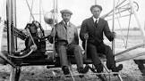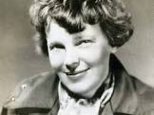

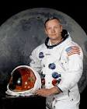

>Create a fact file about artist Andy Warhol and his connection to Pop Art.
Focus on:
Where he was born
His art techniques
His pop art paints and illustrate (Marylin Monroe and soup can)
(see art progression)
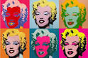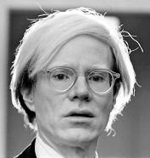
Year 2  Children will know how to…. | Composite:  > The lives of significant individuals in the past who have contributed to national and international achievements, some should be used to compare aspects of life in different periods.  > Significant historical events, people and places in their own locality. | Composite:  > Events and changes beyond living memory that are significant nationally or globally. | Composite:  > Changes where appropriate, should be used to reveal aspects of change in national life.
 | Components:  >Collect key fact about local sculptor Daisy Makeig-Jones. For example, Makeig-Jones was born in Wath-upon-Dearne near Rotherham, Yorkshire, the eldest of seven children. Her father, K. Geoffrey Makeig-Jones, was of Welsh descent and was a medical doctor, and her mother was the daughter of Thomas Reeder, a solicitor. Makeig-Jones was taught by a governess at home, then attended a boarding school near Rugby. After her family moved to Torquay, she entered the Torquay School of Art. After an introduction from a relative to the managing director of Cecil Wedgwood, Makeig-Jones joined the firm as an apprentice painter in 1909. After two years at Wedgwood, Makeig-Jones, clearly talented, started to design tableware in 1911. Attracted to the fanciful, she began to design Oriental dragon patterns in 1913. She moved on to her signature Fairyland Lustre design in 1915, a year after the war. (to be studied during art)  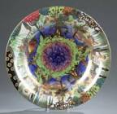 | Components:  >Research World War 1 discover facts, such as:  WW1 started 28th July 1914 and ended 11th November 1918.  It started when Belgium Franz Ferdinand was shot.  >Germany, Austria-Hungary, and Turkey joined the war and were fighting against mainly France, Great Britain, Russia, Italy, Japan, and, from 1917, the United States and 40 million people (military and civilians)  >Sequence events on a timeline from WW1. The timeline will range from 1914-1918 denoting the key events from: Christmas Truce 1914  Men living in trenches 1915  Sunken Submarine 1915  Varying countries fought 1916  Russian and Germany stopped fighting 1917  Peace Treaty 1918  >Understand the meaning behind remembrance by identify key artefacts and symbols such as: poppies, minutes silence, national and local cenotaphs (Cortonwood cenotaph) Armistice Day  >Record Signiant facts about poppies, such as: they grow in Flanders Field in France which was the final bottle ground for WW1, The poppy is a symbol of Remembrance and hope, including hope for a positive future and peaceful world. They are a show of support for the Armed Forces community, those currently serving, ex-serving personnel and their families; and a symbol of Remembrance for all those who have fallen in conflict.  >Discuss specific events that effect England include the Battle of the Somme which was the bloodiest and most harrowing battle of The Great War.  >Compare between old and new soldier’s uniform and equipment, such as camouflage and non- camouflage, armour and weapons(swords to guns and bombs)  >Contrast their lives to the lives of children during WW1, including the facts that children had to pack up and move away, they carried gas masks, food was rationed/ rationing and if children were taught they were taught underground. Existing teacher went to support during the war.  >Understand how aircrafts changed during WW1 exploring good and bad points of:  Airships  Single seat fighter planes  Two seater planes  Bomber planes  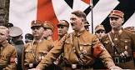  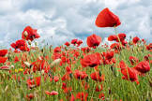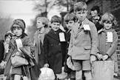 | Component:  > Revisit key facts about Queen Elizabeth II (these facts were learnt in year 1 when comparing Queen Victoria and Queen Elizabeth II) These facts are to support with geography autumn 1 when learning about different countries and the common wealth.
 | Component:  >Recall facts about Sacagawea. Including her been part of the first group of people to explore the world. Their expeditions helped us to learn about new plants and animals today. They created the first accurate map to access the pacific. Learn about her family including her brother who she met later in life, who died of pneumonia and her husband Jean who she had two children with called Jean and Lizet. She was kidnapped from her family’s tribe at 11 years old and died at 25.  >Recall when Captain Robert Falcon Scott was born in 1868 and died 1912. He served in the Royal Navy. He went on his first expedition in 1901-1904 to explore the Antarctic, specifically the south pole. He went on the ship called ‘Discovery’ and wanted to be part of the first team to reach the south pole, unfortunately, conditions were too treacherous.  In 1910-1912 Scott went on his second expedition called the Terra Nova in order to be the first to reach Antarctica, unfortunately the Norwegians bet him there. During their journey back, conditions were uncontrollable that caused them to run out of food and died.  >Record key facts of a timeline, e.g. birth, royal Navy, first expedition, marriage, children, second expedition, found diary, Captain Robert Falcon Scott’s death.  >Comparing differences and similarities between Sacagawea and Falcon Scott, such as expeditions, findings and life achievements. (see above)  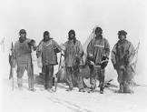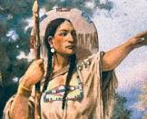 |  | Component:  >Research information about Prince Harry such as: Queen Elizabeth II is his Grandmother, Princess Diana and Prince Charles are his mother and father and Charles will become King one day, Harry is 37 years old and was born before you were born but is still alive today. His brother Prince William will someday become King of England. Prince Harry is married to Megan Markle.  >Record facts about Prince Harry’s link to war such as: Prince Harry served in the Army for ten years, rising to the rank of Captain and undertaking two tours of Afghanistan. He continues to work in support of his fellow servicemen, promoting support for wounded men and women as they adapt to life post-injury. (Invictus Games)  >Create a family tree of the immediate Royal family (Monarchy)  Queen Elizabeth II + Prince Philip  Prince Charles, Prince Edward, Princess Anne, Prince Andrew  Prince William, Prince Harry  Prince GeorgeII, Prince LouisII, Princess Charlotte  Princes Archie, Princess Lilibet  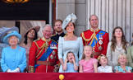
 | >Create a fact file about the artist Claude Monet and his connection to painting and watercolour.  Focus on:  Where he was born  His art techniques and art pieces  Family  Career  (see art progression)  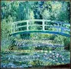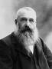 |  | Component:  >Recall significant life achievements of the modern-day explorer David Attenborough. He works to try and save the planet. He has discovered new types of plants and animals. He encouraged people to be excited about caring for the planet. He shows the world animals, habitats and vegetation that people have never seen.
Year 3
Children will know how to….

Key = Autumn 1, Autumn 2, Spring 1, Spring 2, Summer 1, Summer 2
Key vocabulary is highlighted in yellow

