Address:
Brampton Cortonwood Infant School
Chapel Avenue
Barnsley
S73 0XH

Brampton Cortonwood
Infant School
Prospectus 2025

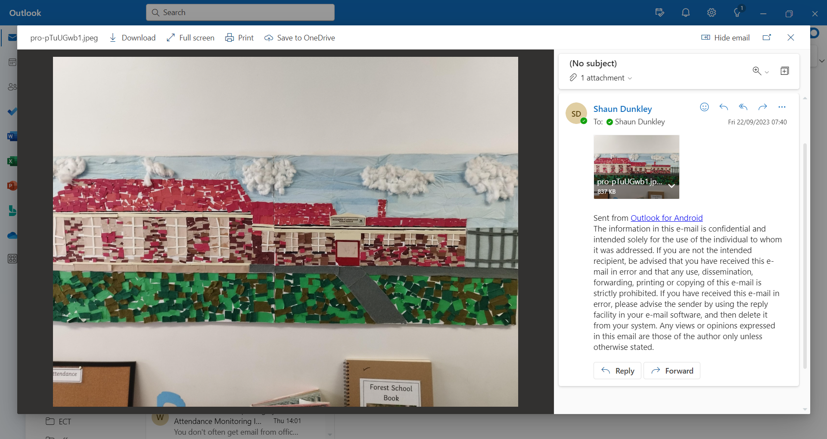



This pack contains key information for parents about their child starting Brampton Cortonwood Infant and Nursery School

Please contact us if you have any further questions or queries.

Mr S Dyson
Head of School

Brampton Cortonwood Infant School
At Brampton Cortonwood we are passionate about delivering a curious, creative and ambitious curriculum that is purposeful and relevant to our children and their needs. Our curriculum is centered around a Forest School ethos and designed to allow all children to...
BELIEVE, ACHIEVE, SUCCEED!
Our curriculum has been designed using the national curriculum as a starting point. We have then built our own curriculum making sure it is relevant in meeting the needs of our community, whilst matched appropriately to the age, maturity and knowledge of our children. We have carefully sequenced the content to ensure a progressive model is in place that is balanced, coherent and focused. We understand the need to continually review our curriculum to ensure that it is always fit for purpose in meeting the learning needs of our children.
Each half term, we have a whole-school theme that the children's learning will be based around. Within each theme, each year group will have a sequential topic that builds on the learning and experiences from the previous year group. Our curriculum is built around essential knowledge and the importance of teaching vocabulary so our children are able to learn and understand more about things outside of their daily experience.
Alongside our curriculum, and intrinsic to its success, are the Brampton Cortonwood 'Green Family Values.' These define the qualities and attributes that our children aspire towards. These family values also include our conduct behaviours focusing on consistency and high expectations.
Meet our Green Family:
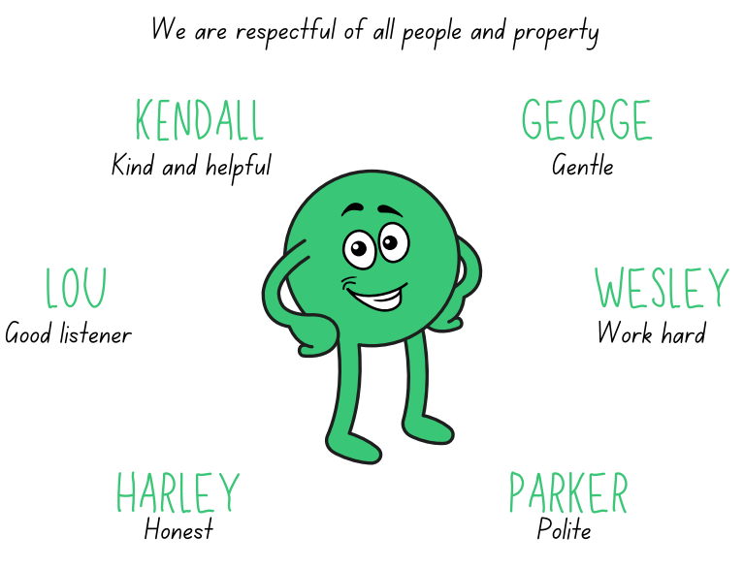

This enables our children to become:
RESILIENT REGULATED RESPECTFUL

General Information about Brampton Cortonwood Infant School

Chapel Avenue
Brampton Bierlow
Wombwell
Barnsley
S73 0XH
Tel: 01226 340044
- Email: school@bc.jmat.org.uk
- Website: www.bramptoncortonwoodinfants.co.uk

Headteacher: Mrs Lambert

We are happy that you have chosen our school to be involved with the education and development of your child. We trust that this will be the start of a long and successful partnership.

- Mrs Lambert is Brampton Cortonwood’s Headteacher and she is supported by teaching staff, dinner supervisors, administrative staff, caretaker and cleaning staff alongside the Board of Trustee of James Montgomery Academy Trust.
- Our Telephone number is: 01226 340044 and will connect you to the school office or the school answer machine.
- As an Infant school, we deliver the Early Years Foundation Stage Curriculum (3 to 5 years) and the Key Stage 1 Curriculum (5 to 7 years).
- The school is open from 8:30am, where children will be dropped off at a designated door (8.45am for F1).
- Lunchtimes in school are between 11:45pm – 1:00pm and school closes at 3:00pm (2.45pm for F1).
- Your child will be provided with a school meal. This is free of charge from Foundation 2 upwards and menus are on display outside each classroom. Parents can choose to opt out by providing a packed lunch for their child.
- There may be occasions when emergencies make it necessary for pupils to be sent home prematurely e.g. illness/snow disruption. In these circumstances it would be useful to have arrangements in place.

Arrival and Departure
Your child will be met at their designated door by their teacher on arrival. You must let us know if a different person will be collecting your child. Please inform the office if there is a change to this, or if someone else is collecting your child on your behalf. You will need to let the office know this in advance and provide us with their name. We will not permit a child to leave the premises unaccompanied or unsupervised.
Late Collection or Failure to Collect
You must notify us as soon as possible if you will be late to collect your child – this helps reduce the stress on the child.
If after closing time your child has not been collected, we will make every attempt to contact you on all of the numbers you have provided, including the Emergency Contact numbers. Our policy states that if after one hour, if all reasonable attempts to contact parent/carers have failed then the school will contact the relevant social services departments as per our Safeguarding Procedure.
Uniform
We believe that wearing a uniform promotes a feeling of community and team spirit amongst our children and can give them a sense of belonging, promoting all of our school values. Whilst we ask that children wear school uniform, we also ask that children are dressed appropriately for the weather and have a change of clothes with them in a backpack. The school has a dress code: white polo shirt or blouse, grey or black trousers/ skirts, blue sweatshirt/ cardigan, leggings/tights and black shoes. Items of uniform incorporating our school logo can be viewed at the school office, however are not essential. All clothes should be clearly marked with the child’s name. Children should have a PE kit in school consisting of shorts, T-shirt and foot wear. Tracksuit bottoms and a tracksuit top will be need during the colder months. Leotards can also be worn.
Children are not permitted to wear jewellery for safety and security reasons. Plain stud earrings are permitted but must be removed for PE.
On Forest School days, children can come in old, warm clothing and bring their school clothes to put on after the session. Children will access our outdoor area in all weathers unless it has been deemed as unsafe.
Children will need a backpack suitable for outdoors that they can carry.

what to wear in SPRING/Autumn
- School uniform
- Comfortable trousers such as jogging bottoms or leggings
- A long sleeved t-shirt or thin jumper
- A waterproof coat
- Closed toe shoes or wellies (which you don't mind getting wet and muddy)
- Spare trousers/leggings & socks in backpack (more than one set of each plus underwear if toilet training)
- Waterproofs on Forest School days (we have a small number that can be borrowed if required)

What to wear in summer
- School uniform
- Comfortable trousers such as jogging bottoms, leggings, dresses or shorts
- A short/long sleeved t-shirt or thin jumper
- Waterproof coat
- Closed toed shoes, wellies (which you don't mind getting wet and muddy)
- A sun hat
- Spare clothes & socks in backpack (more than one set of each plus underwear if toilet training)
- Waterproofs for Forest School days

What to wear in winter
- School uniform
- Warm hat
- Gloves – fleece lined waterproof gloves or mittens with a pair of “magic gloves” underneath work well and help keep the children's hands extra warm
- One or two pairs of socks – a thin pair of cotton socks topped with a thick wool/thermal/fluffy pair of socks
- Snow boots– If wearing wellies please send extra socks.
- Spare clothes (in backpack) – (more than one set of spare trousers plus underwear if toilet training)
- Waterproofs and extra layers for Forest School days.

Food and Drink
Milk/water and healthy snacks are available throughout your child’s school day. Children are encouraged to bring their own water bottle to school.
Dinners & Free School Meals
All Infant school children are entitled to a universal free school dinner. However, you may also be entitled to Free School Meals (FSM) if your household is on a low income. Applying for this means you will also qualify for additional funding in school. To apply for FSM please see the following web address.
https://www.rotherham.gov.uk/benefits/apply-free-school-meals
A copy of the dinner menu will be provided on Dojo and the website each term. You may also send a healthy packed lunch for your child. Parents are responsible for providing food their child will eat and the utensils required. In warm weather, parents may want to include a cool pack in the lunch box.
Packed Lunch – the possibilities are endless but here are some suggestions…
- Baguette/ bagel/ ciabatta/ wrap/ sliced/ wholegrain/ bread roll/ pitta pocket… with salad and favourite filling
- Hummus tub and vegetable sticks
- Sausage roll or vegetarian alternative
- Cooked pasta/ couscous/ rice/ quinoa (make a large batch and use a little each day, add flavour with sauces and vegetables)
We have children in school with a nut allergy, so please do not send in any foods containing nuts – including: packs of nuts, nut butter spreads e.g. peanut butter, Nutella, or fruit and cereal (muesli) bars that contain nuts etc.

Children are reminded and carefully supervised to minimise the act of food sharing with their friends. They are also taught good hygiene practices such as washing hands before and after eating to help reduce the risk of secondary contamination.

Please indicate on the Registration Forms if your child has any food allergies or special dietary requirements.
Payments
We are a ‘cashless school’ and currently operate an online payment system called ‘School Money’. Any payments for uniform, educational visits and after school clubs etc. can be made online or by card payment at the school office.
Attendance
Regular attendance is vital if children are to achieve their potential. It is the responsibility of parents to ensure that children attend regularly and make the most of the educational opportunities provided. Attendance will be monitored by the school. Please see the Attendance Policy on the school website or ask for a paper copy from the school office. The policy includes information about late gate and attendance panel meetings. We also have a reward system in place for the classes that meet our attendance target each week. If your child is absent from school, you MUST contact the office to inform us why they are absent.
Medication and Illness
We will only administer medication that has been prescribed by your child’s doctor, dentist, nurse or pharmacist. The medication must be in the original packaging and have your child’s name and dose clearly on the container. You will need to complete our Medication Form with the office staff before staff will administer any medication. When medication is administered at school, it will be recorded on the form. Ideally all medicines should be administered by the child’s parents.
If your child has regular medication – for example an inhaler for asthma - you must ensure it is handed over to a member of staff and ideally a separate inhaler should always be kept in school. A separate form will be completed for this purpose. If your child does not have their regular medication with them, they may be unable to attend.
If your child has more complex medical needs, we will work closely with you and health professionals involved in your child’s care to ensure we meet their needs fully.
- Diarrhoea and Sickness: Any child who is ill with diarrhoea and / or sickness must have 48 hours clear before returning to school.
- Head lice are a recurring problem in schools. We’d ask that you check your child’s hair daily when combing.
- The treatment for head lice should be administered at home before the child returns to school.
- Prescribed Medication: Any medication (apart from asthma treatment) which involves the taking of 4 doses must be administered by the parent/carer during the lunch break or at a mutually convenient time. In some circumstances staff may administer medication. This must be prescription only, not over the counter medication.
- Long Term Illnesses or Medical Conditions: Contact the office and an appropriate care plan will be put in place
Admissions
If you wish your child to attend our school, you need to:
- Contact the school Tel: 01226 340044.
- Please see our Admissions Policy on the school website.

Early Years Foundation Stage
At Brampton Cortonwood Infant School, we work hard to provide high quality care and education for our children through the creation of a safe, stimulating and happy learning environment. We strive to offer a warm welcome to each individual child and family. Meeting your child’s individual needs is our priority and we will work in partnership with you to ensure we achieve this. Learning in the Early Years Foundation Stage is a unique and exciting time for your child to discover their potential and spark their enthusiasm for learning. We are thrilled to welcome you all into our BCI family.

Foundation 1
We want your child to feel happy and safe with us. We offer two initial (shorter) “settling-in” sessions that give us the opportunity to meet you and your child and begin to build positive relationships. Some children settle quickly, others require more time. You may feel ready to leave them for a short period or you may wish to stay with them. We will work with you to decide how best to settle your child - there are no expectations or rules about this. Staff will be guided by you and support you with this. We are happy to listen to your views and ideas and to answer any questions.
As we are a small preschool and Foundation 1 class, all the adults will be part of your child's experience, however your child will be assigned a member of staff as their 'key person'. You will be introduced to your child’s key person; they will be responsible for supporting your child, sharing information with you about your child’s learning and supporting any concerns you may have or specific needs as they arise.
All staff have Enhanced Disclosure and Barring (DBS) checks and are experienced in working with children. The Lead Practitioner or an equivalent level 3 practitioner are in charge and are present at all sessions. Staff are trained in early years childcare and are qualified in Paediatric First Aid. We operate on a ratio of 1 adult: 8 children for three-year olds. We are term time only and are open from 8.45am-2.45pm- Monday- Friday.

Session Times
Our sessions run from 8:45am to 11:45am and 11:45am to 2:45pm. At this time, we offer a minimum of 15hrs across either the morning sessions or afternoon sessions. We can only offer specific sessions or full days if we have been unable to fill these sessions.

Fees
For 3-year olds, we charge £14.61 per session £73.05 per week (5 sessions). Children must access either all AM or all PM sessions. We can only offer flexibility on this if spaces are available. Priority will be given to children accessing 15 hours then 30 hours.
Fees are payable monthly in advance and must be paid before your child attends on the first day of each month. Fees must still be paid if children are absent for a short period of time including holiday and illness. If your child is likely to be absent for a long period of time, please talk to our School Business Manager, Julie Fenton. For your child to keep their place, you must pay the fees. Fees will still be charged if you take a holiday in term time.

Funding
Some parents are eligible for funding for 3-year-old places. Visit www.gov.uk to check if you are eligible for funding. If you are eligible for funding, you will be able to apply for a code from the above website. We can offer you support with this. Please contact our school office.

Parental Involvement
There are many ways in which you can participate in your child’s learning including:
  - Sharing knowledge of your child’s needs, activities and interests with staff.
  - Talking to your child about their day, what they have done and what they have enjoyed.
  - Encouraging your child to become more independent at home, provide opportunity for them to practice dressing themselves for example.
  - Sharing your own interests with your child.
  - Ensuring your child is dressed appropriately.
  - Participate in community activities and events organised by school.
  - Building friendships with other parents at the school.
  - Accessing our school’s Dojo page and your child’s class Dojo page to help keep you updated with events happening at school.
As a parent/carer, you are welcome to visit us any time. Please see a member of staff to make a mutually convenient time. You will also be invited to a parent meeting to discuss your child’s development.

Toileting
Children in nappies are changed regularly in our changing area. Parents/carers provide their own supply of nappies, wipes or cotton wool for their child. We encourage the children to be as independent as possible while still providing supervision and support. If you are thinking of starting toilet training with your child, make a member of staff aware so that we can support you and your child.
Foundation 2
We want your child to feel secure and happy within our Foundation 2 class. If your child is new to our school, or you feel that they may need support with transition, then we will work with you to decide how best to settle your child - there are no expectations or rules around this. We are happy to listen to your views and ideas and to answer any questions. The teachers, or an equivalent level 3 practitioner, are in charge and present at all sessions. Staff are trained in early years childcare and are qualified in First Aid or Paediatric First Aid. All the adults in your child’s class will be part of your child's experience, however your child will be assigned a member of staff as their 'key person'. Your child’s key person plays a large role in supporting your child, sharing information with you about your child’s learning and supporting any concerns you may have, or specific needs as they arise.
Session Times
Our school day runs from 8:30am to 3:00pm and your child will be provided with a free lunch.
Learning and Development within EYFS
In the Early Years Foundation Stage (EYFS) we follow the EYFS Framework to ensure we provide children with a broad range of knowledge, skills and experiences. Much of our learning is child-led and play-based; we plan half termly following the children’s interests. We encourage the children to develop their own ideas, think critically and creatively and become motivated by their own learning. We also provide adult-planned learning experiences throughout the week. They may be based on specific interests expressed by the child or designed to develop specific skills. We provide a range of open-ended resources which children can access and make full use of the resources found in our indoor and outdoor environment.
Assessment during EYFS
All our assessment is carried out through observation and discussion; it is non-obtrusive, informal and on-going. We use this assessment to document your child’s progress, identify next steps to move the learning on and to help us plan further learning opportunities. We share this information with you regularly and we also ask you to contribute to this by sharing information about what your child enjoys doing at home – this helps form the bigger picture of your child’s learning experience. As required by the Government, we carry out a baseline assessment during the first six weeks of F2. This is an activity-based assessment of pupils’ ability in:
- language, communication and literacy
- mathematics
Key Stage 1
Once your child has progressed through our early years classes they will move into Key Stage 1 that comprises of Year 1 and Year 2 classes.
Key stage 1 builds on your child’s prior knowledge and skills form EYFS progressing them onto the Key Stage 1 National Curriculum.
Learning and Assessment
Your child will experience a broad and balanced curriculum that follows all of the subject areas outlined within the National Curriculum. Children will be assessed against all subject areas and assessments will be undertaken through hands on tasks that allow all children to display their skills and knowledge in different ways.
Reading and Phonics at Brampton School
Learning to read is one of the most important skills that your child will develop over the next few years at Brampton Cortonwood Infant School. The more support and encouragement that you can offer your child, the more likely that they are to progress with enthusiasm and confidence.
At Brampton Cortonwood Infant School, we are committed to the delivery of excellence in the teaching of phonics. Our aim is that every child becomes a fluent, confident reader and develops a lifelong love of reading.
We use the systematic, synthetic phonics programme Letters and Sounds (Revised), which follows the principles of the English Programmes of Study for Early Years and Key Stage 1. The programme ensures that children are taught the letter–sound correspondences of the English alphabetic code explicitly and comprehensively for reading and spelling. It also develops children’s vocabulary, language comprehension, and writing transcription skills.
Not all words in English follow regular phonics patterns. For these, we teach children to recognise ‘common exception words’. These are introduced systematically, with an emphasis on identifying which parts of the word are decodable and which need to be remembered by sight, helping children to build fluency and automaticity in reading.
Phonics
- In Nursery, children’s early phonological awareness is developed through songs, rhymes, stories, and listening to environmental sounds.
- As they progress through the Early Years Foundation Stage and Key Stage 1, children are systematically taught the 44 phonemes of the English language and the many ways these can be represented (e.g., ai as in rain, ay as in play, a-e as in cake).
- Children are taught the essential skills of:
  - Blending sounds together to read words.
  - Segmenting words into sounds to spell.
- As confidence grows, children are introduced to alternative spellings of sounds and taught how to apply simple spelling rules and grammar in their writing.
Phonics sessions take place daily from Reception to Year 2. Each lesson follows a clear structure:
- Revisit and review previously learned sounds.
- Teach a new sound.
- Practise the new sound in reading and writing.
- Apply learning in context through reading decodable texts and/or writing sentences.
Teaching is rigorous, consistent and engaging, with children working at pace and applying their knowledge across the wider school curriculum. A range of multisensory resources and approaches are used, including interactive whiteboards, flashcards, grapheme tiles, speaking and listening activities, and practical games.

Reading
Reading is a high priority across the school. Children are immersed in high-quality texts and encouraged to develop a love of books through well-resourced classroom reading areas, timetabled story sessions, and access to the school library.
- Early Reading:
  - In F1, children begin their reading journey with wordless books, focusing on book-handling skills, sequencing, and storytelling through pictures.
  - In F2, children begin guided reading sessions once they are ready to blend. These sessions combine phonic decoding practice with early comprehension skills.
- Home Reading:
  - Once children can blend, they are given decodable reading books that match their secure phonics stage.
  - Books are carefully matched to the Letters and Sounds (Revised) progression to ensure children practise only the sounds they have been taught.
  - Online phonically decodable books are also available for additional practice at home.
- Comprehension:
  - From Year 1 onwards, children take part in structured reading sessions three times per week, focusing on the five reading domains: vocabulary, inference, prediction, explanation, and retrieval.
- Promoting Reading for Pleasure:
  - Daily quality story sessions are timetabled in every class.
  - Each classroom has a “book of the week” and a range of texts linked to current topics.
  - All children visit the library weekly and choose a book for enjoyment, which may be shared with an adult at home.

Support and Intervention
We want all children to become fluent readers, regardless of starting point or barrier to learning. For children who are at risk of falling behind, we provide:
- Keep-up sessions: delivered promptly and regularly to reinforce learning from whole-class teaching.
- Catch-up support: targeted, small-group or one-to-one intervention based on individual need, delivered by trained staff.
Through this consistent and ambitious approach, we ensure every child at Brampton Cortonwood Infant School has the best possible start in learning to read.
Behaviour and Rewards
We aim to provide a happy and secure environment for all those who work in or visit our school.
The core element of our ethos is positivity. Having unconditional positive regard for all pupils is the driving force in supporting the range needs presented by our pupils. At Brampton Cortonwood we recognise that behaviour is driven by feelings and displays of negative behaviour are often a result of the child being unable to identify, understand and communicate those feelings. We aim to provide a safe, nurturing environment that is built on warmth, understanding and trust so our pupils can be supported in self-regulation and managing their feelings to achieve positive behaviour.
Safeguarding
Brampton Cortonwood fully recognises its responsibilities for safeguarding and child protection. We know that children learn best when they are healthy, safe and secure, when their individual needs are met, and when they have positive relationships with the adults caring for them. Our school provides a natural learning environment that is safe and stimulating and where children are able to enjoy learning and grow in confidence.
• We work with children, parents, external agencies and the community to ensure the welfare and safety of children and to give them the very best start in life. Children have the right to be treated with respect, to be helped to thrive and to be safe from abuse in whatever form.
• We support the children within our care, protect them from maltreatment and have robust procedures in place to prevent the impairment of children’s health and development. In our school we strive to protect children from the risk of radicalisation, and work hard to promote acceptance and tolerance of other beliefs and cultures.
The Designated Safeguarding Lead is the Head Teacher, Mrs Lambert. If you have a concern that a child is being harmed, is at risk of harm, or any child makes a disclosure to you, you must report it to the Designated Safeguarding Lead as soon as possible. If the concern relates to a member of staff, you must report it to the Designated Safeguarding Lead who will contact the Local Authority Designated Officer (LADO).
If the concern relates to the Designated Safeguarding Lead or the Designated Safeguarding Lead is unavailable, you must contact the Deputy Safeguarding Leads, Mrs Levitt (Early Years Lead) or Mrs Preece (HLTA).

School Staff
Teaching Staff
Mrs V Lambert Headteacher
Mrs T Levitt Foundation
Miss H Stewart Y1 Teacher
Miss M Cox Y2 Teacher
Early Years F1 Team
Mrs C Steeple EYFS Lead
Mrs V Spencer FS1
Miss L Tadajewski FS1
HLTA and Safeguarding
Mrs L Preece
Teaching Assistants
Mrs J Balint-Pratt KS1
Mr M Savage KS1
Mrs M Conway KS1
Mrs K Bennison EYFS
Mrs G Young EYFS
School Business Manager
Mrs J Fenton
Administrative Assistants
Mrs K Taylor Mrs E Hirst
SMSAs
Mrs D Cusworth Mrs J Lodge
Caretaker
Mr M Salmons

